On Track


The On Track Survey 2013

Goulburn Ovens Study Area

TAFE Study Area Report



This report provides information about the destinations of 2012 exiting students in schools in your TAFE Study Area (TSA).

On Track follows up young people in the six months after they leave school to obtain data about their post Year 12 education, training and employment destinations.

Data obtained through the On Track survey are used to publish post Year 12 education, training and employment destinations celebrating the broad range of outcomes schools create for young people – not just university but studying at TAFE, undertaking apprenticeships and other forms of training or employment. Those not studying or in part‐time work who request additional pathway advice and support are referred to Youth Connections providers for help with their career plans.

Since 2003, more than 415,000 Year 10, 11 and 12 school‐leavers have participated in On Track Surveys.

The first On Track Longitudinal Surveys followed groups of 2003 and 2004 school leavers to gain a more detailed picture of their transitions over the four years after they leave school.

The second longitudinal study began in 2008 and followed a cohort of 2007 school leavers until 2011.

Annual On Track reports and the On Track longitudinal reports are available on the On Track website:
www.education.vic.gov.au/ontrack.

Data note
Schools are assigned to the closest TAFE Study Area and multi campus Institutes may therefore request data reports for other the TAFE Study Areas relevant to those campuses.

Tables

1. | On Track responses for 2012 Year 12 or equivalent completers and early school leavers, by TAFE study area
2. | Destinations of 2012 Year 12 or equivalent completers, by TAFE study area
3. | Destinations of 2012 early school leavers, by TAFE study area
4. | Destinations of 2012 Year 12 or equivalent completers undertaking campus-based certificate study in 2013: level of study by institution, Goulburn Ovens Study Area
5. | Destinations of 2012 Year 12 or equivalent completers undertaking campus-based certificate study in 2013: course of study by institution, Goulburn Ovens Study Area
6. | Reasons for not studying, Goulburn Ovens Study Area and Victoria

Figures

1. | Destinations of 2012 Year 12 or equivalent completers, Goulburn Ovens Study Area and Victoria
2. | Destinations of 2012 Year 12 or equivalent completers, showing deferrals, Goulburn Ovens Study Area and Victoria
3. | Destinations of 2012 early school leavers, Goulburn Ovens Study Area and Victoria

  Table 1
  On Track responses for 2012 Year 12 or equivalent completers and early school leavers, by TAFE study area
 | Year 12 or equivalent completers |  |  |  |  | Early school leavers
TAFE study area | Consenters | Respondents | Response rate | Consenters | Respondents | Response rate
Ballarat | 1,622 | 1,191 | 73.4 | 581 | 161 | 27.7
Bendigo | 1,478 | 1,154 | 78.1 | 631 | 235 | 37.2
CBD | 1,212 | 857 | 70.7 | 383 | 86 | 22.5
Central Gippsland | 1,110 | 898 | 80.9 | 437 | 185 | 42.3
East Gippsland | 523 | 382 | 73.0 | 250 | 90 | 36.0
Eastern | 8,114 | 6,133 | 75.6 | 1,253 | 383 | 30.6
Geelong | 1,921 | 1,393 | 72.5 | 506 | 134 | 26.5
Goulburn Ovens | 1,854 | 1,350 | 72.8 | 571 | 168 | 29.4
North West | 9,940 | 7,445 | 74.9 | 2,376 | 642 | 27.0
South East | 8,043 | 5,887 | 73.2 | 1,431 | 444 | 31.0
South West | 503 | 379 | 75.3 | 201 | 50 | 24.9
Sunraysia | 674 | 485 | 72.0 | 193 | 61 | 31.6
Wodonga | 258 | 165 | 64.0 | 69 | 12 | 17.4
Unknown TSA | 7,995 | 6,052 | 75.7 | 1,652 | 530 | 32.1
Victoria | 45,247 | 33,771 | 74.6 | 10,534 | 3,181 | 30.2

  Table 2
  Destinations of 2012 Year 12 or equivalent completers by TAFE study area
TAFE study area |  |  |  |  |  |  |  |  | Total Interviewed
  University
  TAFE/VET
  Apprentice/ Trainee
  Employed
  Looking For Work
  NILFET*
  Unknown
 | n | 514 | 126 | 108 | 356 | 73 | 14 |  | 1,191
  Ballarat
 | % | 43.2 | 10.6 | 9.1 | 29.9 | 6.1 | 1.2 |  | 100
 | n | 464 | 129 | 126 | 357 | 62 | 16 |  | 1,154
  Bendigo
 | % | 40.2 | 11.2 | 10.9 | 30.9 | 5.4 | 1.4 |  | 100
 | n | 623 | 84 | 15 | 101 | 18 | 16 |  | 857
  CBD
 | % | 72.7 | 9.8 | 1.8 | 11.8 | 2.1 | 1.9 |  | 100
 | n | 328 | 142 | 107 | 248 | 63 | 10 |  | 898
  Central Gippsland
 | % | 36.5 | 15.8 | 11.9 | 27.6 | 7.0 | 1.1 |  | 100
 | n | 126 | 46 | 72 | 118 | 18 | 2 |  | 382
  East Gippsland
 | % | 33.0 | 12.0 | 18.8 | 30.9 | 4.7 | 0.5 |  | 100
 | n | 3999 | 727 | 276 | 825 | 205 | 96 | 5 | 6,133
  Eastern
 | % | 65.2 | 11.9 | 4.5 | 13.5 | 3.3 | 1.6 | 0.1 | 100
 | n | 639 | 219 | 121 | 317 | 73 | 23 | 1 | 1,393
  Geelong
 | % | 45.9 | 15.7 | 8.7 | 22.8 | 5.2 | 1.7 | 0.1 | 100
 | n | 516 | 178 | 187 | 391 | 71 | 7 |  | 1,350
  Goulburn Ovens
 | % | 38.2 | 13.2 | 13.9 | 29.0 | 5.3 | 0.5 |  | 100
 | n | 4020 | 1560 | 422 | 998 | 386 | 57 | 2 | 7,445
  North West
 | % | 54.0 | 21.0 | 5.7 | 13.4 | 5.2 | 0.8 | 0.0 | 100
 | n | 3140 | 1062 | 364 | 946 | 306 | 68 | 1 | 5,887
  South East
 | % | 53.3 | 18.0 | 6.2 | 16.1 | 5.2 | 1.2 | 0.0 | 100
 | n | 118 | 57 | 54 | 127 | 21 | 2 |  | 379
  South West
 | % | 31.1 | 15.0 | 14.2 | 33.5 | 5.5 | 0.5 |  | 100
 | n | 171 | 60 | 69 | 161 | 23 | 1 |  | 485
  Sunraysia
 | % | 35.3 | 12.4 | 14.2 | 33.2 | 4.7 | 0.2 |  | 100
 | n | 51 | 25 | 29 | 48 | 10 | 1 | 1 | 165
  Wodonga
 | % | 30.9 | 15.2 | 17.6 | 29.1 | 6.1 | 0.6 | 0.6 | 100
 | n | 3272 | 917 | 450 | 1066 | 293 | 51 | 3 | 6,052
  Unknown TSA
 | % | 54.1 | 15.2 | 7.4 | 17.6 | 4.8 | 0.8 | 0.0 | 100
 | n |  |  |  |  |  |  |  | 33,771
  Victoria
  17,981
  5,332
  2,400
  6,059
  1,622
  364
  13
 | % | 53.2 | 15.8 | 7.1 | 17.9 | 4.8 | 1.1 | 0.0 | 100

  Notes:
  Completers who deferred a place at university or TAFE have been allocated to their labour market destinations.
  NILFET*: Not in labour force, education or training

Table 3
  Destinations of 2012 early school leavers by TAFE study area
TAFE study area |  | University | TAFE/VET | Apprentice/ Trainee | Employed | Looking For Work | NILFET | Unknown | Total Interviewed
 | n | 0 | 25 | 50 | 47 | 29 | 10 | 0 | 161
  Ballarat
 | % | 0.0 | 15.5 | 31.1 | 29.2 | 18.0 | 6.2 | 0.0 | 100
 | n | 0 | 42 | 84 | 60 | 38 | 11 | 0 | 235
  Bendigo
 | % | 0.0 | 17.9 | 35.7 | 25.5 | 16.2 | 4.7 | 0.0 | 100
 | n | 4 | 20 | 8 | 29 | 22 | 3 | 0 | 86
  CBD
 | % | 4.7 | 23.3 | 9.3 | 33.7 | 25.6 | 3.5 | 0.0 | 100
 | n | 0 | 38 | 69 | 47 | 24 | 7 | 0 | 185
  Central Gippsland
 | % | 0.0 | 20.5 | 37.3 | 25.4 | 13.0 | 3.8 | 0.0 | 100
 | n | 0 | 15 | 35 | 26 | 11 | 3 | 0 | 90
  East Gippsland
 | % | 0.0 | 16.7 | 38.9 | 28.9 | 12.2 | 3.3 | 0.0 | 100
 | n | 9 | 89 | 102 | 87 | 62 | 34 | 0 | 383
  Eastern
 | % | 2.3 | 23.2 | 26.6 | 22.7 | 16.2 | 8.9 | 0.0 | 100
 | n | 0 | 32 | 46 | 23 | 22 | 11 | 0 | 134
  Geelong
 | % | 0.0 | 23.9 | 34.3 | 17.2 | 16.4 | 8.2 | 0.0 | 100
 | n | 1 | 32 | 45 | 52 | 23 | 15 | 0 | 168
  Goulburn Ovens
 | % | 0.6 | 19.0 | 26.8 | 31.0 | 13.7 | 8.9 | 0.0 | 100
 | n | 9 | 176 | 133 | 148 | 133 | 43 | 0 | 642
  North West
 | % | 1.4 | 27.4 | 20.7 | 23.1 | 20.7 | 6.7 | 0.0 | 100
 | n | 2 | 120 | 123 | 102 | 75 | 22 | 0 | 444
  South East
 | % | 0.5 | 27.0 | 27.7 | 23.0 | 16.9 | 5.0 | 0.0 | 100
 | n | 0 | 11 | 18 | 15 | 5 | 1 | 0 | 50
  South West
 | % | 0.0 | 22.0 | 36.0 | 30.0 | 10.0 | 2.0 | 0.0 | 100
 | n | 0 | 15 | 20 | 12 | 11 | 3 | 0 | 61
  Sunraysia
 | % | 0.0 | 24.6 | 32.8 | 19.7 | 18.0 | 4.9 | 0.0 | 100
 | n | 0 | 4 | 6 | 1 | 1 | 0 | 0 | 12
  Wodonga
 | % | 0.0 | 33.3 | 50.0 | 8.3 | 8.3 | 0.0 | 0.0 | 100
 | n | 5 | 117 | 137 | 140 | 102 | 29 | 0 | 530
  Unknown TSA
 | % | 0.9 | 22.1 | 25.8 | 26.4 | 19.2 | 5.5 | 0.0 | 100
 | n |  |  |  |  |  |  |  | 3,181
  Victoria
  30
  736
  876
  789
  558
  192
 | % | 0.9 | 23.1 | 27.5 | 24.8 | 17.5 | 6.0 | 0.0 | 100

  Figure 1
  Destinations of 2012 Year 12 or equivalent completers: Goulburn Ovens Study Area TSA and Victoria
 | 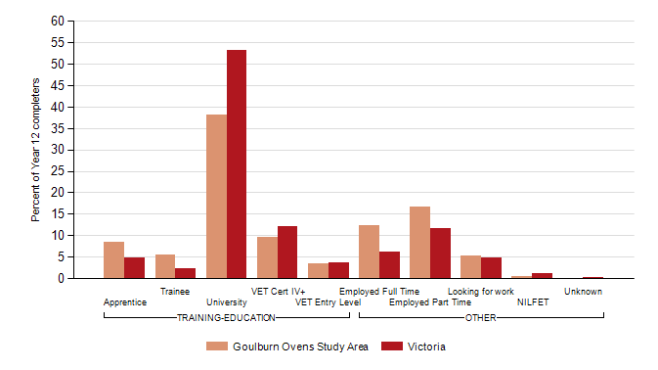
  Note:
  Completers who deferred a place at university or TAFE/VET have been allocated to their labour market destinations.
  Figure 2
  Destinations of 2012 Year 12 or equivalent completers, showing deferrals: Goulburn Ovens Study Area TSA and Victoria
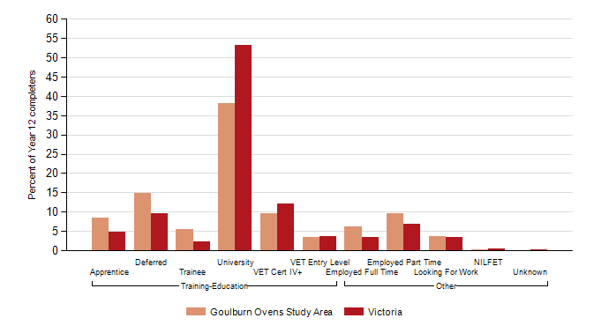

  Figure 3
  Destinations of 2012 early school leavers: Goulburn Ovens Study Area TSA and Victoria
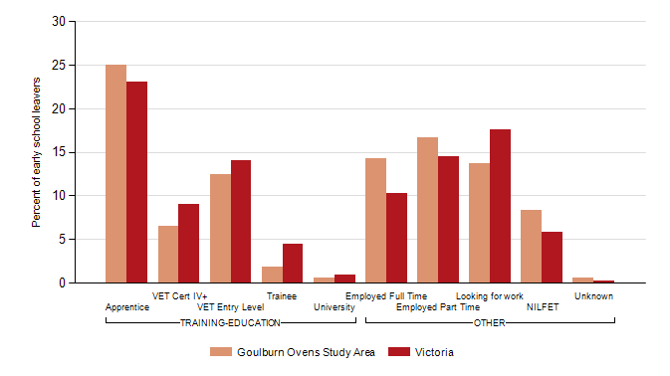

Table 4
  Destinations of 2012 Year 12 or equivalent completers undertaking study in 2013, level of study by institution: Goulburn Ovens Study Area
Institution |  |  |  |  |  |  |  |  |  |  | Total
  Adv dip
  Assoc degree
  Cert I
  Cert II
  Cert III
  Cert IV
  Cert unspec
  Dip
  Other
Australian Catholic University
  n
  1
  1
Australian Catholic University | % |  |  |  |  |  |  |  | 0.1 |  | 0.1
Ballarat University
  n
Ballarat University | %
Ballarat University (TAFE Division)
  n
  1
  1
Ballarat University (TAFE Division) | % |  |  |  |  |  | 0.1 |  |  |  | 0.1
Bendigo Regional Institute of TAFE
  n
  1
  3
  2
  1
  7
Bendigo Regional Institute of TAFE | % |  |  |  | 0.1 | 0.2 | 0.1 | 0.1 |  |  | 0.5
Box Hill Institute of TAFE
  n
  1
  2
  1
  2
  6
Box Hill Institute of TAFE | % | 0.1 |  |  |  | 0.1 |  | 0.1 | 0.1 |  | 0.4
Central Gippsland TAFE
  n
  2
  1
  3
Central Gippsland TAFE | % |  |  |  |  | 0.1 | 0.1 |  |  |  | 0.2
Chisholm Institute of TAFE
  n
  2
  1
  3
Chisholm Institute of TAFE | % |  |  |  |  | 0.1 |  | 0.1 |  |  | 0.2
Deakin University
  n
  1
  1
Deakin University | % |  |  |  |  |  |  |  | 0.1 |  | 0.1
Don't know institution of person conducting training in the workplace
  n
  15
  3
  3
  21
 | % |  |  |  |  | 1.1 | 0.2 | 0.2 |  |  | 1.6
Gordon Institute
  n
  3
  6
  2
  5
  16
Gordon Institute | % | 0.2 |  |  |  | 0.4 | 0.1 |  | 0.4 |  | 1.2
Goulburn Ovens Institute of TAFE
  n
  1
  1
  13
  48
  16
  2
  18
  99
Goulburn Ovens Institute of TAFE | % | 0.1 | 0.1 |  | 1.0 | 3.6 | 1.2 | 0.1 | 1.3 |  | 7.3
Holmesglen Institute
  n
  1
  2
  1
  4
Holmesglen Institute | % | 0.1 |  |  |  | 0.1 | 0.1 |  |  |  | 0.3
Kangan Batman Institute of TAFE
  n
  5
  9
  6
  1
  21
Kangan Batman Institute of TAFE | % |  |  |  | 0.4 | 0.7 | 0.4 |  | 0.1 |  | 1.6
La Trobe University
  n
  1
  1
  5
  1
  8
La Trobe University | % | 0.1 |  | 0.1 |  |  |  |  | 0.4 | 0.1 | 0.6
Melbourne University
  n
  2
  1
  3
Melbourne University | % |  |  |  |  |  |  | 0.1 |  | 0.1 | 0.2
Monash University
  n
Monash University | %
Northern Melbourne Institute of TAFE (NMIT)
  n
  1
  3
  4
  1
  9
Northern Melbourne Institute of TAFE (NMIT) | % |  |  |  | 0.1 | 0.2 | 0.3 |  | 0.1 |  | 0.7
RMIT (TAFE Division)
  n
  1
  3
  1
  1
  8
  14
RMIT (TAFE Division) | % | 0.1 |  |  |  | 0.2 | 0.1 | 0.1 | 0.6 |  | 1.0
RMIT University
  n
  1
  6
  1
  2
  4
  1
  15
RMIT University | % | 0.1 | 0.4 |  |  | 0.1 | 0.1 |  | 0.3 | 0.1 | 1.1
Swinburne (TAFE Division)
  n
  1
  1
  1
  3
Swinburne (TAFE Division) | % |  |  |  |  |  | 0.1 | 0.1 | 0.1 |  | 0.2
Swinburne University
  n
  1
  2
  3
Swinburne University | % |  | 0.1 |  |  | 0.1 |  |  |  |  | 0.2
Victoria University
  n
  1
  1
Victoria University | % |  |  |  |  |  |  |  | 0.1 |  | 0.1
Victoria University (TAFE Division)
  n
  1
  1
  1
  3
Victoria University (TAFE Division) | % |  |  |  |  | 0.1 | 0.1 |  | 0.1 |  | 0.2
William Angliss Institute of TAFE
  n
  4
  3
  4
  11
William Angliss Institute of TAFE | % | 0.3 |  |  |  | 0.2 | 0.3 |  |  |  | 0.8
Wodonga Institute of TAFE
  n
  1
  3
  2
  1
  7
Wodonga Institute of TAFE | % | 0.1 |  |  |  | 0.2 | 0.1 |  | 0.1 |  | 0.5
Proxy/Respondent does not know
  n
  1
  2
  1
  4
Proxy/Respondent does not know | % |  |  |  |  | 0.1 | 0.1 |  |  | 0.1 | 0.3
Other
  n
  5
  1
  3
  39
  25
  7
  18
  5
  103
Other | % | 0.4 |  | 0.1 | 0.2 | 2.9 | 1.9 | 0.5 | 1.3 | 0.4 | 7.6
All institutions | n | 19 | 8 | 2 | 23 | 145 | 74 | 19 | 68 | 9 | 367
 | % | 1.4 | 0.6 | 0.1 | 1.7 | 10.7 | 5.5 | 1.4 | 5.0 | 0.7 | 27.2

Table 5
  Destinations of 2012 Year 12 or equivalent completers undertaking campus-based certificate study in 2013, Course of study by institution: Goulburn Ovens Study Area
 | Goulburn Ovens Study Area |  |  | State
Course of study | n | % | n | %
Accounting | 1 | 0.6 | 62 | 1.2
Aerospace Engineering And Technology | 2 | 1.1 | 50 | 0.9
Agriculture | 4 | 2.2 | 72 | 1.4
Architecture And Urban Environment | 1 | 0.6 | 63 | 1.2
Arts (General) | 2 | 1.1 | 66 | 1.2
Behavioural Science | 1 | 0.6 | 27 | 0.5
Biological Sciences | 1 | 0.6 | 47 | 0.9
Building | 3 | 1.7 | 228 | 4.3
Business And Management | 9 | 5.1 | 311 | 5.8
Civil Engineering | 1 | 0.6 | 113 | 2.1
Communication And Media Studies | 5 | 2.8 | 164 | 3.1
Curriculum And Education Studies | 1 | 0.6 | 51 | 1.0
Dental Studies | 1 | 0.6 | 10 | 0.2
Electrical And Electronic Engineering And Technology | 7 | 3.9 | 159 | 3.0
Employment Skills Programmes | 1 | 0.6 | 12 | 0.2
Environmental Studies | 1 | 0.6 | 29 | 0.5
Food And Hospitality | 12 | 6.7 | 181 | 3.4
Geomatic Engineering | 1 | 0.6 | 8 | 0.2
Graphic And Design Studies | 15 | 8.4 | 346 | 6.5
Human Welfare Studies And Services | 6 | 3.4 | 174 | 3.3
Information Systems | 3 | 1.7 | 95 | 1.8
Justice And Law Enforcement | 5 | 2.8 | 133 | 2.5
Language And Literature | 1 | 0.6 | 29 | 0.5
Mathematical Sciences | 1 | 0.6 | 4 | 0.1
Mechanical And Industrial Engineering And Technology | 1 | 0.6 | 66 | 1.2
Nursing | 23 | 12.9 | 224 | 4.2
Other | 3 | 1.7 | 82 | 1.5
Other Agriculture, Environmental And Related Studies | 1 | 0.6 | 32 | 0.6
Other Creative Arts | 3 | 1.7 | 99 | 1.9
Other Education | 2 | 1.1 | 98 | 1.8
Other Health | 3 | 1.7 | 209 | 3.9
Other Information Technology | 1 | 0.6 | 106 | 2.0
Other Management And Commerce | 5 | 2.8 | 133 | 2.5
Other Society And Culture | 1 | 0.6 | 37 | 0.7
Performing Arts | 8 | 4.5 | 156 | 2.9
Personal Services | 13 | 7.3 | 221 | 4.1
Philosophy And Religious Studies | 2 | 1.1 | 32 | 0.6
Public Health | 3 | 1.7 | 24 | 0.5
Sales And Marketing | 2 | 1.1 | 105 | 2.0
Science (General) | 1 | 0.6 | 66 | 1.2
Sport And Recreation | 9 | 5.1 | 238 | 4.5
Teacher Education | 6 | 3.4 | 192 | 3.6
Tourism | 3 | 1.7 | 83 | 1.6
Visual Arts And Crafts | 3 | 1.7 | 133 | 2.5
 |  | 100.0 | 5332 | 100.0
  All courses of study
  178

Table 6
  Reasons for not studying in 2012: Goulburn Ovens Study Area TSA and Victoria
 |  |  | Goulburn Ovens Study Area | Victoria
Reasons for not studying |  |  | % | %
Year 12 or equivalent completers
Not in education or training and did not defer
 | You just needed a break from study | 69.6 | 67.2
 | You wanted some other experiences, like travel, before continuing your education | 32.4 | 26.1
 | You wanted to start earning your own money | 84.4 | 80.2
 | You would have had to move away from home | 27.2 | 20.5

Early school leavers
 | The courses you were interested in were not available locally | 33.3 | 26.3
 | You just needed a break from study | 46.9 | 56.9
 | You never planned or intended to study | 25.9 | 22.0
 | You wanted to start working | 77.8 | 80.7

  Notes:
  1. The data in this table are for all school leavers who are not in education or training, including those who
  deferred a place at university or TAFE, as well as those who did not apply for study.
  2. Respondents may have selected more than one reason.

