On Track


The On Track Survey 2012

Goulburn Ovens Study Area

TAFE Study Area Report



This report provides information about the destinations of 2011 exiting students in schools in your TAFE Study Area (TSA).

On Track follows up young people in the six months after they leave school to obtain data about their post Year 12 education, training and employment destinations.

Data obtained through the On Track survey are used to publish post Year 12 education, training and employment destinations celebrating the broad range of outcomes schools create for young people – not just university but studying at TAFE, undertaking apprenticeships and other forms of training or employment. Those not studying or in part‐time work who request additional pathway advice and support are referred to Youth Connections providers for help with their career plans.

Since 2003, more than 415,000 Year 10, 11 and 12 school‐leavers have participated in On Track Surveys.

The first On Track Longitudinal Surveys followed groups of 2003 and 2004 school leavers to gain a more detailed picture of their transitions over the four years after they leave school.

The second longitudinal study began in 2008 and followed a cohort of 2007 school leavers until 2011.

Annual On Track reports and the On Track longitudinal reports are available on the On Track website:
www.education.vic.gov.au/ontrack.

Data note
Schools are assigned to the closest TAFE Study Area and multi campus Institutes may therefore request data reports for other the TAFE Study Areas relevant to those campuses.

Tables

1. | On Track responses for 2011 Year 12 or equivalent completers and early school leavers, by TAFE study area
2. | Destinations of 2011 Year 12 or equivalent completers, by TAFE study area
3. | Destinations of 2011 early school leavers, by TAFE study area
4. | Destinations of 2011 Year 12 or equivalent completers undertaking campus-based certificate study in 2012: level of study by institution, Goulburn Ovens Study Area
5. | Destinations of 2011 Year 12 or equivalent completers undertaking campus-based certificate study in 2012: course of study by institution, Goulburn Ovens Study Area
6. | Reasons for not studying, Goulburn Ovens Study Area and Victoria

Figures

1. | Destinations of 2011 Year 12 or equivalent completers, Goulburn Ovens Study Area and Victoria
2. | Destinations of 2011 Year 12 or equivalent completers, showing deferrals, Goulburn Ovens Study Area and Victoria
3. | Destinations of 2011 early school leavers, Goulburn Ovens Study Area and Victoria

  Table 1
  On Track responses for 2011 Year 12 or equivalent completers and early school leavers, by TAFE study area
 | Year 12 or equivalent completers |  |  |  |  | Early school leavers
TAFE study area | Consenters | Respondents | Response rate | Consenters | Respondents | Response rate
Ballarat | 1,500 | 1,111 | 74.1 | 644 | 180 | 28.0
Bendigo | 1,487 | 1,169 | 78.6 | 790 | 317 | 40.1
CBD | 1,281 | 843 | 65.8 | 436 | 96 | 22.0
Central Gippsland | 1,176 | 928 | 78.9 | 434 | 168 | 38.7
East Gippsland | 580 | 431 | 74.3 | 345 | 117 | 33.9
Eastern | 8,353 | 6,125 | 73.3 | 1,319 | 371 | 28.1
Geelong | 1,909 | 1,382 | 72.4 | 602 | 198 | 32.9
Goulburn Ovens | 1,582 | 1,080 | 68.3 | 533 | 144 | 27.0
North West | 9,984 | 7,422 | 74.3 | 2,755 | 745 | 27.0
South East | 8,621 | 6,223 | 72.2 | 1,602 | 476 | 29.7
South West | 428 | 340 | 79.4 | 213 | 70 | 32.9
Sunraysia | 626 | 452 | 72.2 | 195 | 68 | 34.9
Wodonga | 275 | 170 | 61.8 | 115 | 25 | 21.7
Unknown TSA | 8,540 | 6,225 | 72.9 | 1,902 | 574 | 30.2
Victoria | 46,342 | 33,901 | 73.2 | 11,885 | 3,549 | 29.9

  Table 2
  Destinations of 2011 Year 12 or equivalent completers by TAFE study area
TAFE study area |  |  |  |  |  |  |  | Total Interviewed
  University
  TAFE/VET
  Apprentice/ Trainee
  Employed
  Looking For Work
  NILFET*
 | n | 492 | 144 | 90 | 317 | 58 | 10 | 1,111
  Ballarat
 | % | 44.3 | 13.0 | 8.1 | 28.5 | 5.2 | 0.9 | 100
 | n | 474 | 168 | 164 | 290 | 62 | 11 | 1,169
  Bendigo
 | % | 40.5 | 14.4 | 14.0 | 24.8 | 5.3 | 0.9 | 100
 | n | 586 | 106 | 29 | 96 | 21 | 5 | 843
  CBD
 | % | 69.5 | 12.6 | 3.4 | 11.4 | 2.5 | 0.6 | 100
 | n | 341 | 161 | 125 | 234 | 54 | 13 | 928
  Central Gippsland
 | % | 36.7 | 17.3 | 13.5 | 25.2 | 5.8 | 1.4 | 100
 | n | 143 | 68 | 76 | 122 | 21 | 1 | 431
  East Gippsland
 | % | 33.2 | 15.8 | 17.6 | 28.3 | 4.9 | 0.2 | 100
 | n | 3852 | 889 | 358 | 776 | 189 | 61 | 6,125
  Eastern
 | % | 62.9 | 14.5 | 5.8 | 12.7 | 3.1 | 1.0 | 100
 | n | 604 | 218 | 115 | 374 | 63 | 8 | 1,382
  Geelong
 | % | 43.7 | 15.8 | 8.3 | 27.1 | 4.6 | 0.6 | 100
 | n | 393 | 173 | 138 | 322 | 43 | 11 | 1,080
  Goulburn Ovens
 | % | 36.4 | 16.0 | 12.8 | 29.8 | 4.0 | 1.0 | 100
 | n | 3971 | 1650 | 488 | 928 | 327 | 58 | 7,422
  North West
 | % | 53.5 | 22.2 | 6.6 | 12.5 | 4.4 | 0.8 | 100
 | n | 3210 | 1232 | 449 | 1021 | 256 | 55 | 6,223
  South East
 | % | 51.6 | 19.8 | 7.2 | 16.4 | 4.1 | 0.9 | 100
 | n | 110 | 50 | 50 | 111 | 18 | 1 | 340
  South West
 | % | 32.4 | 14.7 | 14.7 | 32.6 | 5.3 | 0.3 | 100
 | n | 172 | 70 | 60 | 127 | 17 | 6 | 452
  Sunraysia
 | % | 38.1 | 15.5 | 13.3 | 28.1 | 3.8 | 1.3 | 100
 | n | 34 | 29 | 29 | 67 | 9 | 2 | 170
  Wodonga
 | % | 20.0 | 17.1 | 17.1 | 39.4 | 5.3 | 1.2 | 100
 | n | 3237 | 967 | 556 | 1158 | 256 | 51 | 6,225
  Unknown TSA
 | % | 52.0 | 15.5 | 8.9 | 18.6 | 4.1 | 0.8 | 100
 | n |  |  |  |  |  |  | 33,901
  Victoria
  17,619
  5,925
  2,727
  5,943
  1,394
  293
 | % | 52.0 | 17.5 | 8.0 | 17.5 | 4.1 | 0.9 | 100

  Notes:
  Completers who deferred a place at university or TAFE have been allocated to their labour market destinations.
  NILFET*: Not in labour force, education or training

Table 3
  Destinations of 2011 early school leavers by TAFE study area
TAFE study area |  | University | TAFE/VET | Apprentice/ Trainee | Employed | Looking For Work | NILFET | Total Interviewed
 | n | 0 | 38 | 82 | 34 | 18 | 8 | 180
  Ballarat
 | % | 0.0 | 21.1 | 45.6 | 18.9 | 10.0 | 4.4 | 100
 | n | 2 | 58 | 138 | 63 | 38 | 18 | 317
  Bendigo
 | % | 0.6 | 18.3 | 43.5 | 19.9 | 12.0 | 5.7 | 100
 | n | 2 | 17 | 12 | 27 | 25 | 13 | 96
  CBD
 | % | 2.1 | 17.7 | 12.5 | 28.1 | 26.0 | 13.5 | 100
 | n | 0 | 42 | 68 | 30 | 19 | 9 | 168
  Central Gippsland
 | % | 0.0 | 25.0 | 40.5 | 17.9 | 11.3 | 5.4 | 100
 | n | 0 | 15 | 53 | 31 | 12 | 6 | 117
  East Gippsland
 | % | 0.0 | 12.8 | 45.3 | 26.5 | 10.3 | 5.1 | 100
 | n | 5 | 82 | 126 | 88 | 58 | 12 | 371
  Eastern
 | % | 1.3 | 22.1 | 34.0 | 23.7 | 15.6 | 3.2 | 100
 | n | 0 | 52 | 68 | 42 | 28 | 8 | 198
  Geelong
 | % | 0.0 | 26.3 | 34.3 | 21.2 | 14.1 | 4.0 | 100
 | n | 1 | 31 | 56 | 36 | 15 | 5 | 144
  Goulburn Ovens
 | % | 0.7 | 21.5 | 38.9 | 25.0 | 10.4 | 3.5 | 100
 | n | 3 | 180 | 213 | 154 | 143 | 52 | 745
  North West
 | % | 0.4 | 24.2 | 28.6 | 20.7 | 19.2 | 7.0 | 100
 | n | 1 | 94 | 146 | 128 | 80 | 27 | 476
  South East
 | % | 0.2 | 19.7 | 30.7 | 26.9 | 16.8 | 5.7 | 100
 | n | 0 | 11 | 28 | 26 | 3 | 2 | 70
  South West
 | % | 0.0 | 15.7 | 40.0 | 37.1 | 4.3 | 2.9 | 100
 | n | 0 | 12 | 28 | 20 | 4 | 4 | 68
  Sunraysia
 | % | 0.0 | 17.6 | 41.2 | 29.4 | 5.9 | 5.9 | 100
 | n | 0 | 7 | 7 | 6 | 4 | 1 | 25
  Wodonga
 | % | 0.0 | 28.0 | 28.0 | 24.0 | 16.0 | 4.0 | 100
 | n | 1 | 122 | 204 | 141 | 86 | 20 | 574
  Unknown TSA
 | % | 0.2 | 21.3 | 35.5 | 24.6 | 15.0 | 3.5 | 100
 | n |  |  |  |  |  |  | 3,549
  Victoria
  15
  761
  1,229
  826
  533
  185
 | % | 0.4 | 21.4 | 34.6 | 23.3 | 15.0 | 5.2 | 100

  Figure 1
  Destinations of 2011 Year 12 or equivalent completers: Goulburn Ovens Study Area TSA and Victoria
 | 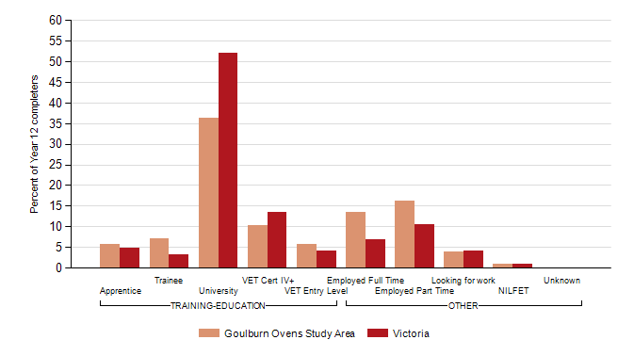
  Note:
  Completers who deferred a place at university or TAFE/VET have been allocated to their labour market destinations.
  Figure 2
  Destinations of 2011 Year 12 or equivalent completers, showing deferrals: Goulburn Ovens Study Area TSA and Victoria
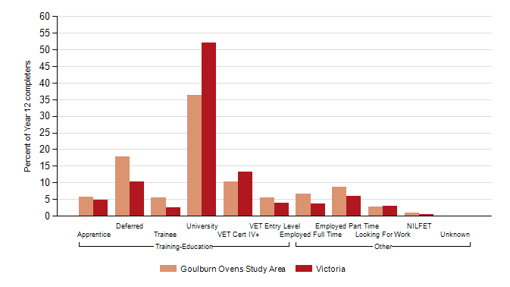

  Figure 3
  Destinations of 2011 early school leavers: Goulburn Ovens Study Area TSA and Victoria
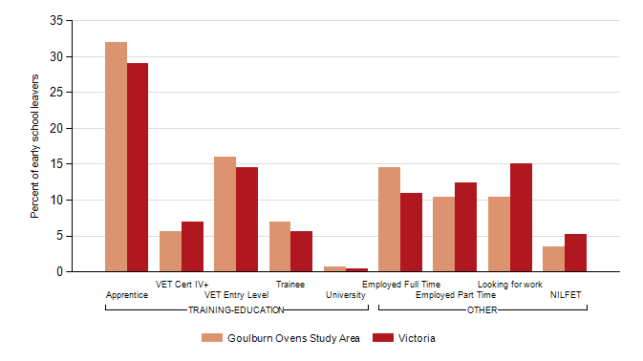

Table 4
  Destinations of 2011 Year 12 or equivalent completers undertaking study in 2012, level of study by institution: Goulburn Ovens Study Area
Institution |  |  |  |  |  |  |  |  |  |  | Total
  Adv dip
  Assoc degree
  Cert I
  Cert II
  Cert III
  Cert IV
  Cert unspec
  Dip
  Other
Australian Catholic University
  n
  1
  1
Australian Catholic University | % |  |  |  |  |  |  |  | 0.1 |  | 0.1
Ballarat University
  n
  1
  1
Ballarat University | % |  |  |  |  |  |  |  | 0.1 |  | 0.1
Ballarat University (TAFE Division)
  n
  1
  1
Ballarat University (TAFE Division) | % |  |  |  |  |  |  |  | 0.1 |  | 0.1
Bendigo Regional Institute of TAFE
  n
  2
  1
  1
  4
Bendigo Regional Institute of TAFE | % |  |  |  |  | 0.2 | 0.1 |  | 0.1 |  | 0.4
Box Hill Institute of TAFE
  n
  3
  1
  2
  1
  7
Box Hill Institute of TAFE | % |  |  |  |  | 0.3 | 0.1 |  | 0.2 | 0.1 | 0.6
Central Gippsland TAFE
  n
  1
  1
Central Gippsland TAFE | % |  |  |  |  | 0.1 |  |  |  |  | 0.1
Chisholm Institute of TAFE
  n
  1
  1
Chisholm Institute of TAFE | % |  |  |  |  | 0.1 |  |  |  |  | 0.1
Deakin University
  n
  1
  1
  1
  2
  5
Deakin University | % |  | 0.1 |  |  |  |  | 0.1 | 0.1 | 0.2 | 0.5
East Gippsland Institute
  n
  1
  1
East Gippsland Institute | % | 0.1 |  |  |  |  |  |  |  |  | 0.1
Gordon Institute
  n
  4
  1
  3
  8
Gordon Institute | % |  |  |  |  | 0.4 | 0.1 |  | 0.3 |  | 0.7
Goulburn Ovens Institute of TAFE
  n
  1
  9
  39
  8
  8
  65
Goulburn Ovens Institute of TAFE | % | 0.1 |  |  | 0.8 | 3.6 | 0.7 |  | 0.7 |  | 6.0
Holmesglen Institute
  n
  1
  1
  3
  5
Holmesglen Institute | % |  |  |  |  | 0.1 | 0.1 |  | 0.3 |  | 0.5
Kangan Batman Institute of TAFE
  n
  2
  3
  2
  7
Kangan Batman Institute of TAFE | % |  |  |  |  | 0.2 | 0.3 |  | 0.2 |  | 0.6
La Trobe University
  n
  1
  5
  1
  7
La Trobe University | % |  | 0.1 |  |  |  |  |  | 0.5 | 0.1 | 0.6
Melbourne University
  n
  1
  1
  2
Melbourne University | % |  | 0.1 |  |  |  |  |  | 0.1 |  | 0.2
Melbourne University (TAFE Division/ILFR)
  n
  1
  1
Melbourne University (TAFE Division/ILFR) | % |  |  |  |  | 0.1 |  |  |  |  | 0.1
Monash University
  n
Monash University | %
Northern Melbourne Institute of TAFE (NMIT)
  n
  2
  1
  2
  1
  6
Northern Melbourne Institute of TAFE (NMIT) | % | 0.2 |  |  | 0.1 | 0.2 |  |  | 0.1 |  | 0.6
RMIT (TAFE Division)
  n
  7
  1
  2
  1
  5
  16
RMIT (TAFE Division) | % | 0.6 | 0.1 |  |  | 0.2 | 0.1 |  | 0.5 |  | 1.5
RMIT University
  n
  2
  2
  4
RMIT University | % |  | 0.2 |  | 0.2 |  |  |  |  |  | 0.4
South West Institute of TAFE
  n
  1
  1
South West Institute of TAFE | % |  |  |  | 0.1 |  |  |  |  |  | 0.1
Sunraysia Institute of TAFE
  n
  1
  1
Sunraysia Institute of TAFE | % |  |  |  |  | 0.1 |  |  |  |  | 0.1
Swinburne (TAFE Division)
  n
  1
  5
  6
Swinburne (TAFE Division) | % |  |  |  |  |  | 0.1 |  | 0.5 |  | 0.6
Swinburne University
  n
  1
  1
  1
  3
Swinburne University | % |  | 0.1 |  |  |  | 0.1 |  | 0.1 |  | 0.3
Victoria University
  n
  1
  3
  1
  2
  7
Victoria University | % |  |  |  | 0.1 | 0.3 | 0.1 |  | 0.2 |  | 0.6
Victoria University (TAFE Division)
  n
  1
  1
  3
  5
Victoria University (TAFE Division) | % | 0.1 |  |  |  | 0.1 |  |  | 0.3 |  | 0.5
William Angliss Institute of TAFE
  n
  4
  3
  7
William Angliss Institute of TAFE | % |  |  |  |  | 0.4 |  |  | 0.3 |  | 0.6
Wodonga Institute of TAFE
  n
  8
  3
  1
  6
  1
  19
Wodonga Institute of TAFE | % |  |  |  |  | 0.7 | 0.3 | 0.1 | 0.6 | 0.1 | 1.8
Proxy/Respondent does not know
  n
  1
  1
  2
Proxy/Respondent does not know | % |  |  |  |  |  |  |  | 0.1 | 0.1 | 0.2
Other
  n
  7
  1
  2
  6
  47
  21
  19
  17
  2
  122
Other | % | 0.6 | 0.1 | 0.2 | 0.6 | 4.4 | 1.9 | 1.8 | 1.6 | 0.2 | 11.3
All institutions | n | 19 | 8 | 2 | 20 | 122 | 43 | 21 | 73 | 8 | 316
 | % | 1.8 | 0.7 | 0.2 | 1.9 | 11.3 | 4.0 | 1.9 | 6.8 | 0.7 | 29.3

Table 5
  Destinations of 2011 Year 12 or equivalent completers undertaking campus-based certificate study in 2012, Course of study by institution: Goulburn Ovens Study Area
 | Goulburn Ovens Study Area |  |  | State
Course of study | n | % | n | %
Accounting | 2 | 1.2 | 117 | 2.0
Aerospace Engineering And Technology | 1 | 0.6 | 44 | 0.7
Agriculture | 2 | 1.2 | 39 | 0.7
Architecture And Urban Environment | 2 | 1.2 | 72 | 1.2
Arts (General) | 4 | 2.3 | 93 | 1.6
Automotive Engineering And Technology | 2 | 1.2 | 23 | 0.4
Banking, Finance And Related Fields | 1 | 0.6 | 23 | 0.4
Behavioural Science | 1 | 0.6 | 13 | 0.2
Biological Sciences | 3 | 1.7 | 44 | 0.7
Building | 2 | 1.2 | 265 | 4.5
Business And Management | 6 | 3.5 | 362 | 6.1
Communication And Media Studies | 3 | 1.7 | 199 | 3.4
Complementary Therapies | 1 | 0.6 | 16 | 0.3
Curriculum And Education Studies | 1 | 0.6 | 36 | 0.6
Electrical And Electronic Engineering And Technology | 2 | 1.2 | 154 | 2.6
Food And Hospitality | 5 | 2.9 | 224 | 3.8
Forestry Studies | 1 | 0.6 | 3 | 0.1
General Degree | 2 | 1.2 | 7 | 0.1
General Education Programmes | 2 | 1.2 | 39 | 0.7
Graphic And Design Studies | 8 | 4.6 | 376 | 6.3
Horticulture And Viticulture | 2 | 1.2 | 26 | 0.4
Human Welfare Studies And Services | 9 | 5.2 | 251 | 4.2
Information Systems | 1 | 0.6 | 91 | 1.5
Law | 1 | 0.6 | 101 | 1.7
Mechanical And Industrial Engineering And Technology | 3 | 1.7 | 85 | 1.4
Medical Studies | 2 | 1.2 | 21 | 0.4
No Course Nominated | 3 | 1.7 | 121 | 2.0
Nursing | 8 | 4.6 | 215 | 3.6
Office Studies | 1 | 0.6 | 12 | 0.2
Other Creative Arts | 5 | 2.9 | 162 | 2.7
Other Education | 7 | 4.0 | 149 | 2.5
Other Engineering And Related Technologies | 3 | 1.7 | 62 | 1.0
Other Health | 8 | 4.6 | 270 | 4.6
Other Information Technology | 5 | 2.9 | 138 | 2.3
Other Management And Commerce | 4 | 2.3 | 137 | 2.3
Other Mixed Field Programmes | 1 | 0.6 | 11 | 0.2
Other Natural And Physical Sciences | 1 | 0.6 | 51 | 0.9
Other Society And Culture | 1 | 0.6 | 55 | 0.9
Performing Arts | 7 | 4.0 | 148 | 2.5
Personal Services | 18 | 10.4 | 259 | 4.4
Philosophy And Religious Studies | 1 | 0.6 | 27 | 0.5
Public Health | 1 | 0.6 | 16 | 0.3
Rehabilitation Therapies | 5 | 2.9 | 43 | 0.7
Sales And Marketing | 2 | 1.2 | 148 | 2.5
Science (General) | 2 | 1.2 | 66 | 1.1
Sport And Recreation | 12 | 6.9 | 359 | 6.1
Tourism | 3 | 1.7 | 85 | 1.4
Veterinary Studies | 3 | 1.7 | 35 | 0.6
Visual Arts And Crafts | 3 | 1.7 | 169 | 2.9
 |  | 100.0 | 5925 | 100.0
  All courses of study
  173

Table 6
  Reasons for not studying in 2011: Goulburn Ovens Study Area TSA and Victoria
 |  |  | Goulburn Ovens Study Area | Victoria
Reasons for not studying |  |  | % | %
Year 12 or equivalent completers
Not in education or training and did not defer
 | The courses you were interested in were not available locally | 26.1 | 20.1
 | You just needed a break from study | 66.8 | 66.7
 | You never planned or intended to study | 27.7 | 26.9
 | You wanted to start earning your own money | 86.4 | 82.8

Early school leavers
 | The courses you were interested in were not available locally | 29.2 | 24.6
 | You just needed a break from study | 47.9 | 56.1
 | You never planned or intended to study | 31.3 | 24.1
 | You wanted to start earning your own money | 85.4 | 80.4

  Notes:
  1. The data in this table are for all school leavers who are not in education or training, including those who
  deferred a place at university or TAFE, as well as those who did not apply for study.
  2. Respondents may have selected more than one reason.

