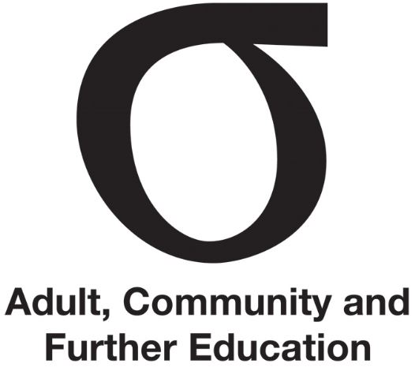 | Working with the Department
Fact Sheet | Working with the Department | September 2015
Audience | All members

This Fact Sheet outlines the roles of the Department and senior Department staff that Regional Council members may work with.

The Participation Branch
ACFE Board (Board) planning, policy and decision implementation and resource allocation are supported by the Participation Branch of the TAFE and ACFE Governance Division, which comprises one central and four regional offices.
Staff support the eight Regional Councils (Councils) and Learn Local organisations in meeting the Government’s goals and targets for adult, community and further education.
The role of the Branch is to:
- strengthen participation in and benefits from senior secondary, vocational training and adult education settings, with a strong focus on high-needs learners
- support the Board to develop and implement its strategic directions and
- support the implementation of the Regional Council Plan and decisions of Council
- provide administrative services for Councils including preparing meeting agendas, minutes of meetings, and meeting papers, and project management of Council projects.
Additionally, the Branch:
- advises the Minister, Secretary and Deputy Secretary on adult, community and further education
- manages the provision of government supported adult education in the community
- negotiates a range of contracts and performance agreements on behalf of the Board, including those with adult education institutions and Learn Local organisations
- monitors and manages performance and ensures financial accountability
- develops and maintains strong working relationships with agencies and organisations relevant to adult, community and further education in Victoria.
Staff maintain a range of working relationships with other areas of the Department, including those working with schools, TAFE institutes, higher education and industry, and through programs such as apprenticeships, accredited training and senior secondary certificates of education.

Council relationship to the Department
The authority of each Regional Council is vested in its meetings. Each Council carries out its legislated functions, determines its own Regional Council Plan and monitors the plan’s implementation.
Individual members of the Council, including the chairperson and deputy chairperson, do not have management authority between meetings or outside meetings. This means they do not have authority as individuals to intervene in implementation issues or to take decisions on behalf of the Council.
Further information
Fact Sheet | Regional Council administration
Fact Sheet | Leading Regional Council
Regional contacts – Participation Branch
General memos communicated to Learn Local organisations by the Department

