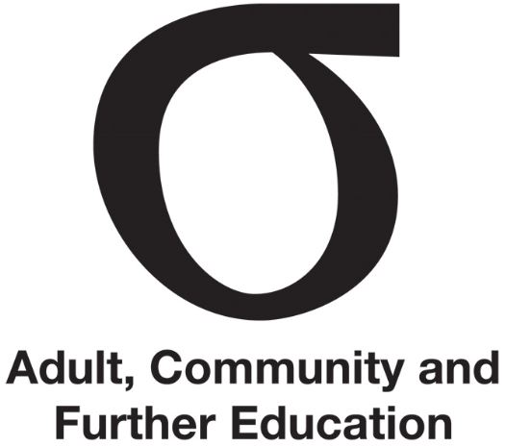 | Legislation and governance
Fact Sheet | Legislation and governance |
May 2016
Audience | New members

This Fact Sheet outlines the legislative responsibilities of the ACFE Board (the Board) and Regional Councils (the Councils).
The authority and establishment of the Board and the Councils derives from the Education and Training Reform Act 2006 (the Act).

The mission

The mission of the ACFE Board and Regional Councils is to increase educational participation and attainment of adults, improve social cohesion and boost the human and social capital of Victoria through:
- working with Government to meet the needs of learners facing barriers to participation and attainment including those from low socio-economic status localities, early school leavers, low skilled and vulnerable workers, Indigenous people, unemployed people and people with a disability
- supporting Victoria’s Learn Local adult community education organisations to focus on quality improvement and sustainability, be responsive to local/regional individual, community and industry needs, and to develop stronger and more visible networks while maintaining the characteristics and approaches that are their historical strength
- maintaining open, consultative and collaborative relationships with its stakeholders and partners, particularly ACFE Regional Councils, Learn Local organisations, adult education institutions and adult and community education sector peak bodies.

The ACFE Board

Establishment
The Board is a statutory authority established under the Act. It supports the provision of adult, community and further education to disadvantaged learners in Victoria. The Board fosters the adult education sector, which in Victoria is known as the Learn Local sector, to ensure that the learning needs of disadvantaged learners are identified and met.

Functions
The Board has five main functions:
- Developmental. The Board enquires into and reports on the general development of ACFE policies, programs and services.
- Advisory. The Board is the source of advice to the Minister (and therefore to the Government) on any ACFE matter.
- Strategic. The Board plans and evaluates policies, programs and services, considering and prioritising community learning needs for disadvantaged learners and establishing objectives and targets to meet them.
- Profiling. The Board promotes research and development in the ACFE sector and public awareness of ACFE generally.
- Operational funding. The Board provides for delivery of ACFE and funds policies, programs and services.
In relation to these functions, the Board has a comprehensive set of powers under the Act, including financial powers such as making payments by way of grants, subsidies and loans. The Board gives consolidated advice to Parliament on the operation of the Learn Local sector, providing an Annual Report that includes reports on the operations of the individual Regional Councils.

Consultation
The Act is clear about the Board’s method of operation and the systems underpinning that. Consultation is to be undertaken as ‘a matter of general practice’, with attention paid to consulting with Regional Councils. The Act requires that, in carrying out its functions and exercising its powers, the Board must:
(b) have regard to the advice of a Regional Council of adult, community and further education on any matter relating to adult, community and further education in that region; and
(c) consult, as a matter of general practice, with:
- the Regional Councils; and
- the governing bodies of adult education institutions; and
- the boards of TAFE institutes; and
- any person or organisation providing or using adult, community and further education on any matter of general concern about adult, community and further education; and
(d) ensure that its actions are consistent with the arrangements for the provision of vocational education and training.
Education and Training Reform Act, s. 3.3.5

Membership
The Board has 12 members, including a chairperson and a deputy chairperson. All members of the Board are appointed by the Governor in Council on the recommendation of the Minister.

Strategic plan and business plan
The Board develops a three-year strategic plan and each year establishes a one-year business plan to support its implementation.

The Regional Councils

Establishment
Under the Act, the Minister establishes each ACFE region and a Council for each region. There are currently eight Regional Councils:
- Barwon South Western
- Eastern Metropolitan
- Gippsland
- Grampians
- Hume
- Loddon Mallee
- North Western Metropolitan
- Southern Metropolitan.
Each Council draws together different expertise and aspects of local knowledge to advise the Board on the needs of ACFE across their region. Councils also contribute to statewide planning, provision and policy development.

Regional Council Charter
Each Council has a Charter that defines its mission, functions, scope and membership. The Charter is based on the Education and Training Reform Act.
The Board and Councils work together to fulfil the mission. The objectives of the Councils are aligned to those of the Board.
Council strategies contribute directly to the achievement of the mission and the Board’s objectives. The Councils have three important functions in meeting this:
- providing ‘regional intelligence’ to the Board on the ACFE learning needs of disadvantaged learners, business and industry in their region
- advising the Board and monitoring the delivery of ACFE in their region
- supporting and promoting ACFE in their region.
In carrying out their functions, there is a requirement for the Councils and the Board to ‘consult as a matter of general practice’ with users and providers of ACFE.

Membership and meetings
Each Council has a minimum of five members appointed by the Minister for a three-year term, and may co-opt two people for one year. All work is undertaken in a voluntary capacity.
There is no required minimum number of meetings that a Council must hold each year.

Regional Council planning
To support the implementation of the ACFE Board strategic plan, Councils develop a Regional Council Plan that meets the mission and individual needs and circumstances of their region.
The Plan may include a project/s that are managed by the Council, with the ultimate aim of providing advice to the Board.

Further information
Your Regional Council’s Charter
Fact Sheet | Consulting with stakeholders
Fact Sheet | Regional Council planning
Fact Sheet | Advising the ACFE Board

