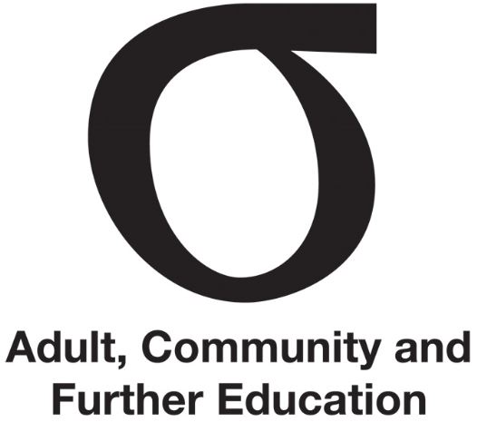 | Consulting with stakeholders
Fact Sheet | Consulting with stakeholders | September 2015
Audience | Chairperson, all members

This Fact Sheet outlines the consultation function of the ACFE Board (Board) and Regional Councils (Councils).
The Education and Training Reform Act 2006 (the Act) is clear that the Board and the Councils’ method of operation must be built on consultation ‘as a matter of general practice’.

The Board
For the Board the Act indicates that consultation is to be undertaken as ‘a matter of general practice’, with specific attention paid to its relationship with Regional Councils.
The Act requires that, in carrying out its functions and exercising its powers, the ACFE Board must:
- have regard to the advice of a Regional Council of adult, community and further education on any matter relating to adult, community and further education in that region; and
- consult, as a matter of general practice, with
- the Regional Councils; and
- the governing bodies of adult education institutions; and
- the boards of TAFE institutes; and
- any person or organisation providing or using adult, community and further education on any matter of general concern about adult, community and further education; and
- ensure that its actions are consistent with the arrangements for the provision of vocational education and training.
Education and Training Reform Act, s. 3.3.5

The Councils
Consultation provides the Councils with the ‘regional intelligence’ to undertake their functions in the Act.

Regional Councils must consult as a matter of general practice with any person or organisation who uses or provides adult, community and further education and any other education and training organisation in its region, including the board of any TAFE institute which provides or offers adult, community and further education in the region and the governing board of an adult education institution if it provides or offers adult, community and further education in the region;
Education and Training Reform Act, s. 3.3.18 (3) (a)

Who and what to consult
The Act indicates that consultation is required with any organisation ‘who uses or provides adult, community and further education and any other education and training’ in its region. Organisations, providers and learners include but are not limited to:
- Learn Local organisations
- TAFE institutes and their Boards
- Adult Education Institutions and their Boards
- registered training organisations
- local councils
- employers and businesses
- industry bodies/associations
- non-school senior secondary education providers
- higher education providers
- learners
- learner cohorts with special needs
- disadvantaged learners
- community organisations
- other government departments.

In carrying out this function, Councils should familiarise themselves with the definition of adult, community and further education (see Fact Sheet | Understanding ACFE) to understand what they should consult on.

Benefits of consultation and engagement
Effective consultation enables more informed advice to the Board and therefore improved policies, projects, programs and services for disadvantaged learners.
For stakeholders, the benefits of consultation include the opportunity to contribute as experts in their field to policy, program development and services, have their issues heard and participate in the decision-making process.
For Councils and the Board, the benefits of stakeholder engagement include improved information flows by tapping into local knowledge and having the opportunity to ‘road-test’ policy initiatives or proposals with stakeholders.

Council Consultation Plan
How consultation is approached on any issue will depend on factors such as:
- the specific matter and significance of the issue for consultation
- the formality of the consultation (and particularly if it relates to a required legislative output)
- the time for consultation
- the resources available to support the consultation
- the most appropriate way to provide information on the process (for example, use of websites).
Department staff can assist Councils to determine the most appropriate way to consult with stakeholders.

Councils should consider timing the development and implementation of their Consultation Plan so that findings can be used to inform the development of the Regional Council Plan. Regional Council planning typically occurs in October/November each year.

Further information

The Department’s guide and template titled Stakeholder Engagement & Communications Plan is available for Councils to assist them in developing their Consultation Plan. Further information is available from Department staff.
Fact Sheet | Leading Regional Council
Fact Sheet | Understanding ACFE
Fact Sheet | Regional Council planning
Fact Sheet | Advising the ACFE Board

