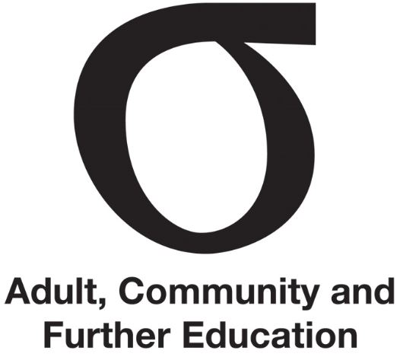 | Code of Conduct for Regional Council members
Fact Sheet | Code of Conduct | September 2015
Audience | All members

This Fact Sheet outlines the Code of Conduct for Regional Council (Council) members.
The Public Sector Standards Commissioner has issued a binding Code of Conduct for Victorian Public Entity Board members. This Fact Sheet is based on that code.

Member Code of Conduct
Members of Regional Councils must abide by the following Code of Conduct:
Act with honesty and integrity
Be open and transparent in your dealings; use power responsibly; do not place yourself in a position of conflict of interest; strive to earn and sustain public trust of a high level.
Act in good faith in the best interests of the public entity
Demonstrate accountability for your actions; accept responsibility for your decisions; do not engage in activities that may bring you or the Council into disrepute.
Act fairly and impartially
Avoid bias, discrimination, caprice or self-interest; demonstrate respect for others by acting in a professional and courteous manner.
Use information appropriately
Ensure information gained as a member is only applied to proper purposes and is kept confidential.
Use your position appropriately
Do not use your position as a member to seek an undue advantage for yourself, family members or associates, or to cause detriment to the Council; ensure that you decline gifts or favours that may cast doubt on your ability to apply independent judgement as a member of a Council.
Act in a financially responsible manner
Understand the resource allocations that come before the Council; actively enquire into this material.
Exercise due care, diligence and skill
Ascertain all relevant information; make reasonable enquiries; understand the financial, strategic and other implications of decisions.
Comply with the establishing legislation, or its equivalent, for your public entity
Act within the powers and for the functions set out in the Education and Training Reform Act 2006 and your Council’s Charter.
Demonstrate leadership and stewardship
Promote and support the application of the Victorian public sector values; act in accordance with the Code of Conduct for Regional Council members.
Councils must annually review their members’ conduct under this code.

Further information
Fact Sheet | Inducting and mentoring new members
Fact Sheet | Leading Regional Council
The Directors’ Code of Conduct and Directors’ Code of Conduct Guidance Notes http://vpsc.vic.gov.au
Fact Sheet | Conflict of interest

