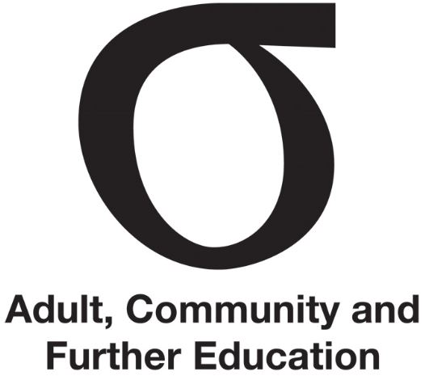 | Regional Council annual review
Fact Sheet | Regional Council annual review | September 2015
Audience | Chairpersons

This Fact Sheet outlines an approach for conducting an annual review of a Regional Council (Council).

Why is this important?
The Victorian Public Sector Commission considers it important that public sector entities undertake an annual review.
Section 3.4.1 of the Council’s Charter indicates the Council must annually review the Regional Council.
Healthy organisations are constantly growing, changing and looking at themselves through fresh eyes. An annual review allows the Council to periodically:
- self-assess its capabilities against characteristics of ‘good practice’ and the functions of Councils as defined in the Education and Training Reform Act 2006
- check appropriateness, for example, of previously adopted policies and codes and other Council documentation.
An annual review helps identify continuous improvement actions that the Council can set for itself in the coming year.

Self-assessment tool
The self-assessment tool will help Councils assess their performance and identify priorities. The combination of performance assessment and priority setting is the foundation of superior Council performance over time.
The tool will help:
- identify the strongest areas of Council performance and those that need improvement
- allow different views to emerge – the responses by different Council members can be tracked and used to start discussions
- identify the areas for the Council to focus on over the next one to two years
- check achievement of legislated functions and seek higher levels of performance and actions for continuous improvement.

Further information
Fact Sheet | Leading Regional Council
Your Regional Council’s Charter
Regional Council self-assessment tool

