Stakeholder Engagement
& Communications Plan
[Project Name]\*

The purpose of this document is to ensure:
- the project team is able to effectively identify, analyse and plan their stakeholder engagement and associated communication activities
- there is a clear and shared understanding of the key stakeholders, level and method of engagement and who is responsible for the actions

 | Name and Title | Phone | Signature | Date
Project Manager | [Name]  [Title] | [Phone]
Project Sponsor | [Name]  [Title] | [Phone]

 Please consider the environment before printing this document use double sided printing if you must print
Introduction
These instructions are provided to you as a guide to help you develop your Stakeholder Engagement & Communications Plan.
Before you start your stakeholder engagement process, you should consider the following:
- how stakeholder engagement will help you to meet your identified project outputs and outcomes?
- how to best utilise existing networks, relationships or engagement processes across the Department to reduce the burden on stakeholders and avoid duplication?
- the historical context and whether there has been previous engagement on the same issue?
- whether it is really necessary for all stakeholders to be involved in all activities and at all stages of the engagement process?
- whether the stakeholders identified will mean that engagement is fully representative and sufficiently informed by diverse perspectives?
- consulting opponents of the particular project or policy in order to gain diverse perspectives and better understand the risks?
- stakeholders’ views on their preferred method of engagement and any constraints they might face?
- how you can establish strong and ongoing working relationships with the stakeholders you are engaging?

There are four steps in completing the plan:
Step 1 – Identify and analyse your stakeholders
Step 2 – Determine the method of engagement
Step 3 – Develop your key messages for each stakeholder
Step 4 – Allocate responsibility to a project team member and specify when it needs to be done.

Step 1 – Identify and analyse your stakeholders

Identify your stakeholders
The first step in your stakeholder analysis is to brainstorm who your stakeholders are. Think of all the people who are affected by your work, who have influence or power over it, or have an interest in its outcomes.

The table below provides a useful starting point:

Examples of internal stakeholders |  | Examples of external stakeholders
- Secretary | - Deputy Secretaries | - Other state departments | - Peak organisations
- General Managers | - Regional Directors | - Federal/Local Government | - Parents and families
- Offices | - Assistant Regional Directors | - Business and industry | - Principals and teachers
- Divisions | - Regional Network Leaders | - Community sector | - Students
- VPS Staff | - Statutory Authorities | - Unions | - Not-for-profit sector
- Regional Staff |  | - Education and training sectors  - Experts | - Special interest groups  - Early childhood/MCH providers
Analyse your stakeholders

After you have identified the key stakeholders, it is important to consider the stakeholders’ levels of interest and influence in relation to the engagement issue.
Use the table below to map each stakeholder onto a quadrant reflecting their level of influence and interest. This will determine the level of engagement (inform, consult, involve, collaborate or empower) that is required with each stakeholder.

- Interest – How important is the project to the stakeholder? How much are they affected?
- Influence – Do they have the ability or power to influence the project – positively or negatively?

The table below will help you analyse and categorise each stakeholder group.

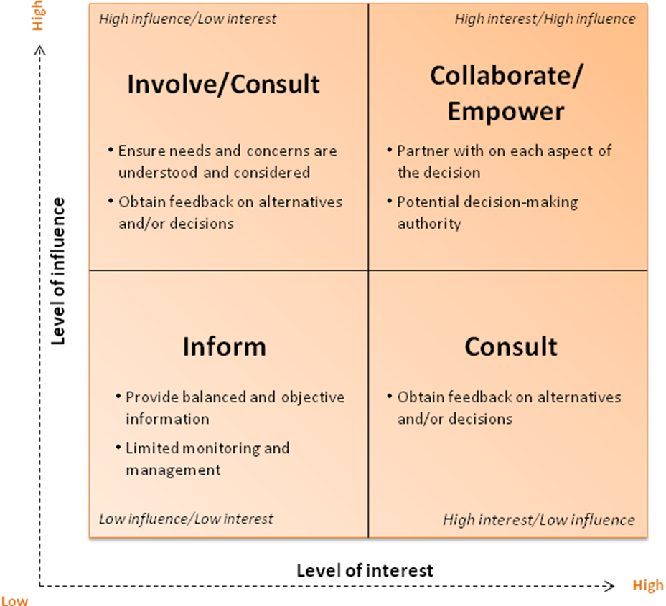
Step 2 – Determine level and method of engagement

Choose a method of engagement
Once you have determined the appropriate level of stakeholder engagement (inform, consult, involve, collaborate and empower), you can then specify the method of engagement. There is no one right stakeholder engagement method and you may choose a number of different methods at different stages of the policy or project process.

The below table provides a useful starting point:
 | Inform | Consult | Involve | Collaborate | Empower
Stakeholder engagement goal | To provide balanced, objective, accurate and consistent information to assist stakeholders to understand the problem, alternatives, opportunities and/or solutions. | To obtain feedback from stakeholders on analysis, alternatives and/or decisions. | To work directly with stakeholders throughout the process to ensure that their concerns and needs are consistently understood and considered. | To partner with the stakeholder including the development of alternatives, making decisions and the identification of the preferred solution. | To place final decision-making in the hands of the stakeholders.
Methods of engagement | - Fact sheets  - Websites  - Open houses  - Newsletters, bulletins, circulars  - Websites, external and eduGate | - Public comment  - Focus groups  - Surveys  - Public meetings  - Ultranet | - Workshops  - Deliberative polling  - Web 2.0 tools  - Forums | - Web 2.0 tools  - Stakeholder reference groups  - Facilitated consensus building forums for deliberation and decision-making | - Facilitation of direct dialogue between stakeholders and government
Source: Adapted from the International Association for Public Participation (IAP2) Spectrum 2007 www.iap2.org

Step 3 – Determine what to communicate with your stakeholders

Key messages to communicate

Before implementing your engagement plan, you should develop key messages that the Department will communicate to stakeholders. This will ensure a consistent message to stakeholders throughout the engagement process. Consider the following questions for your Stakeholder Engagement & Communications Plan:
- what can actually change as a result of engagement and what will not change
- whether stakeholders will be involved in the final decision making or as input only
- expectations of the level of input required of stakeholders.

You should also check if your stakeholders are included on the list of the Department’s key stakeholders. If your stakeholders appear on the list, communication with the lead General Manager should occur before any engagement occurs. This will help to ensure a consistent approach to managing and communicating with the Department’s key stakeholders.

Step 4 – Determine who is responsible and by when

Specify who will be responsible for the planned action and when it will need to be completed by.
Stakeholder Engagement & Communication Plan for [Project Name]\*

Step 1 |  | Step 2 | Step 3 | Step 4
Stakeholder group | Level of Engagement | Method of engagement | Key Messages | Responsibility | By When

