Transition to Secondary



School for students

with an ASD

Dr. Avril V. Brereton

Autism Spectrum Disorders (ASDs) are neurodevelopmental disorders affecting up to 1 in 160 Australians1.

Although the presenting symptoms change with maturation, they continue to be a major source of distress and difficulty for many. Most students with an ASD find school difficult at some time or other. This can be the case no matter what the type of school; specialist or mainstream, primary or secondary. The continuing challenges of ASDs (difficulties with communication and social skills, emotional and behavioural difficulties) combined with the added demands of school indicate that they will require more support at this time. Difficulties may arise for children and young people with ASDs because of:

• the social interaction required with teachers and students throughout the day and their response to these social and emotional demands

• the student’s learning and thinking style and symptoms of ASD

• difficulties in managing stressful situations

• poor organizational skills

• poor peer social interaction

• insistence on sameness and special interests

or obsessions

• difficulties in both understanding and using language

• other co morbid conditions (health, ID and

mental health problems)

All of the above may contribute to making going to school and coping with school difficult for the student with an ASD.

Individuals with ASDs experience high levels of stress at

times of change. As children move beyond the safety, routine and predictability of the family and early childhood settings, they enter a much larger and diverse

**1**

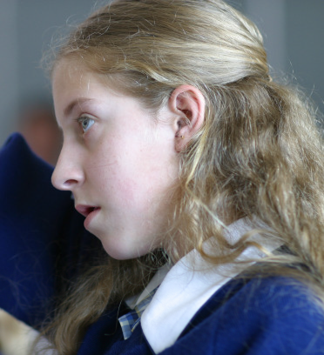

school community. This places greater demands on them both academically and socially. The stressors of moving to a new place, having a larger and more complex peer group, meeting new teachers, and daily increased responsibilities, can contribute to students feeling unsettled or overwhelmed.

Starting secondary school is an exciting step for students and their families, but it can also be a difficult time for some. When a student has an ASD, the transition usually involves extra challenges and may be a source of considerable stress and anxiety for parents/carers, professionals and the student. Successful transition to secondary school requires careful planning, preparation and communication that lead to a shared understanding of each student. The National Autism Society in the UK2 offered guidelines for good practice in the management of transition for youth with Asperger’s Disorder in the transition between secondary school and college but could also be applied to any student with an ASD moving between primary and secondary school.

ASSESS the student’s:

• Health needs

• Education needs

• Emotional and behavioural development needs

• Identity needs

• Family and social relationships needs

• Social presentation and self care skills needs

Then

• Form a transition planning group

• Map out links between schools and agree on a support pathway for transition

• Provide the student and family with consistent support and information

• Good practice will require a named person to oversee the move



It is important to develop a process that brings parents, primary school and secondary school staff together to share a common understanding of the student and provide an opportunity to work together to prepare and implement the transition plan. To this end, Brereton and Bull3 in collaboration with DEECD developed a one day workshop for parents and professionals to get together and learn more about students with ASDs in general and prepare a transition plan for specific students. A “transition team” comprising parents and a representative from the current primary school and one from the new secondary school can work together at this workshop to learn more about making the transition to secondary school as smooth as possible. An important



part of the workshop activities is completion of a transition statement.

ASDs: Secondary School Transition Statement’

|  |  |  |
| --- | --- | --- |
| The ‘ASDs: | Secondary School | Transition |
| Statement’3 | (download | from |

[www.education.vic.gov.au](http://www.education.vic.gov.au/) ) provides a means for

parents and educators to work together. This additional information assists parents and professionals to have a shared understanding of the student’s symptoms of ASD, profile of abilities and how these impact upon him/her. Once the statement has been completed, it will include a summary of previous assessments and reports and also provide information on the student’s current learning profile. A student snapshot may be part of this statement to provide teachers with a one page summary of each student. The statement also provides the opportunity for the student him/herself to contribute to the transition statement by responding to the questions listed or by writing down some comments about him/her self to share with teachers and staff at the

secondary school. References

1. Wray J, Williams K. The prevalence of autism in

Australia. Report commissioned by the Australian Advisory Board on Autism Spectrum Disorders, 2007.

2. National Autistic Society, (2003) National Autism

Plan for Children. London

3. Brereton A. and Bull, K. (2011) Planning a successful transition to secondary school: A workshop for parents and professionals. Department of Education and Early Childhood Development (DEECD), Govt, of Victoria, Melbourne, Australia