A Guide to Support Victorian Schools to Meet Child Safe Standard 7

Strategies to Promote Child Empowerment and Participation

Purpose:
This guide is designed to support all Victorian schools (government, Catholic and independent) to meet Child Safe Standard 7 (CSS-7).

This guide provides information on all four elements of CSS-7 and includes:
- checklists to support schools to determine if they are meeting the requirements of CSS-7 (a consolidated checklist is at page 12)
- links to evidence based resources that support schools to meet the requirements of CSS-7 and enhance their practice.

Requirements:
All Victorian schools are required to meet the seven Child Safe Standards, to ensure that they are well prepared to protect children from abuse, family violence and neglect.

Requirements for these standards are set out in Ministerial Order 870 (MO 870) and compliance is monitored by the VRQA.
Under CSS-7 schools are required to deliver appropriate education about:
ELEMENT ONE: Standards of behaviour for students attending the school
ELEMENT TWO: Healthy and Respectful Relationships (including sexuality)
ELEMENT THREE: Resilience
ELEMENT FOUR: Child Abuse Awareness and Prevention
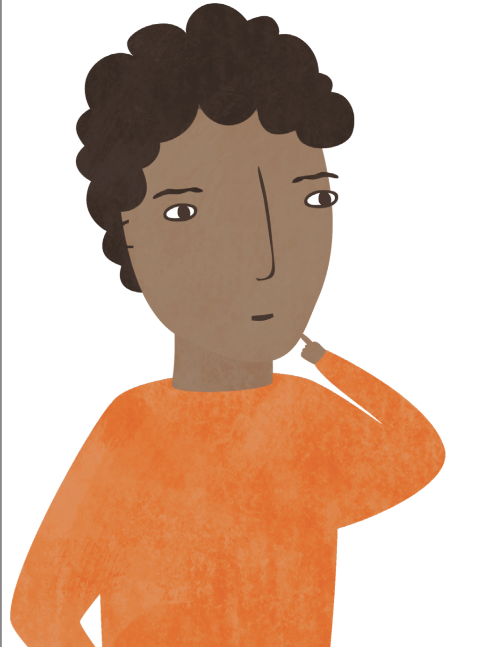

MO 870 also specifies that schools must promote the Child Safe Standards in ways that are readily accessible, easy to understand and user-friendly to children.
ELEMENT ONE: Standards of behaviour for students attending the school

Required
Are there standards of behaviour in place for students attending the school?
Recommended Practice
Have students been engaged in establishing these standards?
Do these standards empower students to speak up and be heard?
Are these standards promoted across the school community and regularly reviewed?

Why is the development of standards of behaviour important?
The right for students to learn and feel safe is underpinned by clearly articulated and well-promoted standards of behaviour (or code of conduct).
Standards of behaviour should extend across the school community (students, staff and parents/carers), setting a positive tone for safe and supportive relationships, articulating clear boundaries and supported pathways for students:
- impacted by the behaviour of others (ensuring students know when and how to seek help)
- who do not uphold the behaviour standards (ensuring that there is support for students to address and mitigate these behaviours and address any underlying factors).
Standards of behaviour should also extend to online environments. Setting clear online standards of behaviour helps to prevent cyber-bullying and helps to keep students safe from predatory behaviours.
Why engage students in the development of these standards of behaviour?
The process for setting, promoting and reviewing standards of behaviour for students is central to their success.
Ideally students will take an active part in setting and embedding standards of behaviour, building their ownership of school culture and empowering them to seek support and make positive changes within their environment. There are many practical approaches for engaging students in this process, including the establishment of student action teams and the implementation of student-directed values education. These strategies are detailed on the next page.

Resources and Requirements
The following text:
- set out existing policy requirements and corresponding resources to support schools in establishing and embedding standards of behaviour
- provide information on further empowering students to make positive changes within their environment.
Resources to support schools in setting standards of behaviour
Government Schools
Government schools can use their Student Engagement Policy to deliver on Element One of CSS-7 (strategies to set standards of behaviour).
The Department of Education and Training’s Student Engagement and Inclusion Guidance requires all government schools to develop a Student Engagement Policy. In developing this policy schools are required to:
- work with the school community to set/review shared values and a vision
- consider if the school environment is inclusive and empowering and provides opportunities for students to take responsibility and be involved in decision-making.
Student Engagement Policy

Catholic Schools
Catholic schools can use their pastoral care policy to deliver on Element One of CSS7 (strategies to set standards of behaviour).
Each Diocesan education office requires schools to develop their own pastoral care policy. This policy should set out standards of behaviour for students (or a ‘behavioural code’) and ideally will be developed with students and the broader school community.
- All diocese: CECV Whole School Approaches to supporting positive behaviour
- Archdiocese of Melbourne: Pastoral Care Policy (2.26)
- Diocese of Sale: Pastoral Care Policy
- Diocese of Ballarat: Pastoral Care Policy
- Diocese of Sandhurst: Pastoral Care Policy available on intranet

All Schools (government, Catholic and independent)
All schools can use the National Safe Schools Framework, eSmart and BullyStoppers and the School-wide Positive Behaviour Support as vehicles to deliver on Element One of CSS-7.
National Safe Schools Framework (Student Wellbeing Hub)
The National Safe Schools Framework is designed to help schools develop ‘positive student safety and wellbeing policies’. It takes schools through a nine-step process for developing student wellbeing policies and procedures.
There are a wide range of useful resources and exemplar policies for schools to reference, including resources to support safe and productive online behaviour.

eSmart
eSmart provides a framework to support schools in the creation of a cyber-safe or eSmart environment. Victorian schools have been funded to participate in the initiative and are supported to develop their school cyber safety policy and implement strategies to build a respectful and caring school community.

BullyStoppers
BullyStoppers includes a wide range of content to support students, parents, teachers and principals to work together to make schools safe and supportive. There are interactive learning modules for teachers and students and fact sheets with practical steps for keeping safe online.

School-wide Positive Behaviour Support
School-wide Positive Behaviour Support (SWPBS) is an evidence-based framework, which supports schools in creating a positive school climate and an open, responsive management system for all school community members. Under SWPBS schools are supported to develop of a set of behavioural expectations and procedures for explicitly teaching and promoting positive behaviour.

- National Safe Schools Framework
- eSmart
- BullyStoppers
- School-wide Positive Behaviour Support

Resources to support schools in empowering students

All Schools (government, Catholic and independent)
In order to engage and empower students in the establishment of behavioural standards and a safe and positive school culture, schools can draw on a range of existing resources.
National Safe Schools Framework (Student Directed Values)
The National Safe Schools Framework includes specific advice on empowering students by implementing student-directed values within the school.
Student Voice and the Education State
This resource outlines recommended approaches to empower students’ voices to be valued in education. Key approaches include:
- engaging the SRC in discussion about expectations, behaviour, mutual respect
- conducting student-led student forums around behaviour, respect etc.
- allocating time and resources to train and support student representatives to intervene around issues of positive behaviour
- establishing Student Action Teams to investigate issues of inclusion and exclusion and of expectations.
- National Schools Framework- Student Directed Values
- Student Voice and the Education State

AND
ELEMENT TWO: Healthy and Respectful Relationships (including sexuality)
ELEMENT THREE: Resilience

Required
Is the school delivering respectful relationships and resilience education* in alignment within the learning standards under Personal and Social Capability and Health and Physical Education in the Victorian Curriculum**?
Is the school delivering sexuality education* in alignment within the learning standards under the Personal and Social Capability and Health and Physical Education within the Victorian Curriculum**?
* Advice on teaching respectful relationships and sexuality education within Catholic schools is available in the Catholic Education Addendum to this Guide and from the Diocesan education offices.

** Independent schools delivering a curriculum other than the Victorian Curriculum are still required under Ministerial Order 870 to deliver appropriate education about healthy and respectful relationships (including sexuality) and resilience. The information provided can support schools in meeting this requirement.

Recommended Practice
Is the school using the Resilience Rights and Respectful Relationships (RRRR) resources, to deliver respectful relationships and resilience education?
OR if drawing on other materials, are these materials evidence-based and meet the requirements under the Victorian Curriculum?
Has the school adopted a whole school approach to promoting respectful relationships?
Is the school using the evidence-based Catching On Early and Catching On Later materials to deliver sexuality education?
OR, if drawing on other teaching and learning materials, has the school mapped the materials against the Victorian Curriculum?
Is the school engaging parents/carers in their child’s learning around resilience, respectful relationships and sexuality?
Have teachers attended professional learning to support them in the delivery of education about healthy and respectful relationships (including sexuality) and resilience?
NOTE: Professional learning to build teacher capacity to deliver the Resilience Rights and Respectful Relationships (RRRR) resources will be made available from 2017.

Why is the delivery of education about respectful relationships, resilience and sexuality important?

Social and emotional learning is a critical part of school education, which is why it is mandated within the Victorian Curriculum.

Research shows us that:
- equipping students with the skills to build positive relationships and communicate respectfully is essential preparation for productive and healthy adult lives
- building resilience (the ability to cope and thrive in the face of negative events, challenges or adversity) has a positive impact on both social and academic outcomes, and is particularly critical for students who may be impacted by abuse
- students who are well informed about sexuality are more likely to make positive and informed decisions and less likely to place themselves at risk in adolescence.

Why engage parents/carers in the delivery of social and emotional learning?

Both schools and parents/carers play an essential role in building students’ social and emotional capabilities.

Parents/carers and schools are critical partners. By equipping parents/carers with information about their child’s learning, schools can support parents to continue learning within the home environment and build strong consistent messages.

Resources to support schools
All Schools (government, Catholic and independent)
All schools can use the Victorian Curriculum (and related teaching and learning materials) to deliver on Element Two and Three of CSS-7 (Healthy and Respectful Relationships including Sexuality).
Resilience and respectful relationships education
All schools delivering the Victorian Curriculum are now required to deliver respectful relationships education to meet the requirements set out within the learning standards.
The Resilience, Rights and Respectful Relationships (RRRR) teaching and learning materials (Foundation to Year 12), designed to deliver on this requirement, address:
- all strands of the Personal and Social Capability curriculum
- the Personal, Social and Community Health Strand of the Health and Physical Education curriculum.
Further advice on how the RRRR resources map to the Victorian Curriculum can be found at the back of each year level’s resource.
These materials are evidence-based and will support students in building their resilience and understanding of respectful relationships.
Professional development will be available across the state to support teachers in the delivery of the curriculum. Funding and further support is also available for selected schools to implement an evidence-based whole school approach to respectful relationships.
OR alternatively schools may choose to draw on other materials. When selecting teaching and learning resources, schools should consider whether these materials are evidence-based and meet the requirements under the Victorian Curriculum.
Catholic schools should refer to the Catholic Education Addendum to the Guide.
Sexuality Education
All schools delivering the Victorian Curriculum are required to deliver sexuality education in order to meet the learning standards within the Health and Physical Education curriculum.
Catching On Early and Catching On Later teaching and learning materials address these learning standards.
If schools choose to draw on other teaching and learning materials, they should map these materials against the Victorian Curriculum.
Advice on teaching sexuality education within Catholic schools is available in the Catholic Education Addendum to this Guide and from the Diocesan education office websites
- Resilience, Rights and Respectful Relationships
- Catching On Early and Catching On Later

ELEMENT FOUR: Child Abuse Awareness and Prevention

Required
Is the school delivering child abuse awareness and prevention education and meeting the relevant learning standards within the Victorian Curriculum**?
Have staff at the school undertaken mandatory reporting training and familiarised themselves with the Four Critical Actions: Responding to Incidents, Disclosures and Suspicions of Child Abuse (essential to addressing disclosures which may be prompted by the delivery of child abuse awareness and prevention education)?
Additional Advice
Is the school drawing on evidence-based materials to deliver child abuse awareness and prevention education to build student capacity to:
- identify when they feel safe and unsafe and when they are at risk
- identify safe and unsafe touching (using the anatomical names for their body parts)
- promote their personal safety (avoiding harm where possible)
- seek help, using their identified safety networks
- overcome barriers to disclosure (e.g. guilt or disbelief)?

** Independent schools delivering a curriculum other than the Victorian Curriculum, are still required under Ministerial Order 870 to deliver appropriate education about child abuse awareness and prevention.

Why is the delivery of child abuse awareness and prevention education important?

The primary objective of child abuse awareness and prevention education is to help to keep children safe from child abuse. School-based child abuse awareness and prevention programs have been found to increase children’s capacity to disclose abuse.

Both schools and parents/carers play an essential role in building these capabilities. Students are supported best when schools:
- work in close partnership with parents/carers
- ensure that parents/carers are provided with the information they need to continue learning within the home environment and build strong and consistent messages.

Knowing how to respond to disclosures of abuse is critical in keeping children safe and is set out within the Identifying and Responding to All Forms of Child Abuse within Victorian Schools.

Resources to support schools
All Schools (government, Catholic and independent)
Resilience, Rights and Respectful Relationships
All schools delivering the Victorian Curriculum are now required to deliver respectful relationships education.
The Resilience, Rights and Respectful Relationships (RRRR)* teaching and learning materials support schools to meet this requirement and include content for all year levels (Foundation to Year 12).
This package can support schools in delivering critical elements of child abuse awareness and prevention education.
The RRRR materials are structured around eight learning topics, which are designed to be delivered sequentially. A significant proportion of these topics relate directly to child abuse awareness and prevention, including:
- Topic One: Emotional Literacy- students are supported to build their self-awareness of emotion, their emotional vocabulary and their capacity to identify when they feel safe or unsafe.
- Topic Four: Problem Solving- students are supported to build their capacity to respond to situations where they may be at risk of abuse or experiencing abuse and to avoid risk.
- Topic Six: Help Seeking- students are supported in their capacity to identify when problems are too large to solve alone, to establish a safety network and rehearse help-seeking strategies.
- Topic Eight: Positive Gender Relations- students are introduced to: the concept of No-Go-Tell (a three step response to harm); body parts and safe and unsafe touching; and to the definitions of abuse. Students are also supported to identify ‘good’ and ‘bad’ secrets.
Professional learning will also be rolled out over 2017 to support schools in delivering this curriculum and implement a whole school approach to RRRR.
*Advice on using the RRRR resource within Catholic schools is available in the Catholic Education Addendum to this Guide and from Diocesan education websites.
Daniel Morcombe Child Safety Curriculum
The Daniel Morcombe Child Safety Curriculum was developed by the Queensland Department of Education, Training and Employment (DETE) in partnership with the Daniel Morcombe Foundation. This Curriculum is available for use in Victorian schools.
The Curriculum is aligned with the Australian Curriculum, and consists of classroom lessons across three levels: Prep - Year 2, Years 3-6 and Years 7-9. It aims to teach children about personal safety, including cybersafety and phone safety, and focuses on three key safety messages: Recognise, React and Report.

Child Wise Personal Safety Education Program
The Child Wise Personal Safety Education Program builds the capacity of students to:
- be more assertive and resilient to risks
- identify their own feelings relating to safety
- identify safety networks
- tell someone if anyone is harming them.
The fee-based program is delivered as 'train the trainer' and includes a parent/carer session.
- Resilience, Rights and Respectful Relationships
- Daniel Morcombe- Child Safe Curriculum
- Child Wise Personal Safety Education Program

Child Safe Standard 7: School Checklist

ELEMENT ONE: Standards of behaviour for students attending the school

Required
Are there standards of behaviour in place for students attending the school?
Recommended Practice
Have students been engaged in establishing these standards?
Do these standards empower students to speak up and be heard?
Are these standards promoted across the school community and regularly reviewed?

ELEMENT TWO: Healthy and Respectful Relationships (including sexuality)

AND
ELEMENT THREE: Resilience

Required
Is the school meeting the learning standards under Personal and Social Capability and Health and Physical Education within the Victorian Curriculum* and delivering respectful relationships and resilience education* as broadly described in the curriculum?
Is the school meeting the learning standards under the Personal and Social Capability and Health and Physical Education within the Victorian Curriculum* and delivering sexuality education*?
Recommended Practice
Is the school using the Resilience Rights and Respectful Relationships (RRRR) resources to deliver respectful relationships and resilience education*?
OR if drawing on other materials, are these materials evidence-based and meet the requirements under the Victorian Curriculum**?
Has the school adopted a whole school approach to promoting respectful relationships?
Is the school using the evidence-based Catching On Early and Catching On Later materials to deliver sexuality education*?
OR, if drawing on other teaching and learning materials, has the school mapped the materials against the Victorian Curriculum**?
Is the school engaging parents/carers in their child’s learning around resilience, respectful relationships and sexuality?
Have teachers attended professional learning to support them in the delivery of education about healthy and respectful relationships (including sexuality) and resilience?
NOTE: Professional learning to build teachers capacity to deliver the Resilience Rights and Respectful Relationships (RRRR) resources will be available from 2017.

* Advice on teaching respectful relationships and sexuality education within Catholic schools is available in the Catholic Education Addendum to this Guide and from the Diocesan education offices.

** Independent schools delivering a curriculum other than the Victorian Curriculum are still required under Ministerial Order 870 to deliver appropriate education about healthy and respectful relationships (including sexuality) and resilience. The information provided can support schools in meeting this requirement.

ELEMENT FOUR: Child Abuse Awareness and Prevention

Required
Is the school delivering child abuse awareness and prevention education and meeting the learning standards within the Victorian Curriculum**?
Have staff at the school undertaken mandatory reporting training and familiarised themselves with the Four Critical Actions: Responding to Incidents, Disclosures and Suspicions of Child Abuse (essential to addressing disclosures which may be prompted by the delivery of child abuse awareness and prevention education)?
Additional Advice
Is the school drawing on evidence-based materials to deliver child abuse awareness and prevention education to build student capacity to:
- identify when they feel safe and unsafe and when they are at risk
- identify safe and unsafe touching (using the anatomical names for their body parts)
- promote their personal safety (avoiding harm where possible)
- seek help, using their identified safety networks
- overcome barriers to disclosure (e.g. guilt or disbelief)?

** Independent schools delivering a curriculum other than the Victorian Curriculum, are still required under Ministerial Order 870 to deliver appropriate education about child abuse awareness and prevention.

Interim Report Volume One (2014), Royal Commission into Institutional Responses to Child Abuse

