Instructions to create a communications tree
July 2014

Published by the Emergency Management Division
Department of Education and Early Childhood Development
Melbourne

© State of Victoria (Department of Education and Early Childhood Development) 2014

The copyright in this document is owned by the State of Victoria (Department of Education and Early Childhood Development), or in the case of some materials, by third parties. No part may be reproduced by an process except in accordance with the provisions of the Copyright Act 1968 or with permission.

Authorised by the Department of Education and Early Childhood Development,
2 Treasury Place, East Melbourne, Victoria, 3002.
Contents
Introduction 3
Edit existing boxes to set titles/names or phone numbers 4
Duplicate text boxes to add more to the tree 4
Duplicate lines to connect more boxes 5
Move boxes and lines as needed 6
Copy the tree into your EM Plan document 7

Introduction
These instructions will assist you with amending the provided communications tree template to suit your situation.
You should have downloaded the relevant template document.
It is recommended that you first manually sketch out your communications tree on paper, so that you can see how it should look before you start. This will minimise the amount of manipulation you need to do.
Given you have the basic structure in the template, you just need to:
- Open the template document.
- Edit existing boxes to set titles/names and phone numbers.
- Duplicate text boxes to add more to the tree.
- Duplicate lines to connect more boxes.
- Move boxes and lines as needed.
Once you have completed the tree in the template document, you can save it, and then copy the contents into your final EM Plan document’s Communications tree section.

Edit existing boxes to set titles/names or phone numbers

- Select the text to be changed by clicking and dragging your mouse over the text.

To quickly select all the text, click once in the box on the text, then press Ctrl+A.

- Change the text by overtyping the selected text.

Duplicate text boxes to add more to the tree

- Choose a box that is closest to what you want (for instance, most of the text is the same).

Click anywhere on the box sides to select it (you will see icons at the corners).

- Press Ctrl+C to copy the box.

- Press Ctrl+V to paste the box.

A new copy should be displayed close to the one you copied.
- Click and hold your mouse on the edge of the box, then drag it to its new position.

Duplicate lines to connect more boxes

- Choose a line to copy.

It can be one in the same direction as what you want, but you can change the direction or length easily later.

Click on the line to select it (you will see icons at the ends).

- Press Ctrl+C to copy the line.

- Press Ctrl+V to paste the line.

A new copy should be displayed close to the one you copied.

- Click and hold your mouse on the line, then drag it to its new position.

To change the direction or length of a line:
- Click on the line to select it (you will see icons at the ends).

- Click and hold on the end to be moved (the icon at the end).

- Drag the line to where you want it to end.

Move boxes and lines as needed

- Click on the line/box edge to select it (you will see icons at the ends/corners).

- Click and hold your mouse on the edge of the box, then drag it to its new position.
- Click and hold your mouse on the line, then drag it to its new position.

Copy the tree into your EM Plan document

To copy the entire tree:
- Click somewhere on the document page to ensure it has ‘focus’. | 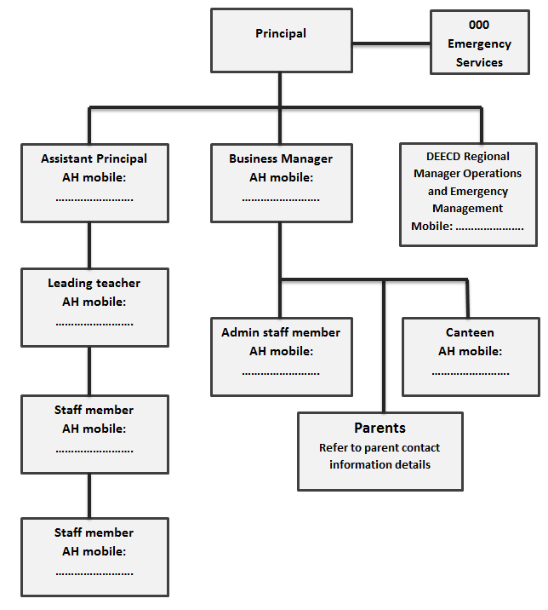
- Press Ctrl+A – this should select everything. | 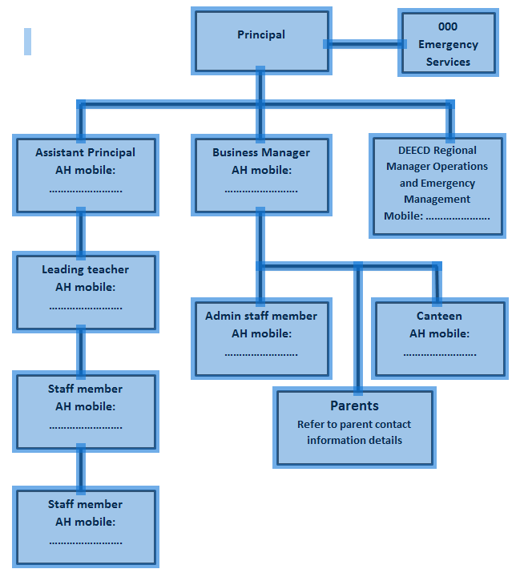
- Press Ctrl+C to copy the tree.

- Swap to your EM Plan document.

- Locate the Tree page, and remove the greyed text. | 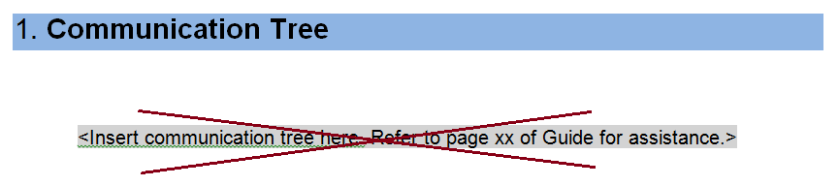
- Click just below the heading, and then press Ctrl+V. The tree should appear. | 