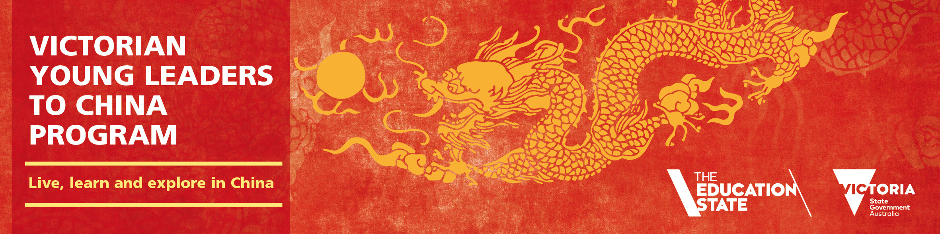
Discover and Learn in China
Victorian Young Leaders to China Program 2018
The program is a life-changing opportunity for Year 9 students to live in and attend school in China for six weeks.
Explore your future, make sure you come to the student and parent information night.

www.education.vic.gov.au/youngleaders

2018 Program Information Evening

