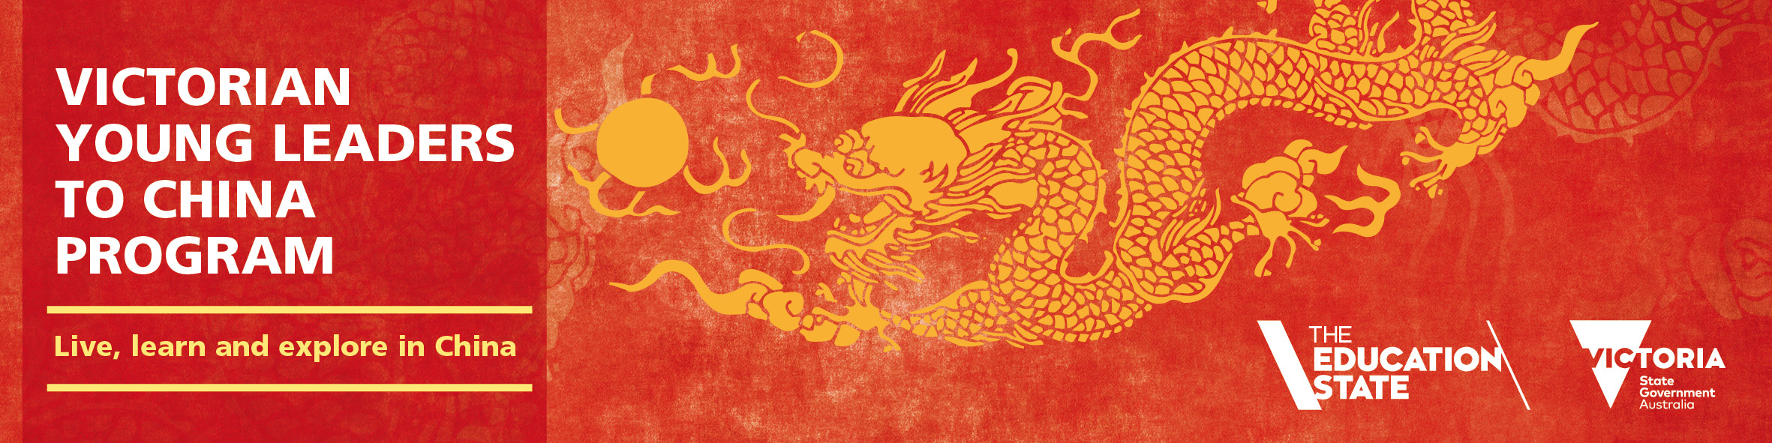
Victorian Young Leaders to China Program 2018
Discover and Learn in China
Information for Parents and Students
Live, learn and explore in China
The program is a life-changing opportunity, where students live in and attend school in China. They will experience daily life as a Chinese student, and get to discover and explore China’s thriving culture, from the traditional to the modern.

For Chinese language students, the immersive nature of the program accelerates their Chinese language proficiency. For all students the culturally rich program can have a transformative impact on their learning at home, and broaden their minds to a future career with an international focus.

Comprising six weeks of intensive language and cultural learning, the program builds intercultural understanding, and lays the foundation skills for leaders of the future. It also encourages self-sufficiency and the development of interpersonal and leadership skills.

Beyond study, students will get to explore the sights and sounds of China, encompassing both traditional and contemporary culture.

Program Costs
The VYLC program, including all core program elements, is costed at $6,000* per student. These costs are funded through a co-contribution model, with the Department contributing $3,000 per student.
The cost to parents/students is $3,000. The entire $6,000 program cost is funded by the Department for students whose parent/guardian holds a current healthcare or pensioner concession card that lists the student by name. (Please note that fully funded places are capped at 25% of total places for the sister school partnership program.)
Any incidental costs (e.g. passport and spending money) are the responsibility of the participating students.
*Core program costs include:
- All travel arrangements, including return airfares, visas and insurance for government schools
- Accommodation, meals and activities organised by the Chinese partners
- Student uniform and curriculum materials.

In-country highlights
A typical school week may include:
- Chinese language classes
- Morning exercises
- Cultural classes
- Attending local classes - math, science, music, arts, PE etc.
- Self–study
- Excursions to nearby attractions and cities

Further information and Eligibility
Applications close Wednesday 2 August 2017, so contact your school directly to find out about the program, eligibility requirements and application details.

For further information visit www.education.vic.gov.au/youngleaders

