Newsletter copy – early childhood services

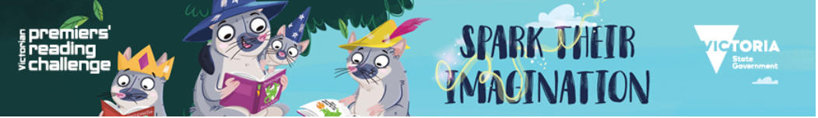

Victorian Premiers’ Reading Challenge

The Victorian Premiers’ Reading Challenge is now open and (insert service name here) is excited to be participating.

The Challenge is open to all Victorian children from birth to 16 years in recognition of the importance of reading for literacy development.

To take part, children from birth to five are encouraged to read 40 books with their parents and carers before the closing date of the challenge. We will also record the books we read with your child at (insert service name here).

All children who meet the Challenge will receive a certificate of achievement signed by the Victorian Premier and former Premiers.
Reading with your child is one of the joys of parenting. It establishes reading as a daily habit and sets children on a path to becoming strong readers and communicators. A 2012 study by the University of Melbourne found that reading frequently to young children has a direct effect on schooling outcomes. To read a summary of this research, see: Reading to Young Children: A Head-Start in Life (http://www.education.vic.gov.au/Documents/about/research/readtoyoungchild.pdf)

For more information on the Challenge and to view the booklists, visit: www.education.vic.gov.au/prc

