The experience of remote and flexible learning in Victoria

  - By Learning First

  - July 2020

Executive Summary
In March 2020, the Victorian school system confronted one of the gravest challenges it had faced in many decades. With the onset of the COVID-19 pandemic, the State Government took decisions designed to save lives by reducing opportunities for human transmission of the Coronavirus. On March 16 it announced the closure of schools for most students. Almost overnight, schools were required to put whole curricula online, and establish new methods of teaching, learning and student support. The pressure on staff, students and parents was intense. No one could be sure of the way forward, since no one had previously endured such a crisis.
Figure 1: Timeline
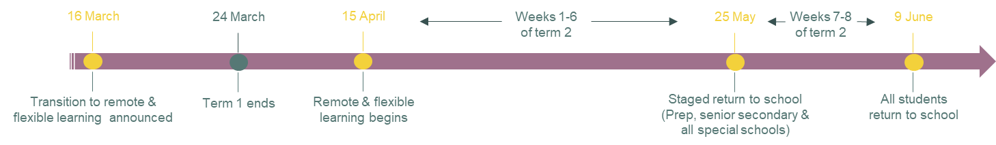
This report presents findings from surveys, focus groups and interviews conducted with school communities to understand their experience of the remote learning period, which ended for all students on 9 June. The report shows that school leaders, teachers, students and parents rallied to meet the challenge head on. School attendance rates remained high -- the vast majority of students took part in remote and flexible learning every day. Morale also stayed high, in the main, as teachers and school leaders worked together to address difficult dilemmas with a sense of mutual respect and common purpose. Parents gained unprecedented insight into their children’s education and school, bringing potential benefits for years to come. New skills have been acquired, new pedagogical opportunities trialled.
However, the period also exposed new challenges, especially for teaching and learning. Reduced face-to-face contact with at-risk students made it difficult for teachers to address ongoing welfare or educational concerns. Some students who lacked supportive family environments struggled to access learning or even log on to classes. About 10 per cent of students from disadvantaged schools were absent during the remote learning period, compared to about 4 per cent of students from advantaged schools. Absenteeism of secondary school students rose in the final two weeks of remote and flexible learning, and many teachers reported slipping student engagement as the lockdown progressed, suggesting that some students struggled to stay the course. Schools face serious difficulties in reintegrating these students into learning and school life. There is a risk that the online learning period has widened the gap between high and low-performing students.
Students were divided in their experience of the remote and flexible learning period. Some greatly enjoyed the flexibility of learning from home, the chance to set their own hours and study regime. Some highly motivated and high achieving students especially thrived on the opportunity to work alone, at their own pace. A surprising outcome was that many students who are normally shy and quiet in class spoke up and contributed more in the online environment. On top of this, a number of teachers and school leaders reported that many students where more engaged with online learning. Nevertheless, more than one in eight students found it hard to maintain focus and not get distracted at home. Children in the early years of primary school, and from low literacy backgrounds in all years, were particularly challenged.
The shift to online learning was a dramatic change; many schools dropped specific subjects, tried to trim content within subjects, and reduced daily contact hours and student workload. Usual assessment techniques became extremely difficult. A number of schools found their assessments during remote and flexible learning to be invalid. Some schools did not focus on assessments during the period, and as schools entered the final week of Term 2, a Department survey found that between a quarter and a third of schools have yet to reach a conclusion about the academic progress of a majority of their students during the period of remote learning. Moreover, nearly one in five principals reported concern or strong concern, about the lack of academic progress during remote learning. These concerns were especially prominent in regional areas.
As schools return to normal, and the sense of purpose that is generated by a crisis passes, the Department and schools should keep an open mind about the gains and losses this period has produced. Online learning is a large and growing part of our educational future. Nevertheless, it is striking, and heartening, that many students missed aspects of school and were glad to return to it. Victoria’s schools should be proud of that, and of what they achieved during this difficult time.
Box 1: The data used in this report
This report draws on a range of different data sources developed and collected in response to the pandemic and the Department’s desire to get feedback on the experience of remote and flexible learning. These data sets include:
- Data from over 60 schools that administered their own surveys of teachers, parents and students
- Engage Victoria: an online Department survey that collected submissions from 2,316 parents, 513 teachers, 206 school leaders, 150 students, 15 peak association representatives, and a small number of education support and service providers.
- Parent and Student Learning From Home Surveys of 20,240 students from 188 schools and 12,160 parents from 234 schools. The Department conducted this optional online survey of students and parents between 14 May and 26 June.
- Weekly school leader surveys conducted by the Department and their regional offices. These data included weekly check-ins that regularly received responses from over 70 per cent of school leaders. One of these was the Learning and Support Continuity Survey, designed for principals to complete on behalf of their school by 3 May 2020. The survey received 1033 completed responses, representing 66 per cent of all government schools.
- Twenty-eight workshops and focus groups conducted by the Department. This included 10 workshops with school leaders, eight with students, four with teachers, three with Senior Education Improvement Leaders in the Department, and three with parents.
- Administrative data sets the Department collects on student absenteeism and other issues such as teacher and school leader well-being.
Since surveys, focus groups and submissions were optional and not representative, some caution must be taken in interpreting the data. The consistency of the feedback from multiple respondents and sources of data gives us confidence in the general findings. But we should be cautious about placing confidence in precise percentages taken from particular survey findings. Various reports also fed into the analysis.

The experience of four schools
The experience of a regional high-SES P-12 school
School A did not have online learning before the period of remote and flexible learning, so the change presented new and sometimes intense challenges for some teachers. Many were not used to using technology in class and struggled with effective ways to use Webex and Google Classrooms. All teachers learnt what worked and what didn’t as they went along and made changes accordingly.
It was clear early on that some parents, especially those with children in both primary and secondary school, were also struggling to manage. In Week 2, School A changed the school day so that Years Prep-4 finished at lunch time to relieve pressure on students and parents. In Week 3, the school modified the timetable to make individual lessons and the school day shorter. The usual 90-minute lessons were reduced 30 minutes, and started at 9am and finished at 1pm. Afternoons were dedicated to independent study, giving teachers time for planning, to contact students and families, provide feedback and discuss student work. Teachers said the extra time allowed them to improve the planning of classes and provide more meaningful direction to students. One student said: “Considering that we were in lockdown, we did pretty good because the teachers responded to our emails straight away.” On the other hand, teachers said that Year 7-9 students were more likely to fall away as they moved online between the shorter classes.
Because younger students struggled with learning on the computer, the school sent learning packs home to students in Years Prep-4 to make learning easier for them, and for their parents in supporting them. Google Classroom worked particularly well for Years 5 and 6 students. All teachers said maintaining student behaviour and dealing with disengaged students was very difficult. Nevertheless, some were happy with the independent learning shown and the growth in student agency of their students.
Like many schools, teachers at School A reported that students who were motivated at school also excelled during remote and flexible learning whereas those who had been disruptive or falling behind at school struggled most during remote and flexible learning.
Parents appreciated the school’s clear guidance on what students in each grade were supposed to be doing. In particular, they appreciated that the school responded to their feedback by shifting to 30-minute lessons. One parent said: “We found that the half hour was a life saver. I think a lot of parents couldn't have stuck with it if we'd kept it as full classes”. Another parent said: “The school's upped the ante on its communications. Now people know what's going on and they're happier. There's a lot more respect for what teachers do.”
The experience of a rural low-SES secondary school
School B changed its approach as remote and flexible learning progressed. At the end of Term 1, it provided students with two handouts containing English and Maths tasks. Year 7-10 students had to choose their learning tasks according to their level. No assessment was undertaken. In the first two weeks of Term 2, the school focussed on familiarising students with Compass how to upload and download documents. It also changed the timetable to shorten all classes and make teachers available in afternoon.
Teachers at School B found it difficult to keep in contact with students. The school is situated in a rural community and students were often working on the farm. Teachers said they wouldn’t see some students for a week; as one reported, in a number of families where parents and older siblings didn’t finish secondary school, children were given permission to not participate in remote and flexible learning. Teachers struggled to know what to do in these cases. The school decided to post learning packs a week in advance to try and maintain some engagement with these students’ learning.
In contrast, a number of parents from School B reported positive experiences of remote and flexible learning. Some said their children performed better learning at home. One parent said: “My two kids were diligent workers, apart from not having direct instruction, they were able to get the work done and set out a program. Our experience was very good because we have good kids.” The parents identified some lessons from the remote and flexible learning period. One said: “I'd like to think moving forward that if a child can't get to school or the teacher's not available - the student doesn't get behind.” Another said: “It can take hours in the country for a student to go somewhere for an appointment. If we had a flexible approach, they wouldn't miss out on the learning.”
School B continues to use some aspects of remote and flexible learning. One student emphasised the benefits of changes the school has made - “Our maths teacher is continuing to make podcasts and videos for our class to support kids who are struggling. These can be downloaded on our computers.”
The experience of an outer-urban low-SES primary school
The leadership team at School C took a consultative approach to deciding the best way forward during this period. The school surveyed families by phone about their readiness for online learning. In week 1 of Term 2, the school distributed computers and devices to students who required them. It is a low-SES community, so many devices were loaned to families during this period. Teachers also prepared hard copy learning packs to help families prepare for online learning, set up a book exchange for students, and started preparing videos for online learning.
Teachers trimmed the curriculum and tried to concentrate on what matters most for students. One teacher said: “We really thought about being specific and precise in what we need to teach and what actually is essential.” From Week 3 onwards, the school started one-on-one reading and numeracy conferences on Webex, along with mini-lessons for Years 4-6, for those students that school leaders and teachers felt were most at risk of not reading at home. By Week 5 there was an expectation that all students would log on for all mini lessons. A range of YouTube videos were developed by each specialist teacher and a YouTube channel set up for families.
School leaders believed that having a consistent pedagogy model from Years Prep- 6 greatly helped them to implement remote and flexible learning. Students’ familiarity with the school’s model improved their continuity of learning at home. Teachers also continued their professional learning teams and continued to collaborate online. But teaching was difficult in a number of instances. One teacher said: “A challenge has been in the quality of work especially in writing and the ability to give instant feedback. We were providing comments on Google Docs but the students found it challenging to interpret feedback and take those examples on board.”
Many students felt remote and flexible learning was a success. Comments included: “Teachers did a great job teaching us from home… If teachers weren't there, I had my family there as well.” But some students struggled. One said: ”It’s harder at home – I get side-tracked and lose focus”. Another found it hard because “siblings wanted to watch TV all the time”. Teachers worried about their students. One wanted “to keep asking students how they are feeling and how they are doing and just really check in on well-being.”
The experience of an inner-urban high-SES primary school
School D had a positive experience during the period of remote and flexible learning. School leaders saw an opportunity to put the teaching and learning program onto Google Suite and See Saw platforms for longer term benefit and use. Two members of the leadership team had strong expertise in using the platforms and led the work developing staff and documentation on what to do. Teachers spent the first two weeks of Term 2 setting up Years 3-6 with Google Classroom and how to use it. Once Google Meet was up and going, lessons started straight away.
Teachers worked closely together to redesign the school’s instructional model. They kept their professional learning community going and uploaded a bank of resources to share and use. One said: “We have a really positive staff culture and have been upskilling each other and organising teach meets which have been scheduled in this term and into next term.”
Students readily participated in online learning and uploaded videos of themselves and their learning tasks. They said it was hard to use Google Classrooms at times but overall, their experience was positive. One said: “It was good at home because we had our own time and space - if we didn't get it done by recess we could keep going, and could keep going after school.” Another said remote and flexible learning “made me feel more confident that I could do my best and I could think it through.” Teachers believed that some students, especially those that created study groups and used teacher feedback, really shone during this period. The school plans to keep using its online platforms because they provide considerable benefit for teaching and learning. It also plans to keep asking students what did and did not work in order to inform the school’s next steps.

Lessons learned for improving education
This section sets out four considerations for Victorian school education that emerge from the experience of remote and flexible learning. These draw on consistent themes in the data obtained from parents, school leaders, teachers and students.
- Better connections with parents. The stronger connections that schools built with parents during this period represent a significant success. School principals, teachers and parents all spoke overwhelmingly of the positive relationships built over the period of remote and flexible learning. Many parents have sat alongside their children during this period; they have become more engaged in their children’s learning and now better understand their work. Schools also learnt more about the home situations of some vulnerable students, and can better incorporate these insights into their teaching and student support.

The situation will change once parents are no longer working from home, but many parents would nevertheless welcome the opportunity to continue closer engagement with schools. Many school principals have said they will use technology to better engage with parents, informing them of what is happening in the school and with their child’s education. Schools can continue to strengthen communications with families over students’ curriculum, learning tasks and assessments, and even to involve them in some learning activities. They can capitalise on parents’ recent exposure to what their children are learning, and on what teachers have learnt from that experience, in order to better communicate with parents. Across the system, best-practice can be disseminated on how to effectively communicate with parents and the local community, and on the more complex tasks of actively including parents in students learning.

- Greater flexibility of remote learning. There is clear evidence from numerous school leaders and teachers that many students enjoyed, and some students excelled in exercising greater student agency with the flexibility that came with remote learning. Highly motivated and high-performing students, in particular, benefitted from opportunities to pursue their work more independently, at the pace and format they wanted.

To leverage these successes, we need to better understand both the actual progress made by students and the structure for flexible learning that is most effective. Simply granting more flexibility and independence for students is unlikely to be successful. Students need structured content in their subjects and a structured process for independent and flexible learning of the Curriculum. There would be value in high-quality instructional resources being developed that teachers can use for more flexible learning of the Curriculum. High-quality professional learning would probably help ensure effective use of the instructional resources. Personalised and flexible learning should not be seen as an end in itself or always beneficial. Some students struggled with it, reflecting broader research that shows that moves to introduce personalised learning can come at the expense of equity. This would be a particular danger if the achievement standards in the Victorian Curriculum are not clearly anchoring the learning tasks provided to students under a flexible learning approach.

- Expanding online learning. A number of schools emphasised the benefits of putting lessons and teaching videos online for students to access whenever they wanted. Numerous teachers spoke of how they have used technology to provide more engaging resources for students. Teachers also saw value in being able to talk to students online at times convenient to both parties.

These insights have significant potential to improve schooling. Putting some classes online and allowing students to access and revisit content at different times can benefit student learning. Other potential applications of online learning identified by school leaders and teachers include:
- Issuing homework to students who are sick and absent
- Using online platforms that allow students to showcase their understanding in non-traditional ways
- Using technology to more effectively support students in asking questions and communicating with teachers and peers in various formats.

- Increasing the effectiveness of how schools operate. The pressure on schools and the need to work hard and fast raised questions for many teachers and school leaders about the way they organise their work and, in particular, the frequency and purpose of meetings. As one school leader said, “People are finding we need fewer meetings and can do them more efficiently.” Schools often moved to online meetings, which many staff members valued, especially those who work part-time or who had to miss a meeting and were able to watch it later. School principals and teachers highlighted the importance of effective leadership to provide clarity and support to staff during the pandemic. For some schools the more effective use of technology was one of the factors that enabled better distributed leadership, with clearer role clarity amongst the leadership team, during this period.

Schools can improve simply by continuing many of the new streamlined practices. The Department could both analyse and disseminate these practices, and develop a process for schools to review their operations (for example, meeting frequency, structure and purpose, and communications with and between staff) and make improvements where appropriate. In particular, the implications for role clarity and more effective distributed leadership need to be better understood and disseminated if the lessons learned are valuable.

People’s experience of remote and flexible learning have broader implications for schools and face-to-face teaching. As much as some students enjoyed remote and flexible learning, many students were eager to return to school. Some found themselves too distracted by the home environment; others struggled with feelings of loneliness and isolation. It is vital to remember that at school students learn how to develop socially and get on with other human beings.
Some students thrived during remote and flexible learning, away from the distractions – the noise and student behaviour – of the classroom. We should consider what this means for our classroom management practices, our school routines and how we deal with behavioural problems?
Finally, schools made huge changes shifting curriculum and instructional materials online. Teachers highlighted the time spent doing this work and the difficulties in knowing which instructional resources are most effective. We should consider what this means for supporting effective curriculum practice in schools. Connected to this is that a number of schools trimmed their curriculum during remote and flexible learning, and we need to understand how decisions were made and the implications for student learning. Many students may have missed out on learning aspects of the Victorian Curriculum and this could have large equity implications if students from disadvantaged schools only receive portions of the curriculum. These broad implications go further than the specifics of remote and flexible learning. They could offer considerable benefit to the overall system.
Table of Contents
Executive Summary 2
1 The experience of four schools 4
2 Lessons learned for improving education 6
3 Attendance 9
4 Student experiences of remote and flexible learning 18
5 Parent experiences of remote and flexible learning 25
6 Teacher experiences of remote and flexible learning 30
7 School leader experiences of remote and flexible learning 33
8 Teaching and learning 35
9 Engagement of vulnerable, at-risk, and low-and high motivation students 39
10 School-family connections 43
11 References 45

Learning First is committed to effective education reform. We work closely with education leaders to tie reform at the highest levels of government to deep change in the classroom. For more information, please visit www.learningfirst.com. Learning First conducted the analysis presented in this report. The interpretations of how these systems operate are the authors’, and do not necessarily represent the views or official positions of governments or officials in the systems analysed. Copyright © Learning First 2020

Attendance
Main findings
Remote and flexible learning attendance
- The vast majority of students participated in remote and flexible learning on a daily basis, with absence rates averaging only 6 per cent across the state. However, attendance rates varied across schools, regions and vulnerable cohorts.
- The average absence rate for secondary schools was 8.4 per cent compared to only 4.4 per cent for primary schools. Absence rates increased for secondary schools during the staged return to school with around 14 per cent of Years 7 – 10 students absent in Week 8.
- Students from more disadvantaged schools recorded higher absenteeism rates (around 10 per cent) than students from more advantaged schools (around 4 per cent).
- Absence rates for vulnerable cohorts steadily increased in Term 2. More than 18 per cent of Aboriginal and Torres Strait Islander students and out-of-home care students in secondary school were absent in Week 6.

At-school attendance
- The average at-school attendance rate increased from 2.2 per cent attendance at the start of term to 3.6 per cent attendance in the week before the staged return to school.
- Special schools, primary schools and non-metropolitan schools recorded the highest at-school attendance rates (up to three or four times the rate of secondary schools and metropolitan schools).

Remote and flexible learning began at the start of Term 2. All students who were able to learn from home were required to do so. Schools remained open for vulnerable students (see cohorts below) and for the children of essential workers. Section 2.1 below presents analysis of attendance and related data for students when they were learning at home. Section 2.2 presents data on students who still attended school during this period. Section 2.3. looks at attendance and related data for the staged return to school up to the end of Term 2, when all students were back at school. First, the report briefly examines how attendance data was recorded during the period of remote and flexible learning.

Checking attendance during remote and flexible learning
School leaders and teachers faced many new challenges during the pandemic, with no playbook for how to act. Monitoring attendance data was one such challenge. Schools had to overcome the obvious problem of monitoring attendance when students were at home. A relatively simple task in normal times suddenly became quite difficult.
The Department’s Learning and Support Continuity Survey shows that 84 per cent of schools recorded attendance at least daily. Many schools recorded attendance for every class. Attendance was most commonly monitored via students’ interaction with their teacher(s) and learning materials. For example, attendance was taken during a whole-class Zoom chat or after completion of a daily log-in question or set of tasks. Less commonly, schools confirmed attendance by directly contacting the student or parent at home. A few principals said their staff visited homes in cases where families were not engaging in remote learning. Some found it difficult to ascertain what was happening with students when their parents did not respond to phone calls and emails. The Department collected attendance data each week via CASES, the administration system used to record enrolment and attendance data in Victorian government schools.

Learning at home attendance data
Overall student attendance was very high during the period of remote and flexible learning. The vast majority of students participated in remote and flexible learning on a daily basis, with absence rates averaging only 6 per cent across the state. In other words, around 94 per cent of students undertook the learning tasks set by their teachers during this period. This high attendance rate should be celebrated given the monumental shift undertaken by students, families and schools amidst the ongoing COVID-19 crisis.
However, attendance rates varied across schools, regions and vulnerable cohorts. Some students had disproportionately higher absenteeism than others. It should also be noted that the average student absence rate increased each week (from 5.3 per cent in Week 1 to 7.1 per cent in Week 6), indicating that some students became disengaged with remote and flexible learning as the weeks progressed. Further, although relatively low, an average absence rate of 6 per cent is problematic if the same students were absent on a consistent basis. In that case, some students’ learning was disproportionately affected by remote learning, just as it is during regular schooling. Schools must continue to carefully monitor and support these students over coming weeks to ensure they can catch up on missed learning and re-engage with the school community.

School type
Secondary schools and combined primary/secondary schools recorded the highest student absences during the remote learning period; primary and special schools recorded the lowest. As Figure 2 shows, the average absence rate for secondary schools was 8.4 per cent compared to only 4.4 per cent for primary schools. This difference may be because primary school students had more one-on-one family support to undertake remote and flexible learning, whereas older students were expected to work more independently. It should also be noted that secondary school absences are typically higher than primary school absences during regular schooling.
Figure 2: Weekly absences by school type (% of students)
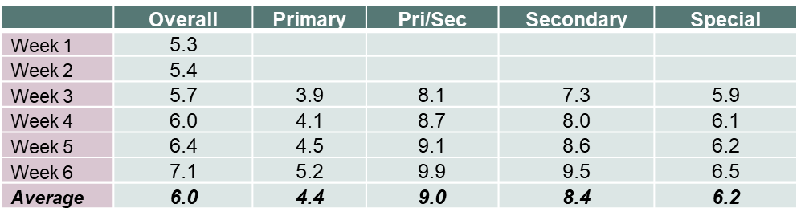
The number of hours in which students took part in remote and flexible learning also varied by school type. Figure 3 shows that most secondary students took part in about 4-5 hours of school-directed learning per day, compared to around 3-4 hours for most primary students. Principals reported that younger students required more supervision and support to complete remote and flexible learning than did older students.
Figure 3: Average hours students were engaged in school directed learning
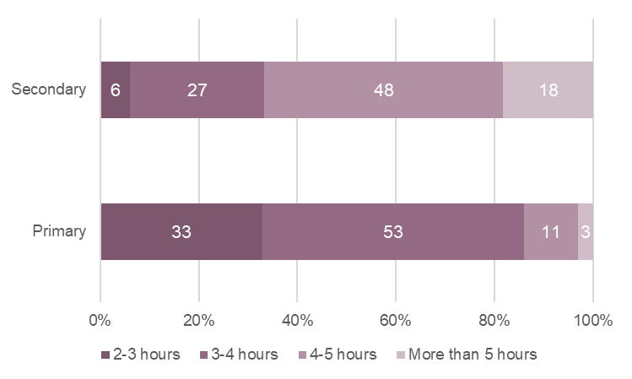
Source: Learning and Support Continuity survey. Percentages represent the average number of hours students were actively participating in school directed learning each day during remote and flexible learning.

School disadvantage
The level of disadvantage, indicated through the Student Family Occupation and Education (SFOE) index, is based on parental occupation and levels of education, and the level of concentration of disadvantage in a school. Students from more disadvantaged schools (those in medium and high SFOE bands) recorded higher absenteeism rates during remote and flexible learning (and typically also record higher absence during on-site learning). About 10 per cent of students from schools in the high SFOE band were absent during remote learning compared to around 4 per cent of students from schools in the low SFOE band. Figure 4 shows the proportion of absent students by schools’ SFOE band during Week 6 of remote learning.
These data indicate that the greater barriers faced by students from disadvantaged schools did not diminish or disappear during remote and flexible learning. As described below, disadvantaged students were less likely to have internet connection and access to devices to facilitate remote and flexible learning, which may have contributed to higher absences.

Figure 4: Proportion of students absent from remote and flexible learning during Week 6 based on SFOE
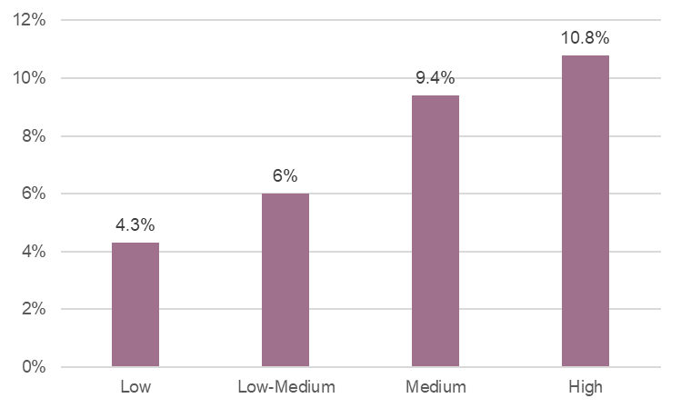
Note: There were 366 schools in the ‘Low’ SFOE category, 356 schools in the ‘Low-Medium’ category, 358 schools in the ‘Medium’ category, and 342 schools in the ‘High’ category.

Vulnerable cohorts
The Department categorises the following cohorts as vulnerable: Aboriginal and Torres Strait Islander students, disadvantaged students, students in out-of-home care, students with disability, and students at high risk of disengagement. Many students fall within more than one of these cohorts. Figure 5 below describes each of these cohorts. Figure 5: Overview of vulnerable cohorts of Victorian students
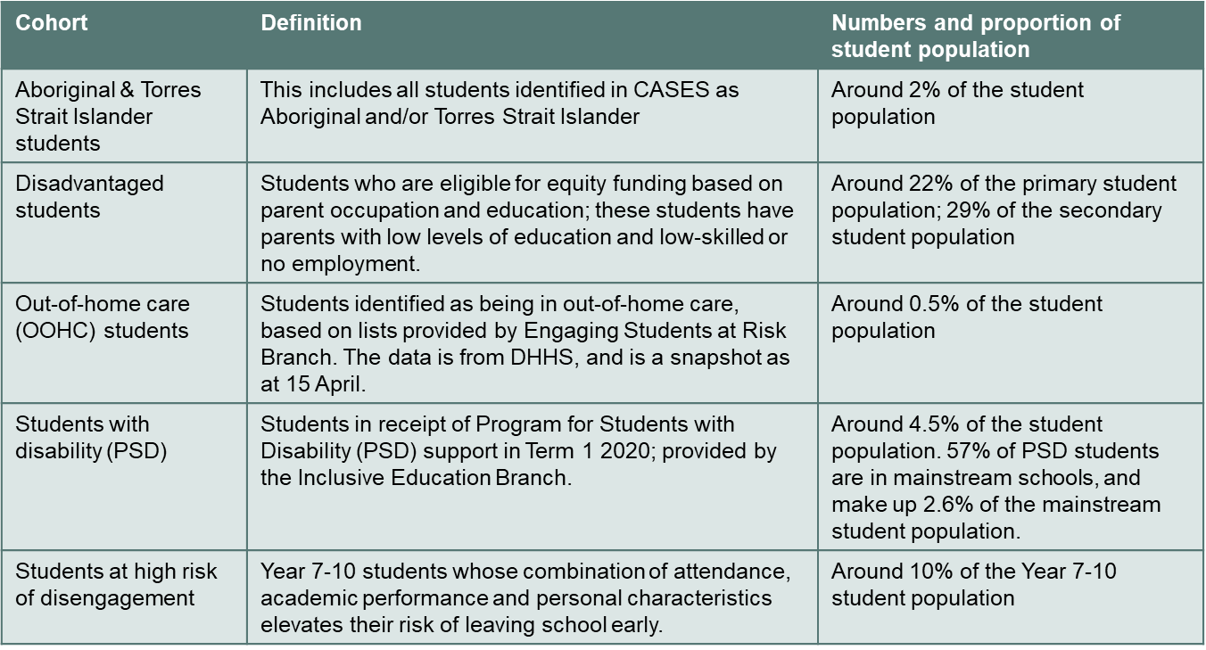
Absence rates for vulnerable cohorts steadily increased in Term 2, with absences in these groups recorded at two to three times the state average. The highest proportions of absent students were among Aboriginal and Torres Strait Islander and out-of-home care secondary school students. The absence rate for out-of-home care primary students is similar to Term 1 levels, but a higher proportion of out-of-home care secondary students were absent in Term 2. Figure 6, which presents absence data for the last week of remote and flexible learning for most students, shows that vulnerable cohorts had significantly higher student rates of absence compared to the state average. This suggests that vulnerable students faced greater barriers to remote and flexible learning than did other students.
Figure 6: Week 6 remote learning student absence data for vulnerable cohorts (% of students)
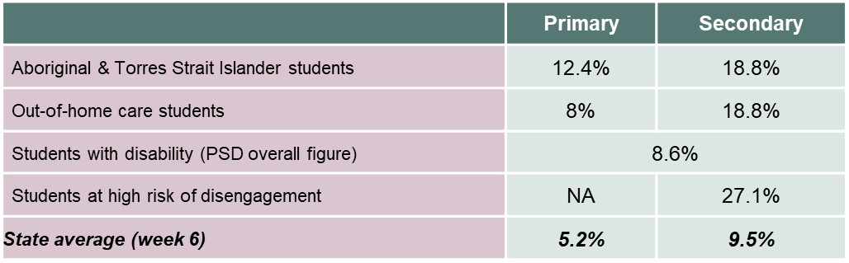

Absenteeism increased over time for secondary students
With the staged return to schooling, students in Years 3-10 had two additional weeks of remote and flexible learning than did other students. While absentee rates for primary school students learning from home were stable during this period, secondary school student absenteeism rose from 10.7 per cent in Week 6 to 14 per cent in Week 8 of Term 2. A number of teachers also reported in surveys and focus groups that it was harder to keep the attention of many students the longer remote and flexible learning continued. Absence rates for Aboriginal and Torres Strait Islander and out-of-home care students also slightly increased.

At-school attendance data
Schools remained open for students who were unable to learn from home. Students who could learn at school (on-site) included students from vulnerable cohorts and the children of essential service workers. These students completed the same learning activities as their peers learning at home, under teacher supervision, with access to a quiet learning space and the internet. At-school attendance rates varied considerably based on school type, location, and vulnerable cohorts. This section summarises these data.

Overall
The state-wide average on-site attendance during remote learning was 3 per cent. This means that 97 per cent of students learned from home. The average on-site attendance rate increased gradually over the six-week period of remote learning, starting at 2.2 per cent attendance at the start of Term 2 and increasing to 3.6 per cent the week before the staged return to school.

School type
Special schools and primary schools had the highest on-site attendance rates, with an average of 5.8 and 4.7 per cent of students, respectively. Secondary schools, by contrast, had the lowest attendance rates, with less than 1 per cent of students attending on-site classes. The discrepancy between school types is most likely because secondary students were able to learn from home without supervision, whereas younger students needed to attend school if they were not supervised at home. Figure 7 shows the weekly on-site student attendance based on school type.
Figure 7: Weekly attendance on-site by school type (% of students)
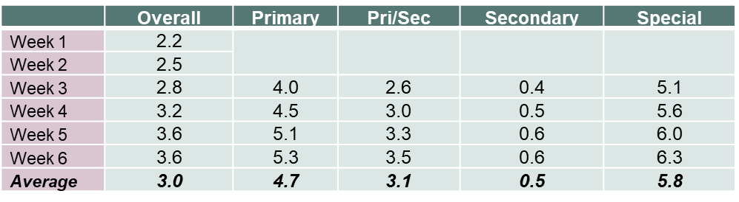

School location
Average at-school attendance rates in Victoria varied by region. Non-metropolitan schools recorded a three or four times higher rate of at-school attendance than did metropolitan regions. For example, Ovens Murray had 7.2 per cent average at-school attendance in Week 6 compared to only 1.5 per cent in Inner Eastern Melbourne. These data might be explained in a number of ways. First, greater fear about COVID-19 cases in the city seemed to deter parents from sending their children to school. This was evident at the end of Term 1 when attendance rates dropped significantly at many Melbourne schools well before schools were closed. Second, student groups who were over-represented in at-school attendance - including Aboriginal and Torres Strait Islander students, out-of-home care, and disadvantaged students - tend to be more concentrated in regional schools and this may account for the higher at-school attendances in those schools. Third, there may have been a higher percentage of non-metropolitan parents who were unable to work from home during this period.

Vulnerable cohorts
On-site attendance for Aboriginal and Torres Strait Islander, disadvantaged and out-of-home care students was higher than the state average in Term 2. The at-school attendance rate almost doubled for Aboriginal and Torres Strait Islander students during the six-week period of remote learning, and steadily increased for out-of-home care students over the same period. Figure 8 shows attendance rates for vulnerable cohorts in the week before the staged return to school.
Figure 8: Week 6 at-school attendance data (% of cases)
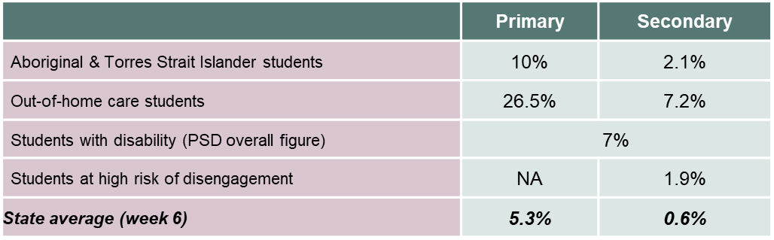
It is noteworthy that many more students in vulnerable cohorts were reported as absent in Term 2. Schools must continue to carefully monitor and support vulnerable students as they return to regular schooling, and work to re-engage those at risk of not returning to school at all.

Staff wellbeing at schools
The Learning and Support Continuity survey shows that the level of at-school attendance rates affected the wellbeing of school leaders and teachers. Fewer than a quarter of respondents who said they were thriving had daily at-school attendances of greater than 5 per cent. Figure 9 shows that respondents from schools with greater than 5 per cent daily attendance were more likely to report poorer wellbeing. That is, of school leaders who said they were mostly struggling, 46 per cent worked in schools that had greater than 5 per cent daily attendance.
Figure 9: At-school attendance and staff wellbeing (% of schools)
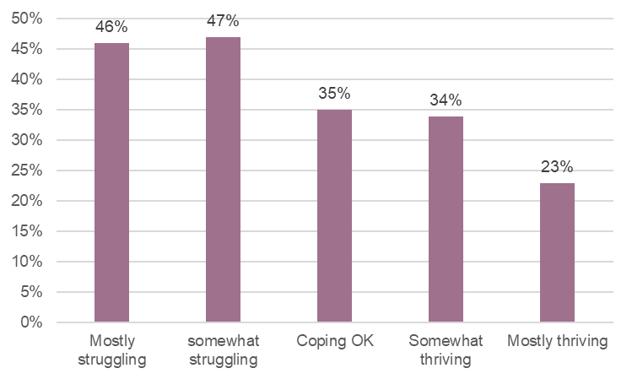
Source: Learning and Support Continuity survey. Percentages represent the percentage of schools with on-site attendance greater than 5% in each category of well-being. For example, 46% of schools that reported well-being of “mostly struggling” were schools that had daily on-site attendance greater than 5%..

These data suggest that schools catering for higher proportions of students on site faced more pressures. These may be associated with family and student wellbeing, student engagement, staffing, parent requests, and hygiene and social distancing. Respondents from schools with higher proportions of at-school attendance rates reported having to deal with a substantial number of families under severe stress as a result of students learning remotely, and reported significant pressure from parents to enable at-school attendance.
Survey respondents from rural schools were more likely to report poorer wellbeing than were respondents from metropolitan schools. As Figure 10 shows, regions with higher proportions of on-site students tended to report they were struggling more than schools with lower on-site attendance. 35 per cent of respondents in Ovens Murray and 27 per cent of respondents in Mallee said they had struggled in the previous 10 days, compared to around 12 per cent of respondents in Inner Eastern Melbourne.
Figure 10: Average on site-attendance versus school wellbeing
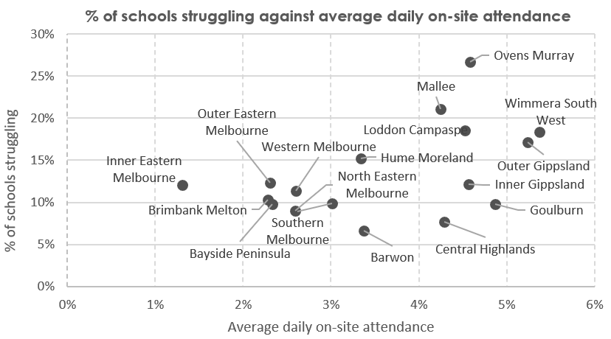

Source: Learning and Support Continuity survey

Attendance during the staged return to school
The staged return to school began in Week 7 of Term 2. Students in special schools and those in Years Prep, 1, 2 and VCE and VCAL returned to school at this time, while students in the remaining year levels continued to learn at home for a further two weeks. A small proportion of students continued to learn at home for medical reasons. Most students marked absent from remote and flexible learning were marked absent for unknown reasons, whereas a higher proportion of student absences from school were for medical reasons or parent choice.

Staged return to school
Overall, absence rates were back to normal for Prep-Year 2 students during this period. By contrast, special school absences were higher than the Term 2 average in 2019, while senior school absences were lower than the same time last year. The period of remote and flexible learning was particularly stressful for VCE students. Attendance data suggest they were keen to return to usual learning at school.
Absence rates for students with a disability increased significantly – to almost 16 per cent in the first week of the staged return to school, up from 8.8 per cent the previous week. Figure 11 shows higher absence rates in both special schools and mainstream schools during the staged return to school (Week 7 and 8). These data suggest that some parents chose to keep their children at home for medical or other reasons.
Figure 11: Absence rates for students with disability during the staged return to school in special schools compared to mainstream schools
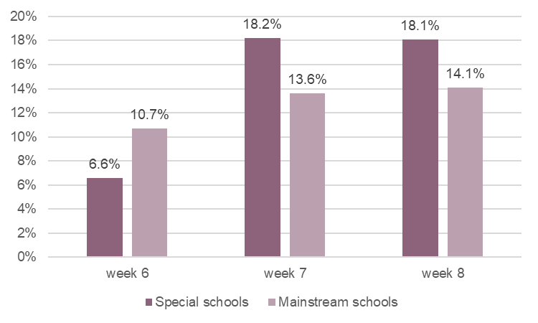

Return to school
Once schools returned to on-site learning for all students, absences stabilised. Yet schools still faced several challenges with student attendance and engagement. A third of schools reported (in the check-in with their regional office during Week 9) that students had been unsettled upon returning to school. The proportion of these students was more concentrated in special schools and regional schools: around half of all special schools and half of all schools in Barwon and Central Highlands reported that students returned unsettled. In the same check-in, nearly one in five principals reported concern or strong concern about the lack of academic progress during remote learning. These concerns were also concentrated in regional areas, with around a quarter of schools in Central Highlands, Goulburn and Inner Gippsland reporting concerns about academic progress, compared to fewer than one in ten schools in parts of Melbourne.
Schools must continue to carefully monitor students in coming weeks to identify learning gaps and provide additional supports to those who need them. The challenge is significantly harder for students who were consistently absent during the remote learning period: these students experienced a larger learning loss than most and some are at risk of disengaging from school altogether.

Student experiences of remote and flexible learning
Main findings
- Students enjoyed the flexibility of learning from home more than any other aspect of the new approach. In a student survey, over a quarter of students identified increased flexibility as the best thing about learning from home. Many students exercised, and seemed to benefit from, increased student agency that was possible with remote and flexible learning.
- Students’ capacity to focus varied markedly. In a survey, 7 per cent of students said they enjoyed being able to do their work without the distractions and noise of the classroom. Yet a larger group – 13 per cent - said it was hard to maintain focus and not get distracted at home. Secondary school students found it much harder to stay motivated while working from home.
- One in 10 secondary school students said their workload was too high while learning from home, compared to only 3 per cent of primary school students.
- Primary students - in particular - enjoyed having more time for non-school activities and spending time with family and their pets.
- There was no single aspect of remote and flexible learning that a large percentage of students reported as needing to change. This suggests that nothing specific about remote and flexible learning went wrong for large numbers of students, even if some challenges were exposed, especially for secondary students.
- Despite these findings, it is clear that many students enjoy being at school and were eager to return.

What students enjoyed about remote and flexible learning
Online school has been a lot better for me because I always didn't like going to school and now that I get to do it in the comfort of my home it’s great.
Above all, students enjoyed the freedom of remote and flexible learning. A Victorian Student Representative Council (Vic SRC) survey asked students to identify the best things about learning from home. Students overwhelmingly reported that they liked being able to work at their own pace (73 per cent), and feeling more comfortable being at home (56 per cent). Nearly half of students in this survey also reported that spending more time with family was one of the best things about learning from home. In short, students appreciated increases in student agency that came with remote and flexible learning.
Focus groups of secondary school students highlighted that students greatly appreciated the ability to plan their day, as the following quotes show:
We have more control over what we are doing during lesson times, e.g. I can work on a project if I feel that is more necessary than the immediate task given to me - I do that later.
There is a lot more flexibility. If I finish the task for the week, I can use the other lessons of the subject in the week to catch up of other work/assessments.
I get to be productive and do things around the house when I finish my work early rather than bother people who haven’t yet finished their work. I get more exercise and I have an established eating routine.
The Parent and Student Learning from Home Survey complements these data. As Table 1 shows, nearly 30 per cent of secondary students and 15 per cent of primary students enjoyed the comfort of remote and flexible learning: the ability to control the temperature, wear any clothes and sleep in. These might at first sound like trivial benefits of remote and flexible learning, but quotes from students show that they enabled students to control their environment in a way that they believe made for fewer distractions and better learning.
Eating and dressing how I want. The environment around me being quiet so I can concentrate.
Feeling comfortable while working! (wearing comfortable clothes in a warm room, especially on cold days)
Primary school students also enjoyed the opportunity to spend more time with family and pets (20 per cent), and to undertake more non-school activities and to enjoy shorter school days (15 per cent). As one said:
The best thing about learning from home is I have more time for my hobbies and my interests.
Yet for all these positive comments, even when asked to identify the best aspect of remote learning, 6 per cent of secondary students and 4 per cent of primary students said there was nothing good about it or could not name one good thing about it. These are not high figures but neither are they negligible.
Table 1: Student experiences: What was the best thing about learning from home?
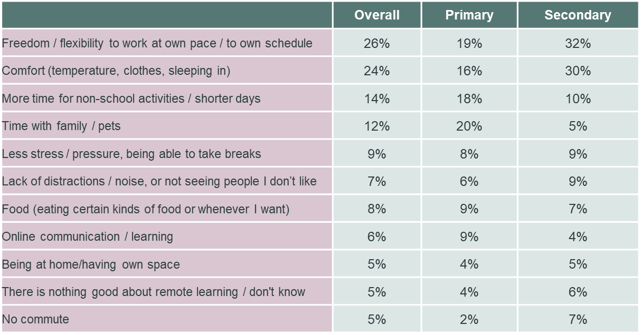Note: Learning from Home Survey. 12,118 students (5,511 primary school students and 6,585 secondary school students) responded to the question “What is the best thing about learning from home” in the survey. Responses were then coded for categorisation.

What students found difficult during remote and flexible learning
Unlike the most cited benefits of remote and flexible learning, students identified no standout difficulties of studying at home. The most striking finding, expressed by just under one in five primary students and one in eight secondary students, was lack of contact with friends and peers (see Table 2 below). Some students poignantly expressed their feelings about this side of remote and flexible learning:
Can’t see my friends and I’m afraid my friendships are deteriorating.
I believe that the hardest thing about learning from home is that you don't get to see your friends in person and it is a little bit lonely for me even though I have my sister and my parent at home.
I would really like it if I was able to Facetime my friends while I am working so that we could discuss some things, like we do at school.
In terms of study, 15 per cent of secondary students found it easy to be distracted and, lose focus, while 13 per cent struggled to stay motivated. About one in 10 of all students, secondary and primary, missed contact with a teacher to explain the work. One regretted:
Not having face-to-face interaction with the teacher (not being able to ask questions and receive an answer right away).
Another wanted:
Less school work since it's hard enough to complete all the work without being in a physical classroom with the teacher.
While some students clearly benefited from being able to study in their own way, others found the temptations and distractions of home hard to manage. Two students identified the problem of:
Staying motivated and disciplined. It was so easy to lose focus and make the decision to watch Netflix instead of studying, because nobody is there to tell you not to
Staying on topic (school work) because there are more distractions at home than at school
In a finding that calls for more investigation, troubling proportions of students – 8 per cent of secondary students and 7 per cent of primary students – had problems with technology: either internet connectivity or hardware or software issues. This exacerbated difficulties in families in disadvantaged communities. To give just one example, in a survey of parents conducted by a primary school in country Victoria, one reported that there was no internet or printer at home. Asked to provide any further comments, the parent said: “I’m an essential worker and a single parent. I work full time”.
Table 2: Student experiences: What was the hardest thing about learning from home?
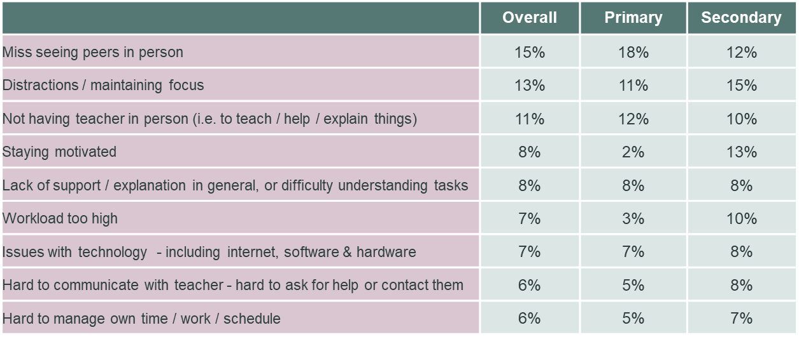
Note: Learning from Home Survey. 11,826 students (5,253 primary school students and 6,550 secondary school students) responded to the question “What is the hardest thing about learning from home” in the survey. Responses were then coded for categorisation.
Yet despite these findings, it is heartening that students were unable to single out significant aspects of remote and flexible learning that they would change if they could, as the table below shows. About one in 10 secondary students thought the workload should be decreased. One said:
The amount of work… has been growing over the weeks and I think that at one point the work will be too much to handle for students.
The low proportions proposing specific changes notwithstanding, students voiced a clear preference for more contact with teachers, even if it is virtual. Two said:
I would like to have video calls every day as it will help to understand more nicely. Every subject will have its own video call as the time-table suggests.
I think I would change the fact that we don't have video calls.

Table 3: Student experiences: If you could change one thing about remote and flexible learning, what would it be?
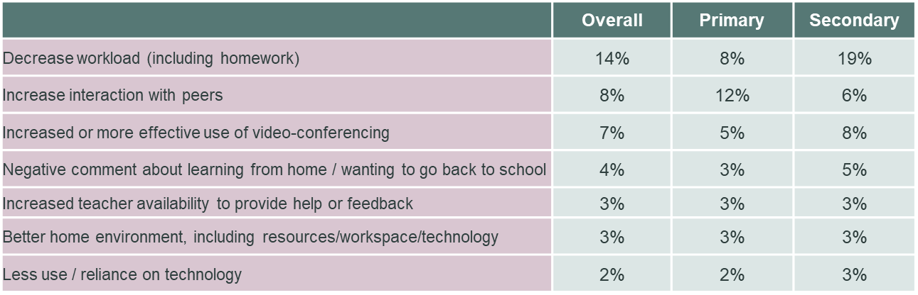Note: Learning from Home Survey. 10,983 students (4,979 primary school students and 5,985 secondary school students) responded to the question “If you could change one thing about learning from home, what would it be?” in the survey. Responses were then coded for categorisation.

Senior secondary students
Learning from home imposed significant pressure on students undertaking their senior secondary education. A number of school principals highlighted that VCE and other senior secondary students felt they were missing out on an important part of their education, with students feeling heightened stress and anxiety as a result. As one student said:
This learning from home experiment is a total fail and I have found that my marks have dropped, which is so annoying as year 12 is the most important year and I feel like because of this learning from home it will affect my marks later on in the year.

Students with disability
Students with disabilities had a varied experience of remote and flexible learning. Many had positive experiences, and some seemed to thrive in the new learning conditions. In a submission to Engage Victoria, one parent said:
Remote learning has been a godsend. He [my son] has flourished, done his work and asked for help – all of this is new. … His school journey is mired with bullying and a lack of understanding and empathy for his dyslexia. He is not happy at school, feels uncomfortable, tired, misunderstood and does not understand the content of all the lessons
In another submission to Engage Victoria, an education service provider to specialist schools said that a key group that thrived under remote and flexible learning were:
Students with special needs who are adversely impacted by environmental factors within a school – i.e. excessive sound or other stimuli, social phobias or other factors that heighten their awareness or vigilance. For these students, school is physically and mentally draining and their cognitive load is significant
Similarly, a special school teacher said in the Engage Victoria survey:
Remote learning has also provided opportunities for learning success for some students with a disability when digital inclusion is a core part of remote learning pedagogy
Special school principals reported that students enjoyed the flexibility of learning at home as they could learn when it suited them. In a focus group, one principal said:
Some of the students … liked learning when it suited them, for example, later in the day when they were more awake and engaged: they learnt much better
However, remote and flexible learning also posed challenges for students with disabilities. Some struggled to learn at home due to added distractions, lack of support and disrupted routines. Several submissions to Engage Victoria indicated that students’ experience of remote and flexible learning was influenced by the ability of their parents and carers to assist them. One special school student said:
I needed lots of help with maths, but my mum couldn't help me at home, so I felt I was missing out on help with maths.
Some parents reported a lack of communication and contact with their child’s school. For some parents, remote learning is just too difficult for students with disability. In a submission to Engage Victoria, a parent said:
Many children with specialist needs were largely abandoned during the period of remote learning - and despite the admirable attempts of their teachers, students like my son simply could not engage with 'online' learning in any real way.
Some of the challenges seemed to stem from existing barriers to learning, such as whether students had access to specialist disability and IT equipment, connectivity and technical support. The Reflections and learnings on schooling during COVID-19 for students with disability report showed that insufficient numbers of students had effective Individual Education Plans prepared for them at the start of the 2020 school year, and too few Student Support Groups were organised to support students learning and wellbeing. Some students experienced poorer wellbeing, including anxiety and self-harm, during this period.
In a submission to Engage Victoria, one specialist school teacher painted a telling picture:
I found that remote learning didn't suit the majority of my special needs students. Out of my class, over a third didn't have computer access. Another third of my cohort were being looked after by their elderly non-English speaking grandparents. They were unable (or not willing) to engage with the classwork. Another child excelled in the situation, with his parent treating his home learning as a nine to five job (she had been made redundant). Another student engaged in learning in 5 to 10 minute blocks throughout the day. Overall my parents reported a lack of sleep by their children. Some of the students were only sleeping 4 hours a night. Over half of my parent cohort were running on less than this.
A large chunk of my time was spent discussing issues with parents about home learning and some of the problems they were encountering. They would then start confiding in some of the emotional problems they were facing with their children. As the length of the learning increased, the parents became more stressed and the need for the family support worker to help our families increased. The burden was for us to listen and to make decisions as to whether the families were really in crisis or just letting off steam. This is what I found the most draining and emotionally taxing.

Going back to school for all students
Even with the success of remote and flexible learning, many students wanted to get back to face-to-face teaching and the social experience that school provides. Students did not say in large numbers that in future they wanted to shift permanently from school to remote and flexible learning. While about a quarter said they enjoyed the freedom and comfort of learning from home, 15 per cent said they missed seeing their peers and 11 per cent found it hard not having their teacher there.
The following two quotes offer typical views:
I am just really excited to get back to school! I’m looking forward to attending my real class at school
I didn't really enjoy it (learning from home) a super amount. Yeah it had its good perks I suppose, but I am so glad to be back at school now.

Parent experiences of remote and flexible learning
Main findings
- Parents now have much greater visibility and understanding of their children’s school experience and how they learn. This may have significant consequences for their views of education, and of their school.
- Of all things that worked well during the period of remote learning, parents most praised the work of teachers, especially in communicating how to help with remote and flexible learning.
- Parents valued the flexibility that remote learning provided to their children.
- Parents of both primary and secondary level students typically cite their newfound appreciation of teacher work, support, engagement and planning as their most positive experience of this period
- Surveys reveal both praise and suggestions for improvement from parents in the way schools communicated, provided technology support, timely feedback to students and structured schedules. Presumably, this means that parents’ experience and views varied across schools, rather than revealing a widespread pattern of success or failure. More research would shed more light on these issues

Parents became more engaged and understood more about their children’s education
In being asked to support their children’s learning from home, parents have needed to develop a closer relationship with teachers and schools, and to be more aware of how they can support their children with schoolwork. Parent survey responses in the Parent and Student Learning From Home Surveys showed that 83 per cent of students had a parent or caregiver home with them from the start of the remote and flexible learning period. These changed relationships have led parents to require more information from schools, and have created opportunities for parents to more closely observe and understand what and how their children are learning. In a parent survey conducted by a primary school in Melbourne, one parent said that the period of remote and flexible learning meant that:
I have a much better understanding of my child's strengths, where they are struggling, and was able to provide one-on-one learning support. This resulted in my child learning much more than in school.
The Department’s survey and focus group work reveals significant differences between parents of primary and secondary school students about the benefits of learning from home. Parents of secondary students were more likely to report reduced distraction or stress, which may be consistent with their focus on the greater stresses and challenges of adolescence, along with more academic pressure. They were also less likely than parents of younger children to say they want strong communications from teachers, visibility into their children’s work, or daily check-ins with teachers.

What worked well
Surveys and focus groups show that parents strongly appreciate what teachers have offered in this time. Parents have increased awareness of the need for technology support, a daily routine and structure, and new skills and knowledge to support more independent approaches to learning. Almost one in four parents praised the support, engagement and planning advice that they and their children received.
Our teacher has been fantastic. Every day we have a list of what has to be done on Google Classroom. They have an online meeting at 9:15am for Roll Call, plus a small group meeting once a week. We can use Class Dojo or email or Classroom to chat with teacher. All classwork is easily accessed from Google Classroom. It has been fantastic
Parents of both primary and secondary level students typically cite their newfound appreciation of teacher work, support, engagement and planning as their most positive experience of this period. One in four primary school parents and around one in five secondary school parents mentioned this benefit. One primary school parent said:
Our Teachers, Principal, literacy specialists and other staff are not paid nearly enough for the pure dedication and love that they pour into our children, daily.
Primary school parents were next most likely to mention the support they got for use of technology at home, although it is important to note that schools differed widely in the amount of support they provided. Seventeen per cent of primary school parents – compared to 11 per cent of secondary school parents – mentioned technology support as a positive aspect of learning from home.
For secondary school parents the second most positive aspect of learning from home, after teacher support, has been reduced distraction and stress for their children. Nearly one in five secondary school parents cited this benefit, and it may reflect parents’ concerns that the pressures or pleasures of peer social interaction reduces their children’s ability to focus on their work while at school. By contrast, just one in 20 parents of primary school children cited reduced distraction and stress as a benefit of remote and flexible learning.
Both groups of parents expressed similar levels of appreciation – at 13 per cent – for the more flexible ways their children were able to learn and to take breaks as they needed them. One parent said:
I like the flexibility of online and offline work so I can choose what will work for my child.
Again, at similar rates for both school levels, parents reported that their children were developing skills and knowledge to learn independently and use technology.
Parents of primary school age children reported a positive experience of communication from the school or their teachers. Parents of secondary school children also mentioned school or teacher communication as positive, but less frequently than did primary school parents. Eleven per cent of primary school parents, but only 7 per cent of secondary parents, felt they understood their children’s learning program. Similarly, twice as many primary school parents felt they could help their children with their learning than did secondary school parents. These differences are unsurprising, given the more complex timetabling and subject matter, and the greater number of teachers, at secondary school.
The following table sets out in detail parents’ views of what worked well during the period of remote and flexible learning.
Table 4: Parents’ experiences: What aspects of learning from home are working well?
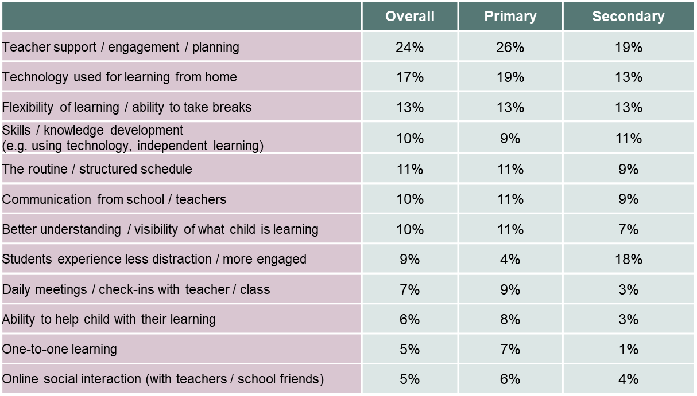Note: Learning from Home Survey. 4,834 parents (3,341 parents of primary school students and 1,488 parents of secondary school students) responded to the question “What aspects of remote and flexible learning are working well?” in the survey. Responses were then coded for categorisation.

What could be improved
Parents highlighted the need for more live and face-to-face teaching online as the most important area of improvement they wanted to see. Just fewer than 1 in 6 parents wanted more live or face-to-face teaching provided directly to their children. This was the greatest area of improvement parents said they wanted to see. Two said:
I feel that the lower year levels could have had face-to-face meetings a little earlier, but that said, my daughter in Year 7 is having on average, 3 'meets' per day and I feel that is suitable and working well for her. I think this aspect is really important and my son in Year 10 has certainly appreciated these lessons especially for Maths and Physics.
Live online classes for all year levels to keep the students engaged and connected with the teachers, as well as being able to explain the task in more detail for students who don’t have a clear understanding of the written tasks.
With less live teaching, parents were inevitably expected to be more responsible for understanding and explaining what their children needed to do, how to go about it, and how to stay on task. This might explain why 8 per cent of both primary and secondary school parents’ would like instructions from teachers to be clearer, and why 6 per cent of primary school parents and 11 per cent of secondary school parents think that communication in general from teachers could have been improved. One parent wanted simple messages such as being able to see what work they are meant to be doing as well as due dates. Not just overdue items.
While primary school parents were in general happy with school communications, one said:
Year 4 number skills. Often took longer than 10 minutes. No instructions or guidance on how to complete more difficult multiplication that has not been taught yet in class. Resulted in heightened disengagement toward the end of remote learning. We were unable to switch on the growth mindset…teacher videos showing examples of maths questions may have been helpful?
Parents now know that a learning routine is important, and have valued schools that have helped them to establish one. Nevertheless, 6 per cent of both primary and secondary school parents think teachers should check in on students more regularly. Six per cent of all parents want more feedback to students from teachers, and 8 per cent of secondary school parents, twice as many as primary school parents, would like more teacher feedback directly to them. One parent would have appreciated:
Being able to see what work they are meant to be doing as well as due dates. Not just overdue items.
A great deal of parent commentary mentioned the challenges, and often frustrations, of setting up the computers, online connection and platforms to support learning. Parents had to acquire new skills and knowledge, and inevitably there were teething problems, as these comments show:
The technology side of things was probably the hardest bit for us. Borrowing a computer from the school was a huge help, passwords were tricky during the initial set up.
Possibly making the first week hard copy only could have helped until everyone got settled on their computers. I know that for us the first week or two were stressful trying to work out computers at home and then learn the school one."
Perhaps if anything negative I would say the obvious technical issues relating to bigger class meets online or systems crashing early in with the influx of students but otherwise nothing, for us it was enjoyable and simple to undertake at home.
About 7 per cent of secondary school parents would have liked their children to get more work. The following table sets out parents’ views of what worked well during the period of remote and flexible learning. These results are from a survey of parents during the period of remote and flexible learning.

Table 5: Parents’ experiences: What aspects of learning from home could be improved?
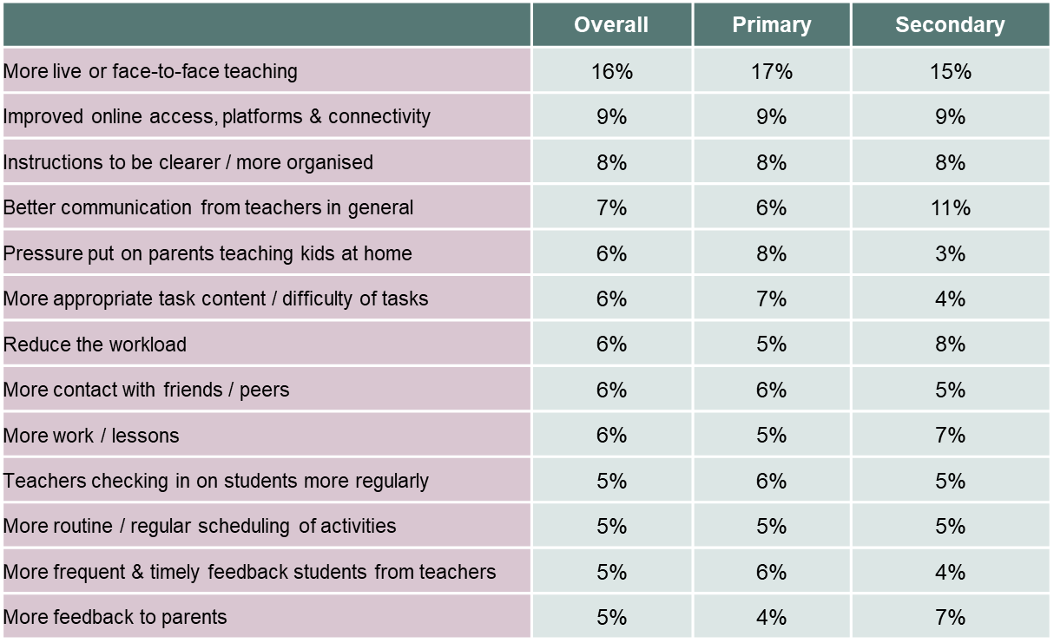Note: Learning from Home Survey. 5,346 parents (3,735 parents of primary school students and 1,603 parents of secondary school students) responded to the question “What aspects of learning from home could be improved?” in the survey. Responses were then coded for categorisation.

What school leaders and teachers thought about their interactions with parents
Comments in a focus group with school leaders, and another with teachers, suggest that the challenges of providing remote learning has strengthened the relationship between many parents and their schools. Here are perspectives from the leadership of a socio-economically disadvantaged rural secondary school:
Parents were given a blunt insight into what the kids are like in the classroom – parents are communicating more with teachers and therefore there is more goodwill from parents.
Parents have better understanding of what their kids are doing and learning. They can have better conversations with their kids; parents are also seeing how much work the kids are doing.
Similarly, school leaders at an outer-urban, low-SES primary school thought that parents, as a result of spending more time with their children on educational matters, had a greater appreciation of the work schools do.
They have a greater realisation that we care about them and their children.
And in a teacher focus group, one teacher said:
Many highly anxious parents have been extremely concerned about their child’s development and unsure how to support them. - I’ve had many back and forth emails with parents. Many just needed someone to talk to.

Teacher experiences of remote and flexible learning
Main findings
- Teachers have faced a huge workload during the pandemic. Some – especially new teachers, single parents and those with mental health challenges – have found this period particularly difficult.
- A number of school leader focus groups highlighted how students and parents appreciated teachers’ work during this period
- School leaders also emphasised that teachers had worked hard to support each other. They highlighted the collegiality and strong supportive environment that had grown in their schools.
- The closure of schools and the shift to remote learning challenged teachers’ beliefs about teaching and learning. Some struggled to teach effectively online. Others were forced to try new approaches, and often benefited from that experience.
This section complements discussion of various elements of teachers’ work throughout this report by focussing on their experience during the pandemic.

Teachers worked hard to make remote learning a success
Teachers, faced with an unusually heavy workload during this period, worked extremely hard to make remote and flexible learning succeed. Many said they had been willing to learn new skills and approaches. They thought success was most likely when they committed time and energy to learning new skills, and were honest about the difficulties they faced. At the end of Term 1, in particular, teachers rallied and worked collectively to set up the necessary online platforms.
Some teachers enjoyed the flexibility of these changes. Focus groups of teachers highlighted the benefits of online meetings and wanted to see them maintained in future. This was particularly important for teachers who work part time and can feel more included in online meetings and communication.
A teacher focus group emphasised how much it meant to teachers to receive emails from students expressing their appreciation for teacher work during this period, and providing supportive feedback of a kind that rarely happens during conventional schooling. One primary school student said in the Engage Victoria survey,
What I learned was that learning from home gave me a new appreciation of just how wonderful teachers are. Being able to have a strong line of communication with our teachers through Webex meets and our class seesaw. This strong line of communication made me feel comfortable and it really felt like we were in the classroom just not face to face.
A number of school leader focus groups highlighted how students and parents appreciated teachers’ work during this period. Stronger school-family relationships had been built on this goodwill. School leaders also emphasised that teachers had worked hard to support each other. They highlighted the collegiality and strong supportive environment that had grown in their schools.
On the other hand, teacher work during the remote and flexible learning period was very challenging. Focus groups with teachers highlighted the frustrations they felt – and that some students shared – in creating a positive learning environment online, and in improving relationships with students that were difficult before or during this period.
Some parents making comments in surveys and focus groups felt that the period of remote and flexible learning had not been a success. They felt that the tasks set for their children online were not appropriate and that the online classes were not effective.

Some teachers found this period very difficult
The lockdown challenged all teachers. Those who found it particularly difficult included teachers who are single parents or have very young children, who are physically or mentally vulnerable, and whose students faced mental health challenges.
A number of teachers highlighted the increase in workload that came with remote and flexible learning. As one primary school teacher reported through the Engage Victoria survey:
The workload for me as a teacher in a Webex meeting from 9.00am-2.00pm followed by hours of reviewing, approving and giving feedback to responses to learning tasks followed by daily timetabling, communicating with parents and creating & assigning lessons for the online platform used by my school (Seesaw), meant many working days were 15 hours long and this included many weekend days. Some tasks can be done in this format but I think that it is better for primary students to work in a face to face situation where the learning can be explained verbally and all students have a voice.
The time taken to develop resources to put online was also emphasised by a specialist school teacher in the Engage Victoria survey:
The majority of students with disabilities find online learning difficult. Online learning is totally different to face to face teaching and takes a lot of time to create resources applicable to individual students.
One secondary school teacher said through the Engage Victoria survey that it would have been helpful to have more support and guidance in determining what are the best resources for online teaching:
It would have been of great benefit to have a teacher librarian employed at the school to assist with remote learning and provide support and learning materials for both staff and students in a time where accessing reliable resources was critical. A teacher librarian could have assisted with identifying reliable sources and assisted staff in creating higher level thinking inquiry projects that would be supported with online materials and databases. Furthermore, the teacher librarian could have worked closely with the English department to continue reading programs during a time where many students would have welcomed a break from their computer screen.
This was reiterated by a primary school leader who offered through the Engage Victoria survey that moving forward the system should:
Create a database of online resources for each curriculum area for assessment and delivery of content.

Principals’ views: the existing beliefs of teachers were challenged
School principals who took part in focus groups were generally optimistic about the work of teachers and impact of the lockdown on teacher practice and student learning. Most observed that the lockdown forced teachers to challenge their personal beliefs about teaching and learning. For example, many teachers needed to understand how to practice flipped learning, in which students learn material before a teacher explains it in a live online classroom, a reversal of the traditional sequence of learning. Other principals drew even larger lessons from this period for the future of education. One said:
This circumstance has demonstrated that we can have students at home and they are learning – the days of needing to have students at school to learn are being challenged.
Some principals were concerned that teachers would forget the lessons of this period. Two said:
We need to get the staff to recognise what they have learnt – not revert to their old ways.
Some teachers will be tempted to revert back – help them identify what was positive in the online environment.
School leaders say most teachers welcomed the return to school. One leader in an inner urban, low-income school said:
Coming back was great and teachers love that there are now less distractions and disruptions. Teachers usually complain about camps etc, and kids not being in class – but they are all working now
A number of casual relief teachers (CRTs) voiced the difficulties they faced during remote and flexible learning. Many felt left mouth of the process and unsure what to do. As one said through the Engage Victoria survey:
I was excluded from remote learning training and expected to find my own way through the plethora of remote learning platforms in use unaided and unsupported.
As we consider changes to be made in the future, it would be valuable to keep in mind this submission to the Engage Victoria survey:
Please include us CRT's.

School leader experiences of remote and flexible learning
Main findings
- Teachers spoke glowingly of the efforts and effective leadership of many Victorian school leaders.
- Many teachers said that their school leaders had responded to the pandemic with more effective leadership that not only enabled more effective teaching and learning, but supported teachers and staff during a difficult and stressful period.
- Parents repeatedly offered their appreciation of the way school leaders led their school and the community through uncertain and anxious times, and the effective communication and caring offered by school leaders.
- The crisis has affected the health and well-being of some school leaders. They needed a well-deserved break at the end of Term 2.
This section complements discussion of various elements of school leaders’ work throughout this report by focussing on their experience during the pandemic.

What has been positive for school leaders?
A Department survey of school leaders found that the crisis had generated a sense of collegiality and shared purpose across their schools, along with shared understanding of their goals during this period. Many leaders were gratified to see their staff helping one another. School leader focus groups emphasised the pleasure school leaders felt in their school coming together for a shared purpose.
In some schools, leadership became more effectively distributed, responsibilities were shared and communication improved. As one primary school leader said in the Engage Victoria survey:
There can be more flexibility in the positions of administrators (Principals, Assistant Principals, Business Managers) as these positions could work remotely without impact to their everyday role. This would enhance the well being of these staff as well as provide the opportunity to complete work uninterrupted, therefore increasing their work output. There is no reason why these staff couldn’t work from home one day a week (where possible), which would increase productivity.

Effective leadership: how teachers saw school leaders during the lockdown
Teachers were overwhelmingly thankful for the support they received from their school leaders. The pandemic and the shift to remote and flexible learning brought great uncertainty and anxiety. Making the changes for remote and flexible learning required strong and empathetic leadership – it simply would not have worked without it. Teacher focus groups suggest that many leaders set structures and processes to make the shift to remote and flexible learning more effective. One teacher said:
Our leaders were great. We felt really supported and valued throughout the process. There was lots of communication around expectations. We were given two weeks to ease into online learning, which gave staff plenty of time to skill ourselves on the best practice.
Similarly, in the Engage Victoria survey one secondary school teacher said:
Our leadership team worked overtime to support their staff and in my opinion this clear, sound guidance was profoundly important at this uncertain time.
Many school leaders went to great lengths to ensure that staff were supported and their well-being maintained. In focus groups, teachers said that their school leaders:
Made sure staff wellbeing was at the forefront. Wellbeing leader sent out regular surveys to seek feedback from staff and find out ways in which we could support one another.
Were able to demonstrate their appreciation of staff. This was always there but not being on site meant Principal team actively contacted staff to check in and praise efforts
Important that leadership team acknowledged when staff are overwhelmed
The crisis enabled school leaders to demonstrate their appreciation of staff and make their wellbeing a priority. While many principals always behaved this way, not being on site encouraged school leaders to actively check in with staff and praise their efforts. In one school, the Wellbeing Leader sent regular surveys to seek feedback from staff and ways in which they could provide mutual support. One school leader passed on “feelgood emails and messages” from parents to teachers. Another staged Friday afternoon catch-up sessions via Zoom to ensure everyone stayed connected.
Positive feedback from teachers was reinforced by parents. As one school parents offered through the Engage Victoria survey:
I thought the way my son's school handled the remote learning period was exceptional. I commend the school leadership for its clear and regular communications during a crisis.
As a family we were more in tune with what our children were learning. Our school did an outstanding job at keeping the students connected with school. Their communication was exceptional. We always knew what was happening in such uncertain times. Both my children kept up with work, had the opportunity to extend themselves and were involved in fun challenges that the school provided - e.g. online challenges, a school leadership meeting (the school even delivered lunch to the children), postcards, phone calls and emails from teachers and regular information from the school administration.

Impact on the health and well-being of school principals
While reports from many teachers show that many school leaders thrived through the period, it also took a toll on some. A Department survey undertaken near the end of Term Two asked school leaders to rate their health and well-being. About 15 per cent of school principals said they were struggling in their health and well-being, up from 11 per cent from a survey the previous week. Leaders in schools with higher on-site attendance rates reported poorer wellbeing, as discussed in Section 3. Department surveys of principals throughout the pandemic showed that about eight in 10 consistently felt that the Department was supportive of their health and wellbeing.

Teaching and learning
Main findings
- The shift to remote and flexible learning posed a massive teaching and learning challenge for schools. Teachers had to quickly adapt, and are still learning which online practices worked and which didn’t. To engage students, instruction needed to be far more explicit and broken down into smaller units than usual, with clear feedback.
- Schools shifted their timetables and trimmed their curriculum in a variety of ways. Some schools dropped specific subjects such as electives, while others tried to trim content within subjects. Many schools reduced student workload, posing ongoing challenges to the planning and development of the curriculum.
- Assessment was particularly challenging. Remote and flexible learning makes usual assessment techniques difficult. In Department surveys of Government schools at the end of Term Two, a third of school leaders reported they had found assessments during remote and flexible learning to be invalid.

Schools adapted their teaching programs for remote and flexible learnings
Schools worked tirelessly to adapt their teaching and learning programs to remote delivery. Over half followed their existing timetable or a moderated version of it. Many schools provided daily task lists to students, while others provided weekly task lists with daily check-ins. Figure 12 shows the different curriculum delivery modes schools used during this period.
Figure 12: Curriculum delivery modes
Mode of delivery | Percentage of schools
Live online chat sessions/video conferencing | 72
Online formats, but provided hard-copies or content on a USB as a backup for anyone who did not have access to online content | 67
Recorded lessons for download, stream or access online | 62
Provided material to download or access online for self-directed study | 54
Predominantly hard-copy/paper-based materials | 23
Source: Learning and Support Continuity survey.
Note: respondents were able to select more than one answer, so percentages do not add up to 100
As the above figure shows, the most common methods of curriculum delivery involved a combination of self-study, recorded and live lessons, and online group chats. A wide variety of online platforms, including Google Classrooms, Webex, Zoom, SeeSaw, Class Dojo, Compass and YouTube, were used to deliver the curriculum.
Most schools did not rely on paper-based instruction as the main method of curriculum delivery. Less than a quarter reported providing hard copies or paper-based instruction to students. About a quarter of primary schools and half of special schools used hard copies to deliver their curriculum to students, compared to only 4 per cent of secondary schools. This suggests that secondary schools were already adept at using online formats for teaching and learning and were able to transition to this mode of delivery more easily than other schools. It also suggests that paper-based instruction may have better suited the needs of primary and special school students than did online formats.
Schools needed to provide paper-based instruction or hard copy back-ups to students who did not have access to internet or a device at home. While schools worked to provide dongles and devices for these students, principals reported that many students received these too late or missed out altogether due to a shortage of dongles or school funds to purchase/hire enough devices. The Learning and Support Continuity Survey showed that more than two-thirds of schools provided hard-copy back-ups for students unable to access online learning. Teachers created resources for these students in addition to the online learning resources they provided to other students, and this contributed to the significant increase in their workload during the period.
Disadvantaged schools were four times as likely to supply hard-copy material to students as were advantaged schools, indicating that students from low-income families did not have equal access to online learning. Further, rural schools were more likely to provide students with paper-based materials and were less likely to deliver live online sessions. For example, nearly half of schools in Mallee and Ovens Murray provided students with paper-based materials, compared to only 10 per cent of schools in Southern Melbourne and Bayside Peninsula. This difference is likely because internet connections in metropolitan areas are more reliable and faster than in regional areas.

Trimming the curriculum
It was considered that schools would not be able to teach the entire curriculum during the period, the Victoria Registration and Qualifications Authority exercised its power to grant schools exemptions from teaching the whole Victorian Curriculum - although they were requested to prioritise English and Mathematics. The Department and the Catholic Education Commission of Victoria requested and were granted exemptions for their schools, and 15 per cent of independent schools requested and were granted an exemption. Health and Physical Education, Sciences and The Arts were common subjects that most independent schools sought an exemption.
Because schools were initially not sure how to put teaching completely online, many reduced student workload and the number of tasks they were required to complete. The change required a significant shift in thinking, especially when planning and developing unit plans and lessons, and it challenged some teachers.
Curriculum at a number of schools was trimmed to core areas such as literacy and numeracy, but some secondary schools reported keeping all subjects open. Some schools reduced core areas. One primary school:
stripped the curriculum right back especially in numeracy and took out things like algebra and focused on hands on learning like telling time and cooking with recipes, things the whole family could be involved in.
A number of schools reported teaching compulsory literacy and numeracy subjects in the morning and other subjects in the afternoon, permitting more flexible delivery and participation.

Teacher practice
Teachers had to quickly learn what practices worked and what didn’t. Exemplars and tutorials were critical to support students learning from home. To engage students, some schools decided that instruction needed to be far more explicit and broken down into smaller units than usual. Clear feedback increased in importance for some schools.
Many teachers highlighted that they were discovering new ways to engage their students online through remote and flexible learning. In the Engage Victoria survey, one secondary school teacher offered a glimpse of the learning that teachers undertook in improving their practice:
How to use Zoom effectively and how to make my lessons more engaging for my students with You Tube links for French songs, exercises, grammar tips, virtual cultural tours in Versailles and the Eiffel Tower etc. Students really enjoyed this as part of their lessons. I will now use these tools to enhance my classroom and online teaching to motivate students more.
Putting some classes online and allowing students to access and revisit content at different times can benefit student learning. As one primary school student said in the Engage Victoria survey:
It was helpful being able to rewatch the teacher explanations when I needed to.
A teacher focus group emphasised that students who learn best through collaborative study found it difficult at first to learn and navigate Google Classroom. Some students overcame this problem by setting up face-time ‘study groups’ to support one another. One primary school teacher said:
We found it was so important to have the Google Classroom catch ups at the end of every day for the students to have interactions with each other. These become non-negotiable.

Assessment
Assessment is central to effective teaching. Teachers need to understand whether students are learning what is being taught, if they are progressing well or struggling, and if they are on track to reach the achievement standard in the Victorian Curriculum for the subject and year level being taught.
Remote and flexible learning made many of the usual assessment techniques difficult. Without daily interactions with students, formative assessment was more difficult, as many teachers pointed out. One said,
It was difficult to ‘read’ students on Webex. In a classroom, you can tell by looking at a student whether or not they have understood something. This was a major challenge, especially if they did not tell you.
It was also unclear how much support students got from parents on their assessments. One primary school leader reported after students had returned to school:
It has become quite clear that parents did, or helped many children with, the assessment tasks and work during remote learning. A lot of data is actually invalid.
In Department surveys of Government schools at the end of Term 2, a number of school leaders expressed similar concerns that assessment during this period was invalid. .Some also reported that assessment was simply not a focus during remote and flexible learning. Teaching is likely to have been less effective as a result. As schools entered the final weeks of Term 2, a Department survey found that between a quarter and a third of schools have yet to come to a conclusion about the academic progress of a majority of their students during the period of remote learning.
For those schools that could more readily assess their students upon return, a Department survey of school leaders found that most thought that the majority of their students had made the expected level of progress and a small percentage thought most of their students had exceeded the amount they would normally learn. Around a third of schools who could judge the learning progress of their students thought the majority of their students had made less than expected progress during this period (the proportions varied depending on the year level of students, the socio-economic background of students and the school’s location) All estimates of student progress during remote and flexible learning should be treated with caution given the problems with assessment that teachers have highlighted, and the lack of system-wide moderation and assessment data available at this stage.

Engagement of vulnerable, at-risk, and low-and high motivation students
Main findings
- The period of remote and flexible learning affected varied groups of students in different ways. Early years students often struggled, as did students whose parents have low literacy levels, students whose first language is not English, students with disabilities and students at risk. On the other hand, high achieving and highly motivated students often thrived. This presents opportunities and risks in thinking about the lessons of this time for their future learning.
- A surprising success was the greater engagement of many normally shy students, who were able to speak up more online than in the classroom. These students were part of a group that was more engaged in remote and flexible learning compared to normal classroom teaching.

Different experiences for different students
It is essential to identify the impact of remote and flexible learning on different types of students. Some students excelled, benefiting from increased student agency that came with the flexibility of remote and flexible learning and became more engaged with their study. Some shy students felt more comfortable at home and also became more engaged in the online environment. Other students struggled, and became more disengaged. As one secondary school leader said:
Some students flew but a significant number fell further behind and we have had to put in place a lot of support to help them catch up and make sure they don’t fail.
Some students struggled to maintain focus while studying at home. They perceived more distractions at home than at school. Student survey data show that over one in seven secondary students and one in ten primary school students said that staying motivated was one of the hardest things about working from home. As one student said:
It was so easy to lose focus and make the decision to watch Netflix instead of studying, because nobody is there to tell you not to.
Early years students, especially in Years Prep to 2, struggled to understand what to do and maintain focus on their tasks. In a primary school focus group, teachers and school leaders said that children in the Foundation to 2 Years, especially Foundation, had “stagnated or regressed.”

Highly motivated and high-achieving students exercising increased student agency
School leaders, teachers and students all emphasised that many highly motivated and high achieving students have enjoyed and benefited from the increases in student agency that came with the flexibility of remote and flexible learning. One leader in a rural school said that as a result:
Teachers are saying the top kids are even further ahead than they would have been.
These students were able to arrange their day, and pursue further topics of interest, as they chose. One school leader said:
Teachers have been creative with really bright kids – helping them to use different spaces on Webex.
In the Engage Victoria survey, a secondary school teacher identified some of the benefits of remote and flexible learning relative to classroom teaching:
For students working above (the rest of the class) it was much easier to provide them with additional work and let them work through it on their own - just responding to emails when they needed additional support. This doesn't happen in face-to-face classrooms because I usually have too many other behavioural issues to deal with so I can't devote the time to these students.
While these findings are encouraging, it is wise to be cautious in drawing conclusions from them before assessing the actual gains and losses in the performance of all students. It seems clear that if the learning of some high-performing, motivated students has improved during this period, then the teaching and learning offered to them in normal circumstances could be improved. Yet while this change might involve more autonomy, autonomy alone is unlikely to be the answer. Far more important is improved teaching with more appropriate learning tasks that provide structured, rich learning experiences that raise student expectations. Research is clear that providing quality instructional materials for these learning tasks is an effective and relatively low-cost intervention that can boost learning and support teachers to implement improved learning of the Victorian Curriculum. To think that high-performing disciplined students simply require more autonomy may be a dangerous over-simplification.

Students who struggled with remote and flexible learning
By contrast, some students struggled with remote and flexible learning. Many of these students became overwhelmed and stopped trying, a teacher focus group reported. A few groups had particular difficulties.

Students and parents with low literacy levels, and second language learners
A teacher focus group noted that learning from home was very difficult for students with low levels of literacy, or whose parents struggled with literacy. One teacher said:
Our students’ literacy levels are relatively low. Remote learning required quite a lot of reading and understanding of written instructions.
Teachers and leaders in schools with high levels of students whose first language is not English found that these students often fell back into old habits of speaking their first language at home. These students lost the opportunity to speak regularly with friends and teachers in English.

At risk and vulnerable students
Reduced face-to-face contact with vulnerable and at-risk students made it difficult for teachers to address any ongoing welfare or educational concerns. A school focus group stressed that students who lacked supportive family environments struggled to access learning or even log on to classes. One educator said:
This was a major concern, particularly for our students who are at risk who we were unable to get in touch with. While the school was open to these students, we found that some did not attend even when invited to, which was concerning for their safety and wellbeing. We are concerned about these students for when they come back.
A primary school teacher said:
It has been difficult to motivate kids that already did the bare minimum, and the parents were having the same issues. I have had to reassure parents that their kids are doing okay when they only write a few sentences a day as even at school they were only writing a paragraph.
Limited access to internet and devices was an issue for some vulnerable students and in those cases, schools supplied hard copies of learning materials. Nevertheless, it is likely that inequities in access to online resources affected students’ ability to adapt to remote learning. As discussed in Section 3.1, students in vulnerable cohorts had significantly higher absence rates compared to the state average.
Schools admitted that they found it hard to support these students. One outer suburban secondary school maintained a list of 30 vulnerable students. This had positive results, a school leader said:
All aides have been communicating with the students all day every day to maintain a direct relationship. ASD (autism spectrum disorder) kids enjoyed being at home: their anxiety levels were reduced, they were relaxed and more active and did a lot better as a result. Teachers better understood the barriers faced by these students.
Similarly, a school leader in an outer-urban, disadvantaged secondary school said the period of remote learning gave teachers greater awareness of the barriers faced by some families, especially when English is not their first language.
Students in some vulnerable cohorts had a positive experience during remote and flexible learning. As discussed in Section 3.2, Aboriginal and Torres Strait Islander and out-of-home care students had higher at-school attendance rates than the state average. Many of these students attending school during the remote and flexible learning were more engaged, had more opportunity for direct relationships with teachers, and experienced less bullying. The Victorian Aboriginal Community Services Association (VACSAL) said:
Koorie students who were on-site at school thrived. Koorie kids felt more comfortable and experienced less bullying because there were fewer students on-site. Smaller groupings can be good for these kids.
For vulnerable students learning at home, some preferred to learn at their own pace and in a quiet space with fewer distractions, while others found learning from home difficult and struggled with isolation, loss of social connections, and the lack of teacher and peer support.

Shy kids talking up, and better engaging some students
A large number of teachers and school leaders identified students who better engaged with their learning during this period. This group included children who are often distracted in classrooms, don’t speak up in class, and are school refusers. As one secondary school teacher said in the Engage Victoria survey, there were benefits for:
Students who were often reluctant to speak up in front of a class or were school refusers actually engaged in one-on-one conversations with me and their confidence grew.
A number of students who are usually quiet during class found their voice online, as these comments from a school leader and from teachers completing the Engage Victoria survey show:
Engaging more openly with quiet students and giving them more one-to-one time to develop their learning developed confidence in their own abilities without the microscope or interruptions of their peers.
Quite a few kids (who are normally) reluctant to speak face to face are piping up all the time – they have found their voice.
The remote learning opportunity saw some of our disengaged students engage better than ever. There were accounts of students who demonstrated highly problematic and disruptive behaviours in the classroom in the normal settings, suddenly become highly engaged learners online! Students who suffer anxiety at school found their 'voice' in some instances. Such students also enjoyed working in a self-paced fashion.

School-family connections
Main findings
- The period of remote and flexible learning created much stronger school-family connections built on working together and better understanding each other’s situation.
- Schools were likely to move even more of their communication with parents online as a result of the pandemic.
During the pandemic, schools focussed heavily on greater communication and connection among all members of their community. One remote school used Facebook, Compass, and letters home to provide detailed information on how to access online learning. Students and parents were provided with an online handbook on what to expect. The principal created videos to explain online learning, and the school activated the parent portal on Google Classrooms so that parents could monitor student progress and track work being submitted.
Teachers across the state reported that the whole experience emphasised the connections between schools and parents. Schools relied on parents to take a larger role in their child’s education. In a survey of parents, two secondary school parents said:
School communities thrive when teachers/staff are compassionate, dedicated, highly communicative, and warm to all parents and all children.
The schools my children attend were fantastic - responsive and accommodating. I have no idea how they managed to respond to the required changes so quickly.
In a Department survey at the end of Term 2, schools identified a number of changes they could make in their relationship with parents, based on lessons drawn from the pandemic. These included:
Engaging parents online is the way to do business.
More sharing of student learning, leading to enhanced parent engagement with curriculum, collaboration with learning and transparent information exchanges.
(taking advantage of) Improved teacher capability to engage with families in a way that is not as threatening -- is tangible, about specific learning that needs to happen.
However, there is a concern these benefits will fade. A school leader said:
Parents are back at work so their opportunity to have the same degree of interaction with their children's learning or their teachers is reducing again.
Many school leaders understood the challenges many parents face. One primary school principal said:
Parents cannot be expected to supervise their children in remote learning while they are working. While teachers provided education packs, there was an inordinate amount of time required of parents to teach their children new concepts, and be available to them. The schoolwork provided was also completed within the first couple of hours leaving kids at a loose end so parents had to supervise. It was offensive to suggest that parents who can work from home can also supervise their child's learning. I understand that this was an unprecedented event and the best was made of the situation, but perhaps a change in the rhetoric around expectations that parents can work and teach at the same time would be recommended.

References
Black, P., & Wiliam, D. (1998) Inside the black box: raising standards through classroom assessment. Granada Learning.
Chingos, M. M., & Whitehurst, G. J. “Russ” (2012) Choosing Blindly: Instructional Materials, Teacher Effectiveness, and the Common Core. Brown Center on Education Policy, The Brookings Institution.
Graduate school of Education, University of Melbourne (2020) Lessons from Remote and Flexible Learning, Victorian Government Consultation, June 2020.
Griffin, P. (Ed.) (2014) Assessment for Teaching. Melbourne: Cambridge University Press.
Santiago, P., Shewbridge, C., Nusche, D., & Hertzog, H.-D. (2011) Evaluation and Assessment Frameworks for Improving School Outcomes: Common Policy Challenges. OECD. Retrieved from http://www.oecd.org/education/school/46927511.pdf
Steiner, D. (2017) Curriculum Research: What We Know and Where We Need to Go. Johns Hopkins School of Education. Retrieved from http://edpolicy.education.jhu.edu/?p=1360
The Victorian Foundation For Survivors of Torture (2020) Foundation House Submission to the public consultation: Lessons from remote and flexible learning.
Victorian Student Representative Council (2020) Learning From Remote Learning.
Yellow Ladybugs (2020) Yellow Ladybugs Submission on Remote and Flexible Learning.

Reports included Graduate school of Education, University of Melbourne, 2020; The Victorian Foundation For Survivors of Torture, 2020; Victorian Student Representative Council, 2020; Yellow Ladybugs, 2020
The Department collected weekly attendance data for students who learned at school (on-site learning) and for students who learned from home (remote learning). The summary shows that attendance rates varied based on school type, demographic and location, and by students in vulnerable cohorts.
The Learning and Support Continuity Survey, designed for principals to complete on behalf of their school by 3 May 2020. The survey received 1033 completed responses, representing 66 per cent of all government schools.
Refers to children whom all registered care givers were essential service workers at the time.
A report produced for the Region weekly check-in on 11 June. The data in the report includes principal feedback on a range of issues including required support, student behaviour and staffing.
Most of the data used in this section comes from the Parent and Student Learning From Home Surveys. While the number of respondents for each question varies, overall, 20,240 students from 188 schools, and 12,160 parents from 234 schools undertook an opt-in survey between 14 May and 26 June. Data from other sources is also used on occasion and this is referenced accordingly.
Victorian Student Representative Council, 2020
Students with disability refers to students who receive funding under the Program for Students with Disabilities (PSD)
Also see submission from Yellow Ladybugs, 2020
Also see submission from Yellow Ladybugs, 2020
Association for Children with a Disability and Amaze (2020), ‘Reflections and learnings on schooling during COVID-19 for Students with disability’, June.
DET Focus Group
Association for Children with a Disability and Amaze (2020), ‘Reflections and learnings on schooling during COVID-19 for Students with disability’, June.
Most of the data used in this section comes from the Parent and Student Learning From Home Surveys. While the number of respondents for each question varies, overall, 20,240 students from 188 schools, and 12,160 parents from 234 schools undertook an opt-in survey between 14 May and 26 June. Data from other sources is also used on occasion and this is referenced accordingly.
19,584 students responded to an online survey that asked them about learning from home. Students were asked “My parent(s)/caregiver(s) have been home during the day since I started learning from home.” 82.6% of students responded Yes, 15.6% of students responded No, and 1.8% did not respond. The results were form the Learning From Home Survey.
Data from the Learning from Home Survey that had 20,240 student respondents and 12,160 parent respondents.
Most of the data used in this section comes from focus groups conducted by the Department, and Engage Victoria: an online Department survey that collected submissions from 2,316 parents, 513 teachers, 206 school leaders, 150 students, 15 peak association representatives, and a small number of education support and service providers. Data from other sources is also used on occasion and this is referenced accordingly.
Most of the data used in this section comes from focus groups conducted by the Department, and Engage Victoria: an online Department survey that collected submissions from 2,316 parents, 513 teachers, 206 school leaders, 150 students, 15 peak association representatives, and a small number of education support and service providers. Data from other sources is also used on occasion and this is referenced accordingly.
Most of the data used in this section comes from focus groups conducted by the Department, and school leader surveys conducted by the Department and their regional offices. This includes the Department’s Learning and Support Continuity for Schools. This data included weekly check-ins that regularly received responses from over 70 per cent of school leaders. Data is also used from Engage Victoria: an online Department survey that collected submissions from 2,316 parents, 513 teachers, 206 school leaders, 150 students, 15 peak association representatives, and a small number of education support and service providers. Data from other sources is also used on occasion and this is referenced accordingly.
This was evident from a number of data sources including school leaders focus groups and surveys and reports from individual schools that surveyed their teachers and/or parents.
Learning and Continuity Support Survey.
See, for example, Black & Wiliam, 1998; Griffin, 2014
The Department’s end of term Learning and Support Continuity Survey included questions on assessment. Additional comments were provided by 217 schools. Thirty-four schools reported that assessments of students were not considered reliable during remote and flexible learning, 18 reported major disruptions to assessment, and 32 schools reported not focusing on assessment during the period. On the other side, 30 schools said there no or minor disruptions to their student assessments.
Santiago, Shewbridge, Nusche, & Hertzog, 2011
Most of the data used in this section comes from focus groups conducted by the Department, and the Engage Victoria: an online Department survey that collected submissions from 2,316 parents, 513 teachers, 206 school leaders, 150 students, 15 peak association representatives, and a small number of education support and service providers. Data from other sources is also used on occasion and this is referenced accordingly.
Chingos & Whitehurst, 2012; Steiner, 2017
Also see submission from The Victorian Foundation For Survivors of Torture, 2020
Wellbeing, Health and Engagement Division 2020
Including Aboriginal and Torres Strait Islander students, students in out-of-home care, and students at risk of disengaging from school
Association for Children with a Disability and Amaze (2020), ‘Reflections and learnings on schooling during COVID-19 for Students with disability’, June.
As above
Most of the data used in this section comes from focus groups conducted by the Department, and Engage Victoria: an online Department survey that collected submissions from 2,316 parents, 513 teachers, 206 school leaders, 150 students, 15 peak association representatives, and a small number of education support and service providers. Data from other sources is also used on occasion and this is referenced accordingly.

