Calling for Victoria’s best early childhood teacher
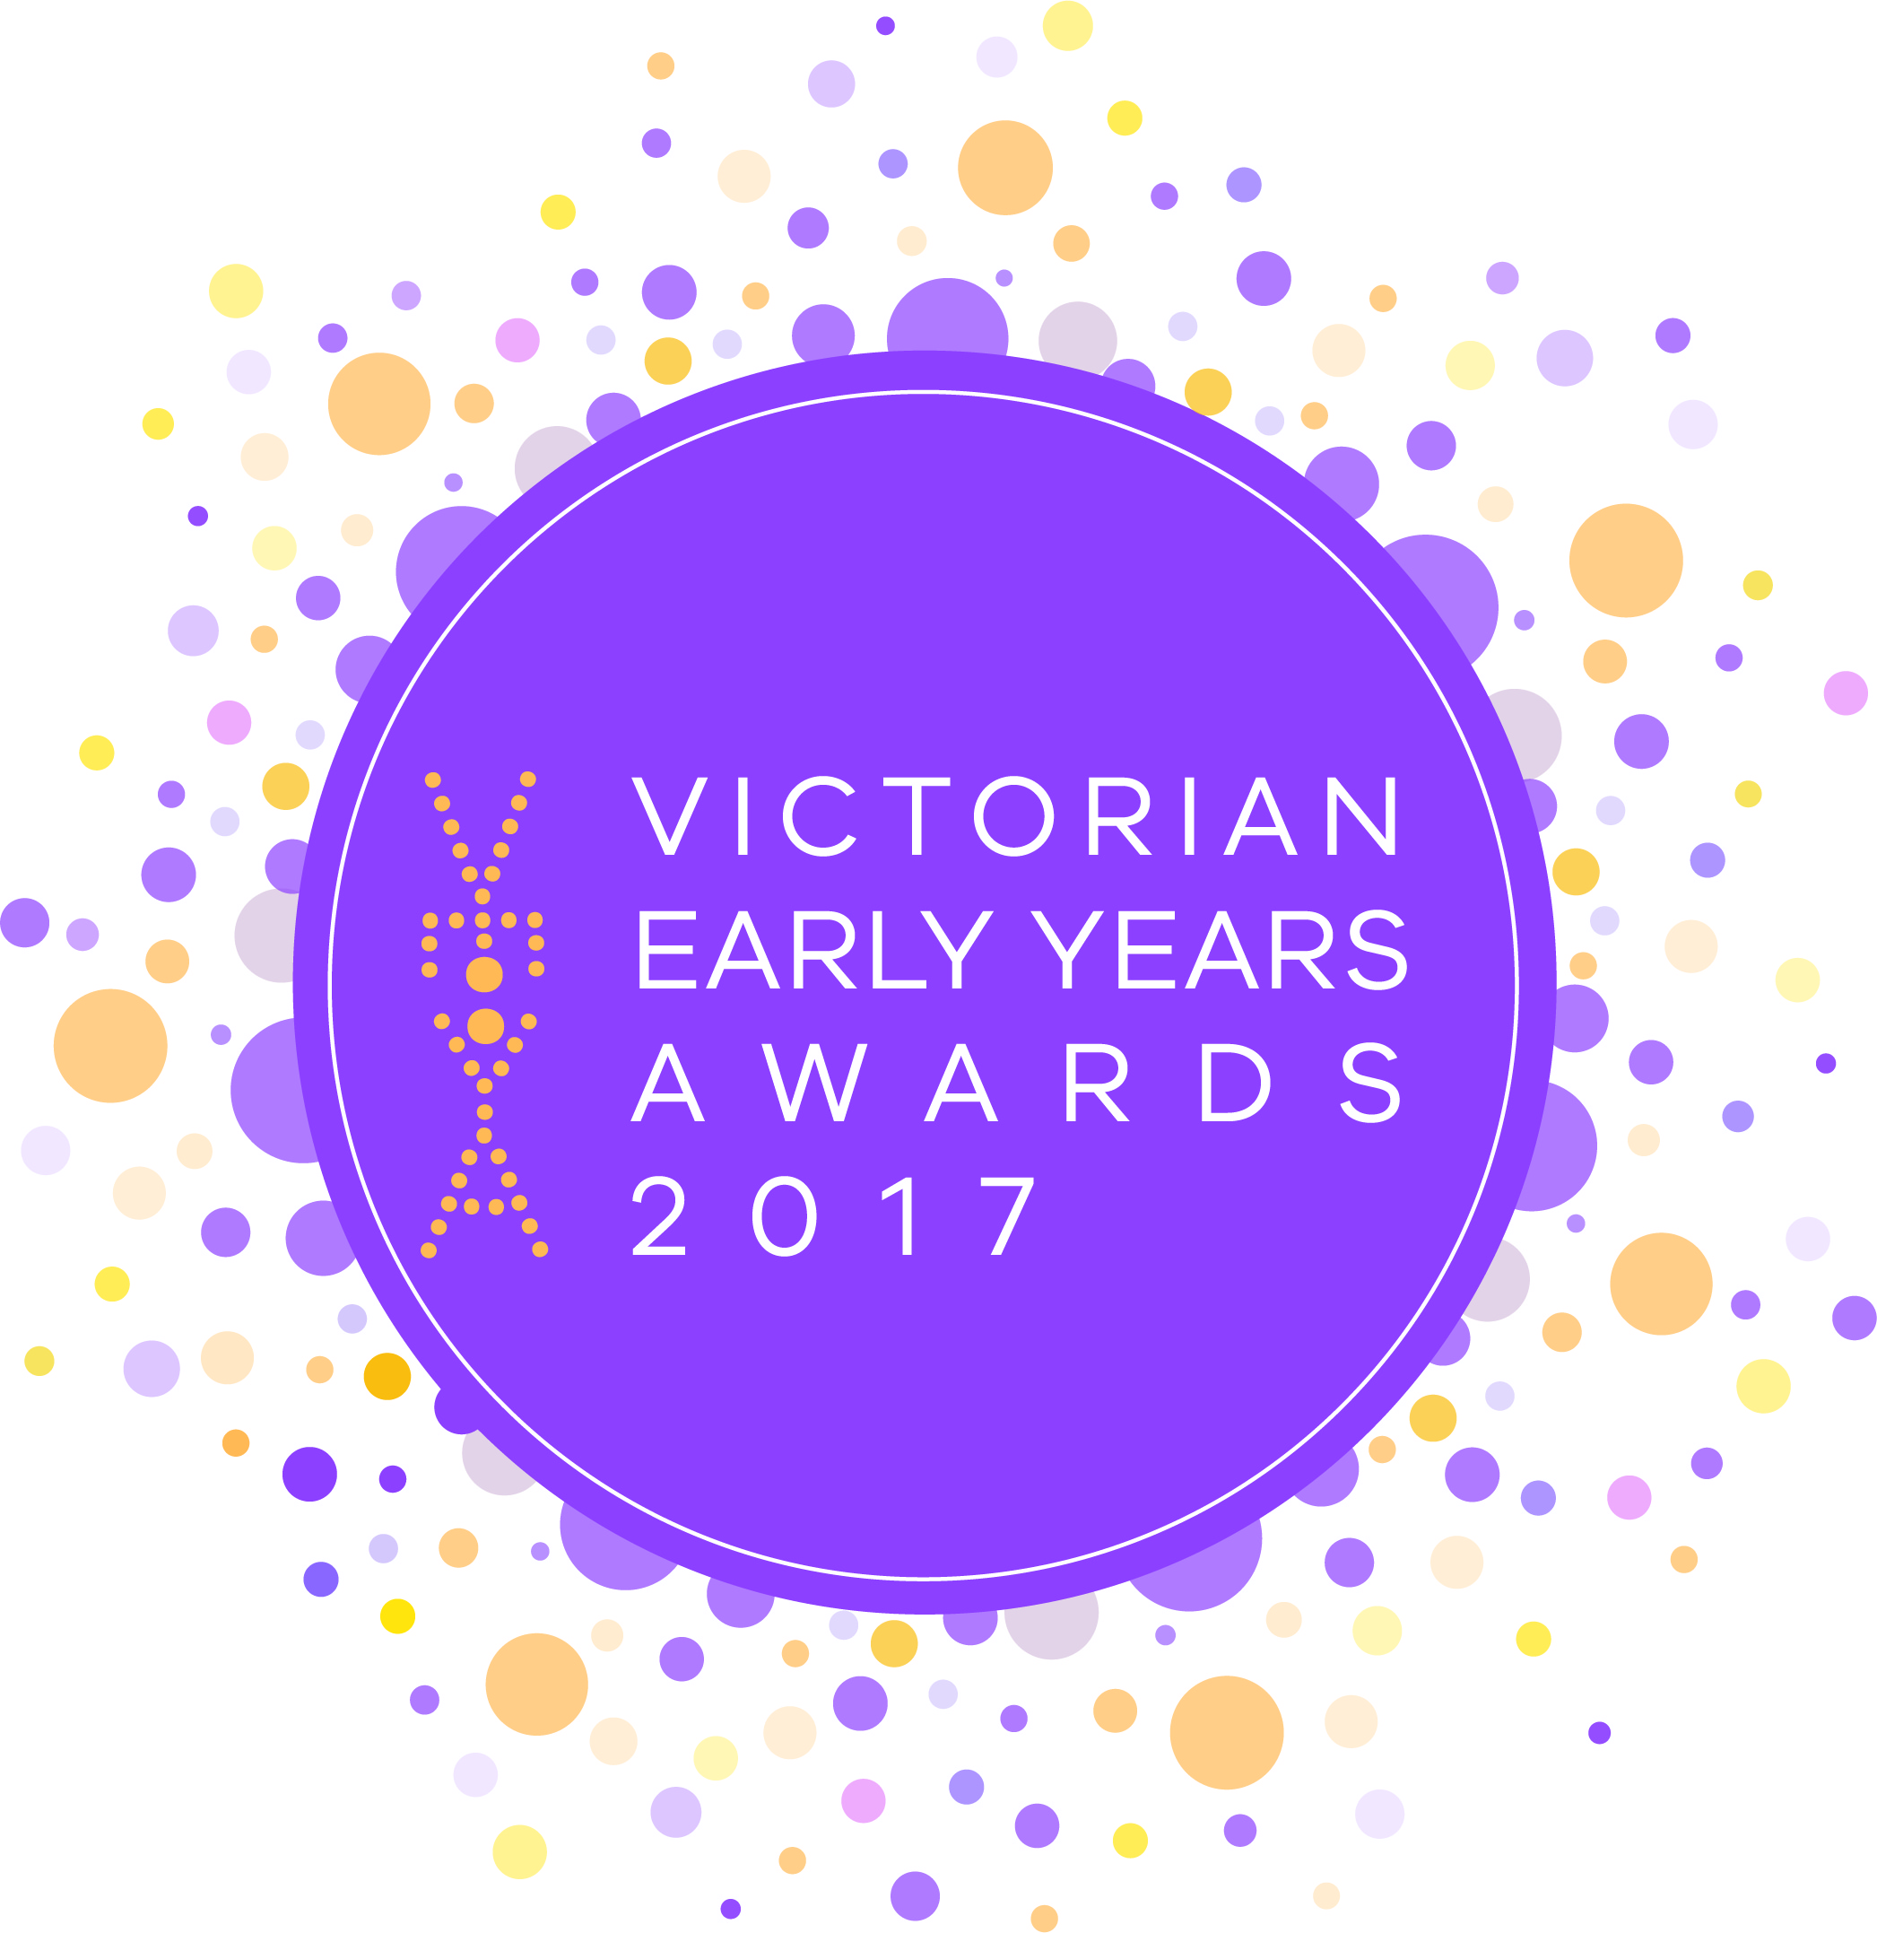
2017 award nominations now open
Making Victoria the Education State starts with the early years. If you are a dedicated early childhood teacher making a difference to Victorian families and children, nominate yourself or encourage a colleague to apply for the Early Childhood Teacher of the Year award.
www.education.vic.gov.au/veya

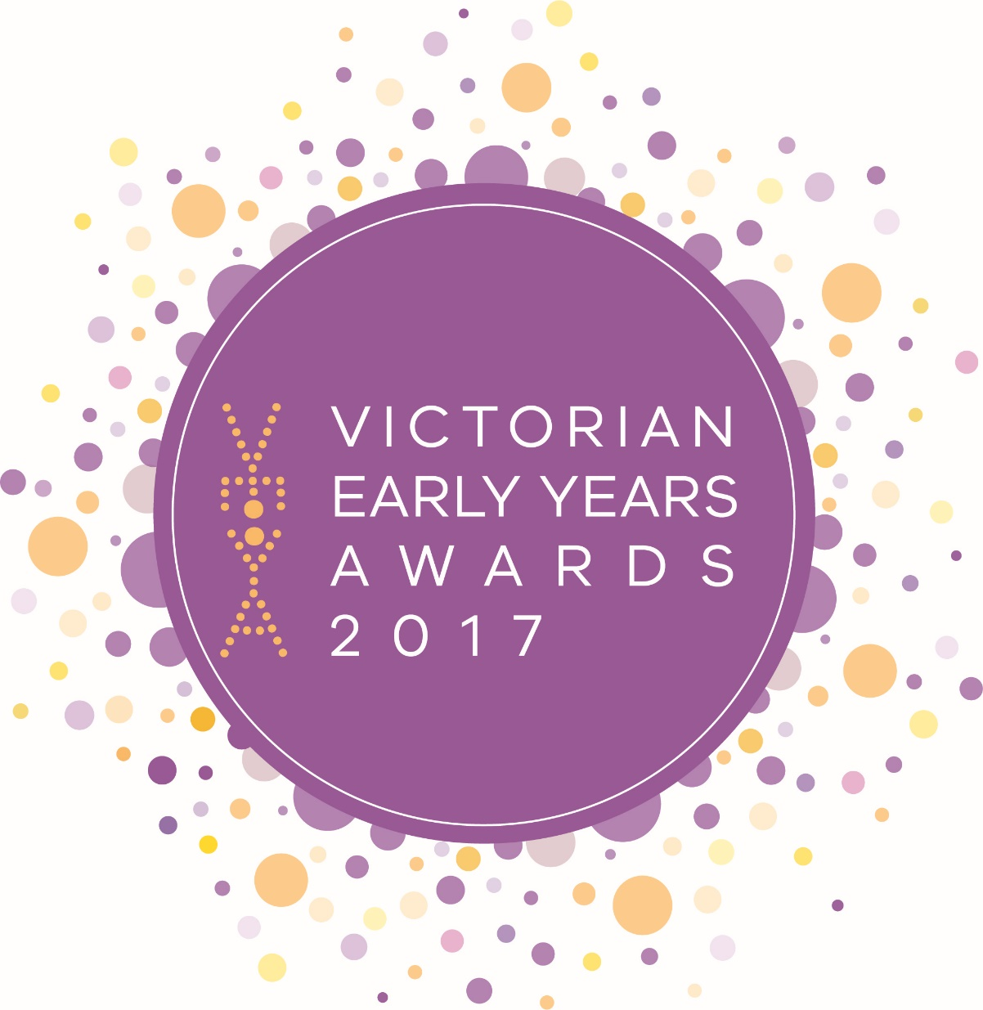

Calling for Victoria’s best early childhood services
and organisations
2017 award nominations now open
Making Victoria the Education State starts with the early years. If you’re part of an exciting early childhood initiative, program or project that is making a difference to the lives of children you should nominate at www.education.vic.gov.au/veya

