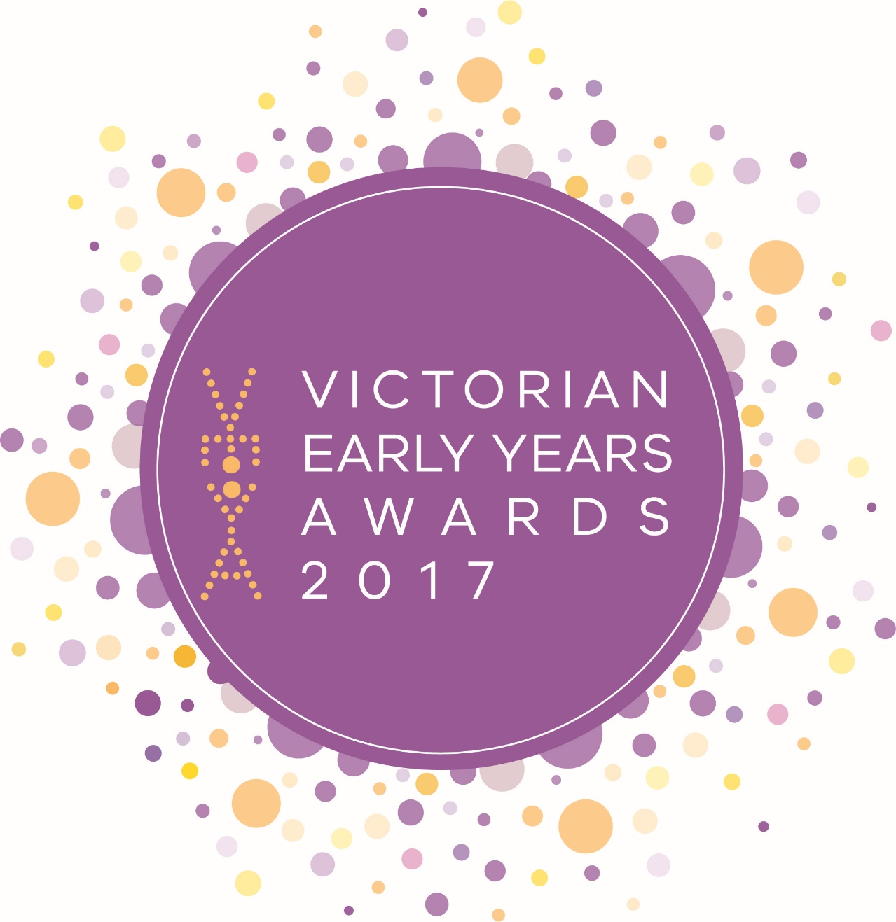
Calling for Victoria’s best early childhood teacher
Nominations close 5:00pm
Monday 15 May 2017

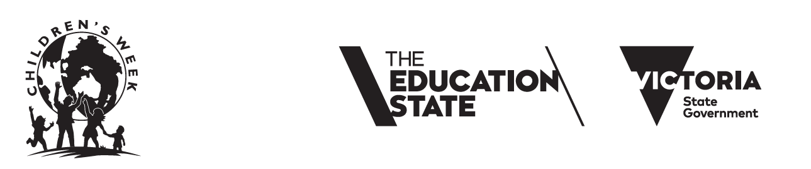

Making Victoria the Education State starts with the early years.
The Victorian Early Years Awards recognise the achievements of dedicated early childhood teachers.
Nominate yourself or encourage a colleague to apply for:

• Early childhood teacher of the year
Or nominate your initiative, program or project for one of these awards:

• Category 1 - Improving access and participation in early learning
• Category 2 - Supporting parents to build their capacity and confidence
• Category 3 - Creating collaborative community partnerships
• Category 4 - Promoting children’s health and wellbeing

Nominate at:
www.education.vic.gov.au/veya before 5pm, Monday 15 May 2017.

Winners in each category receive between $10,000 - $15,000

Awards ceremony:
24 October 2017, National Gallery of Victoria.

Who’s eligible?
You are! If you’re an early childhood teacher who is making a difference to the lives of children
you should nominate. For further information, contact: early.years.awards@edumail.vic.gov.au
or (03) 8392 5064

Calling for Victoria’s best early childhood services and organisations
Nominations close 5:00pm
Monday 15 May 2017
Making Victoria the Education State starts with the early years. The Victorian Early Years Awards recognise the organisations, services and early childhood teachers that are leading the way in improving outcomes for children and families.

Nominate your initiative, program or project for one of these awards:

• Category 1 - Improving access and participation in early learning
• Category 2 - Supporting parents to build their capacity and confidence
• Category 3 - Creating collaborative community partnerships
• Category 4 - Promoting children’s health and wellbeing

Or nominate yourself or encourage a colleague to apply for:
• Early childhood teacher of the year

Nominate at: www.education.vic.gov.au/veya before 5pm, Monday 15 May 2017

Winners in each category receive between $10,000 - $15,000

Awards ceremony:
24 October 2017, National Gallery of Victoria.

Who’s eligible?

You are! If you’re part of an exciting initiative, program or project that is making a difference to the lives of children you should nominate. For further information contact: early.years.awards@edumail.vic.gov.au or (03) 8392 5064

